
VMware Pro Cloud Service for Private Cloud Infrastructure - vSphere Kubernetes Service in VMware Cloud Foundation Standard Operating Procedures 9.0

You can find the most up-to-date technical documentation on the Broadcom website at:
https://techdocs.broadcom.com/
Broadcom®
3421 Hillview Ave.
Palo Alto, CA 94304
www.vmware.com
Copyright© 2026 Broadcom® All rights reserved.
Contents
1. Version History 5
2. Document Overview 6
3. Solution Adoption Overview 7
4. vSphere with Tanzu in VMware Cloud Foundation Standard Operating Procedures 8
Configuring and Managing vSphere Namespaces 8
Create and Configure a vSphere Namespace on the Supervisor 9
Create and Configure a vSphere Namespace on a Supervisor with NSX VPC 12
Remove a vSphere Namespace from Supervisor 14
Set Resource Limits to a vSphere Namespace 15
Configure Object Limitations on a vSphere Namespace 15
Provision a Self-Service Namespace Template in vSphere Supervisor 16
Change Storage Settings on a vSphere Namespace 24
Add Security Policies to an NSX vSphere Namespace 25
Configuring and Managing vSphere Zones 26
Add a Cluster as a vSphere Zone to a Supervisor 26
Add a vSphere Zone to a vSphere Namespace 27
Remove a vSphere Zone from a vSphere Namespace 27
Remove a vSphere Zone from a Supervisor 28
Configuring and Managing a Supervisor 28
Replace the VIP Certificate to Securely Connect to the Supervisor API Endpoint 29
Integrate the on the Supervisor with Tanzu Mission Control 30
Set the Default CNI for VKS Clusters 31
Change the Control Plane Size of a Supervisor 33
Change Load Balancer Settings on a Supervisor Configured with VDS Networking 34
Add Workload Networks to a Supervisor Configured with vSphere VLAN Port Groups 35
Change the Management Network Settings on a Supervisor 37
Change the Workload Network Settings on a Supervisor Configured with VDS Networking 38
Change Workload Network Settings on a Supervisor Configured with NSX 40
Configuring HTTP Proxy Settings in vSphere Supervisor 42
Configure an External Identity Provider for VKS Clusters 45
Register an External Identity Provider with Supervisor 52
Change Storage Settings on the Supervisor 55
Modify the List of Supervisor Control Plane DNS Names 57
Maintenance Mode for a Datastore Used by Supervisor 57
Monitoring vSphere Supervisor 61
Monitor and Manage Resources in a vSphere Namespace 61
Forwarding Supervisor Logs to External Monitoring Systems 62
Streaming Supervisor Metrics to a Custom Observability Platform 67
Monitor Foundation Load Balancer 71
Running VKS Clusters 73
VKS Components 73
Deploying VKS Clusters 75
Reference Architectures for VKS Clusters 76
Installing and Upgrading VKS 77
Using the vSphere Kubernetes Service 77
Verify the VKS Status 79
Register a New Version of the VKS 79
Upgrade the VKS Version 80
Upgrade VKS from a Private Registry 81
Troubleshoot the VKS 84
Administering Kubernetes Releases for VKS Clusters 85
Using Kubernetes Releases with VKS Clusters 85
Required Role Permissions for Administering Content Libraries 93
Create a Subscribed Content Library 94
Create a Local Content Library for the Air-Gapped Environment 96
Enable Publishing of a Local Content Library 100
Add or Update VKS Content Libraries on a Supervisor 100
Resource Requests for Components in VKS Clusters 101
VKr and OS Image Resolution Process 113
Configuring vSphere Namespaces for Hosting VKS Clusters 118
Using vSphere Namespaces with VKS Clusters 118
Create a vSphere Namespace for Hosting VKS Clusters 123
Configure a vSphere Namespace for VKS Clusters 124
Configure vSphere Namespace Permissions for vCenter Single Sign-On Users and Groups 126
Override Workload Network Settings for a vSphere Namespace 127
Using VM Classes with VKS Clusters 130
System Resource Reservations in VKS Nodes 132
Verify vSphere Namespace Readiness for Hosting VKS Clusters 134
Enable vSphere Namespace Creation Using Kubectl 135
Integrating TMC with VKS Clusters 136
Registering Tanzu Mission Control Hosted with Supervisor 136
Registering Tanzu Mission Control Self-Managed with Supervisor 138

Version History
Date | Ver. | Author | Description | Reviewers
Important Amend the text as needed and address the consultant and or architect notes. After completion, the notes can be removed. This text provides either sample guidance information, configuration recommendations for specific services, or customer-specific configurations.

Document Overview
This adoption guide document is created by VCF Professional Services to support the subsequent standard operating procedures of the VMware by Broadcom solution at Customer.
This document is accompanied by other documents that focus on implementation and operation subjects, such as installation guides, configuration, and verification workbooks.

Solution Adoption Overview
Adoption of any solution involves the incorporation of the technology into existing business processes. The creation, training, and verification of adopted processes is required to ensure that the original business aims are achieved post implementation of the solution.
VMware has created a simple methodology to assist with this methodology. The following diagram illustrates this strategy.
Figure 3-1. See One, Do One, Teach One

Using this methodology Customer has details on many standard operational processes that can be used post implementation of the solution.

vSphere with Tanzu in VMware Cloud Foundation Standard Operating Procedures
This section lists the operational guidance and solution interoperability details for installation and adoption of Developer Ready Infrastructure using vSphere with Tanzu with VMware Cloud Foundation Solution.

Configuring and Managing vSphere Namespaces
vSphere Supervisor workloads, including vSphere Pods, VMs, and VKS clusters, are deployed to a vSphere Namespace. A vSphere administrator defines the namespace on a Supervisor and configures it with resource quota and user permissions. Depending on the DevOps needs and workloads they plan to run, the vSphere administrator might also assign storage policies, VM classes, and content libraries for fetching VM images.
When initially created, the namespace has unlimited resources within the Supervisor. As a vSphere administrator, you can set limits for CPU, memory, storage, and the number of Kubernetes objects that can run within the namespace. Storage limitations are represented as storage quotas in Kubernetes. A resource pool is created in vSphere per each namespace on the Supervisor
In a Supervisor activated on vSphere Zones, a namespace resource pool is created on each vSphere cluster that is mapped to a zone. The resources utilized by the namespace on a three-zone Supervisor are taken from all three underlying vSphere clusters in equal parts. For example, if you dedicate 300 MHz of CPU, 100 MHz are taken from each vSphere cluster.
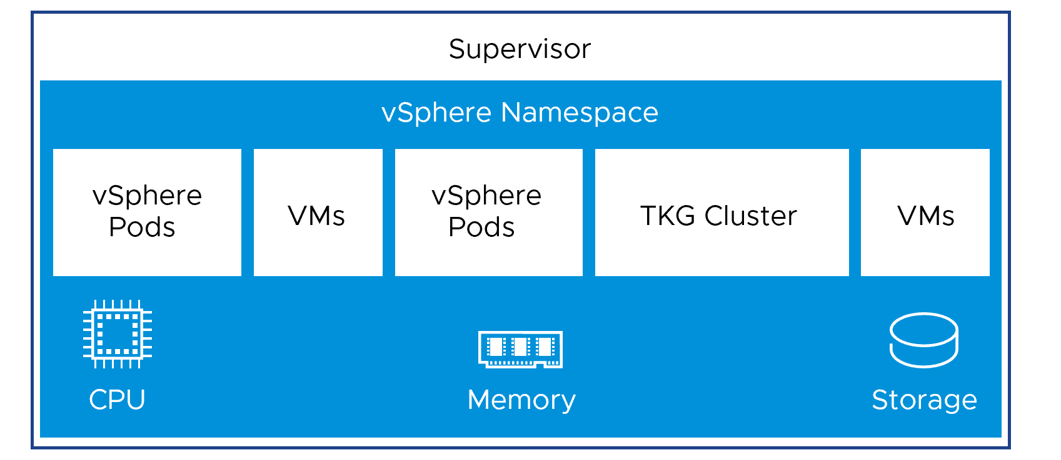
To provide access to namespaces to DevOps engineer, a vSphere administrator assigns permission to users or user groups available within an identity source that is associated with vCenter Single Sign-On or from an ODIC provider that is registered with the Supervisor. For more information, see Understanding Authentication and Authorization in vSphere Supervisor.
After a vSphere Namespace is created and configured with resource, object limits, permissions, and storage policies, as a DevOps engineer, you can access the namespace to run the following workloads:
- For information about running Supervisor Services, see Managing Supervisor Services.
- For information about running vSphere Pods, see Deploying Workloads to vSphere Pods.
- For information about deploying VMs, see Deploying and Managing Virtual Machines in vSphere Supervisor.

Create and Configure a vSphere Namespace on the Supervisor
Checkout how to create a and configure a vSphere Namespace on the Supervisor. As a vSphere administrator, after you create a vSphere Namespace, you set resources limits to the namespace and permissions so that DevOps engineers can access it. You provide the URL of the Kubernetes control plane to DevOps engineers where they can run workloads on the namespaces for which they have permissions.
You can also set resources limits to the vSphere Namespace, assign permissions, and provision or activate the vSphere Namespace service on a cluster as a template. As a result, DevOps engineers can create a vSphere Namespace in a self-service manner and deploy workloads within it. For more information, see Provision a Self-Service Namespace Template in vSphere Supervisor.
If you use NSX for your Supervisors, you have the option to override the networking settings on vSphere Namespace level. Have in mind the following considerations if you select that option:
Table 4-1. vSphere Namespace Network Planning Considerations
Consideration | Description
NSX Installation | To override Supervisor network settings for a particular vSphere Namespace, the NSX must include an Edge Cluster dedicated for Tier-0 Gateways (routers) and another Edge Cluster dedicated for Tier-1 Gateways. Refer to the NSX installation instructions provided in the guide Installing and Configuring vSphere Supervisor.
IPAM Required | If you override Supervisor network settings for a particular vSphere Namespace, the new vSphere Namespace network must specify Ingress, Egress, and Namespace Network subnets that are unique for the Supervisor and from any other vSphere Namespace network. You will need to manage IP address allocation accordingly.
Supervisor Routing | The Supervisor must be able to route directly to the VKS cluster nodes and ingress subnets. When selecting a Tier-0 Gateway for the vSphere Namespace, you have two options for configuring the required routing:  - Use a Virtual Routing and Forwarding (VRF) Gateway to inherit the configuration from the Supervisor Tier-0 Gateway  - Use the Border Gateway Protocol (BGP) to configure routes between the Supervisor Tier-0 Gateway and the dedicated Tier-0 Gateway  Refer to the NSX Tier-0 Gateways documentation for details on these options.
Prerequisites
- Deploy a Supervisor.
- Create users and groups for DevOps engineers and developers, who will need access to the vSphere Namespace. Create the users or groups in identity sources that are connected to vCenter Single Sign-On or in an OIDC provider configured with the Supervisor.
- Create storage policies for persistent storage. If the vSphere Namespace is in a multi-zone Supervisor, use topology aware policies. You cannot assign storage policies that are not topology aware to the multi-zone vSphere Namespace .
- Create VM classes and content libraries for stand-alone VMs.
- Create a vSphere Zone to associate with the vSphere Namespace. For isolation of between the workload and management plane, you can assign a vSphere Zone that is different from the zone where the Supervisor is running. See Add a Cluster as a vSphere Zone to a Supervisor
- Required privileges: Namespaces.view, Namespace.edit and Namespaces.owner. See How Permissions Work in Supervisorfor more information.
Procedure
- From the vSphere Client home menu, select Supervisor Management.
- Select the Namespaces tab.
- Click New Namespace.
- Select the Supervisor where you want to place the vSphere Namespace.
- Enter a name for the vSphere Namespace..
The name must be in a DNS-compliant format.
- From the Network drop-down menu, select a Workload Network for the vSphere Namespace.
Note This step is available only if you create the vSphere Namespace on a cluster that is configured with the vSphere networking stack.
- If you have configured the NSX networking stack for your Supervisor, you can select Override cluster network settings to override the Supervisor network settings and configure network settings for the namespace.
Configure the following network settings for the namespace:
Option | Description
Tier-0 Gateway | Select the Tier-0 gateway to associate with the namespace Tier-1 gateway.  Selecting a Tier-0 gateway overrides the tier-0 gateway you configured while enabling the cluster, so you must configure the CIDR ranges again.  Note The Supervisor must be able to route directly to the VKS cluster nodes and ingress subnets.  - If you select a VRF gateway that is linked to the Tier-0 gateway, the network and subnets are automatically configured.  - If you have selected the NAT mode, you must configure the subnet, ingress, and egress CIDRs.  - If you deselect the NAT mode, you must only configure the subnet and ingress CIDRs.  Note Once you select a Tier-0 gateway, you cannot change it.
NAT Mode | The NAT mode is selected by default.  If you deselect this option, all the workloads such as the vSphere Pods, VMs, and VKS clusters node IP addresses are directly accessible from outside the tier-0 gateway and you do not have to configure the egress CIDRs.  Note Once you enable a namespace mode, you cannot change it.
Load balancer Size | Select the size of the load balancer instance on the tier-1 gateway for the namespace.
Namespace Network | Enter one or more IP CIDRs to create subnets/segments and assign IP addresses for workloads connected to namespaces.  Note Enter the CIDR range if you did not configure it for the cluster. You can configure additional CIDRs after you create the namespace, by editing the namespace network settings.
Namespace Subnet Prefix | Enter the subnet prefix that specifies the size of the subnet reserved for namespaces segments. Default is 28.  Note Once you specify the subnet prefix, you cannot change it.
Ingress | Enter a CIDR annotation that determines the ingress IP range for the virtual IP addresses published by the load balancer service for vSphere Pods or VKS clusters.  You can configure additional CIDRs after you create the namespace, by editing the namespace network settings.
Egress | Enter a CIDR annotation that determines the egress IP range for the SNAT IP addresses.  You can configure additional CIDRs after you create the namespace, by editing the namespace network settings.
- Select a zone to associate with the vSphere Namespace.
- Enter a description, and click Finish.
The namespace is created on the Supervisor.
- Set permissions for users who can access the namespace.
See How Permissions Work in Supervisor for more information on seeting up persmission for useres and groups on the vSphere Namespace.
  - From the Permissions pane, select Add Permissions.
- Assign storage to the namespace.
Storage policies that you assign to the namespace make persistent storage available to the DevOps team and determine the storage placement of persistent volumes.
  - From the Storage pane, select Add Storage.
  - Select a storage policy to control datastore placement of persistent volumes and click OK.
After you assign the storage policy, the system creates a matching Kubernetes storage class in the vSphere Namespace. The storage class is automatically replicated from the namespace to the VKS cluster. When you assign multiple storage policies to the namespace, a separate storage class is created for each storage policy. For information about verifying storage classes, see Display Storage Classes in a Namespace.
- From the Capacity and Usage pane, select Edit Limits and configure resource limitations to the namespace.
CPU | The amount of CPU resources to reserve for the namespace.
Memory | The amount of memory to reserve for the namespace.
Storage | The total amount of storage space to reserve for the namespace.
Storage policies limits | Set the amount of storage dedicated individually to each of the storage policies that you associated with the namespace.
A resource pool for the namespace is created on vCenter.
- Set up VM Service for stand-alone VMs.
For information, see Deploying and Managing Virtual Machines in vSphere Supervisor.
What to do next
Share the Kubernetes Control Plane URL with DevOps engineers as well as the user name they can use to log in to the Supervisor through the VCF Consumption CLI. You can grant access to more than one namespace to a DevOps engineer. See Connecting to Supervisor and VKS Clusters.

Create and Configure a vSphere Namespace on a Supervisor with NSX VPC
Check out how to create and configure a vSphere Namespace on a Supervisor that uses NSX VPC.
If NSX VPC is configured on the Supervisor, a Namespace in the Supervisor must use the VPC networking. The Namespace can either inherit the NSX Project of the Supervisor or select another existing NSX Project.
Prerequisites
- Deploy a Supervisor.
- Configure NSX VPC for the Supervisor.
- Create users and groups for DevOps engineers and developers, who will need access to the vSphere Namespace . Create the users or groups in identity sources that are connected to vCenter Single Sign-On or in an OIDC provider configured with the Supervisor.
- Create storage policies for persistent storage. If the namespace is in a three-zone Supervisor, use topology aware policies. You cannot assign storage policies that are not topology aware to the three-zone namespace.
- Create VM classes and content libraries for stand-alone VMs.
- Required privileges: Namespaces.view, Namespace.edit and Namespaces.owner. See How Permissions Work in Supervisorfor more information.
Procedure
- From the vSphere Client home menu, select Supervisor Management.
- Select the Namespaces tab.
- Click New Namespace.
- Select the Supervisor where you want to place the vSphere Namespace.
- Enter a name for the namespace.
The name must be in a DNS-compliant format.
- Select the option to override the networking settings.
- You can use the existing VPC or create a new one.
  - If you select an existing VPC, select the NSX project and the VPC that you want to use and default subnet size. Default Subnet size is 32.
  - If you create a new VPC, the namespace uses the default NSX Project and VPC Connectivity Profile configured in the Supervisor to create the new VPC.
Configure the following settings:
Default Subnet Size | Default is 64.
Private VPC CIDRs | List of IPv4 CIDRs. This list is used for IP allocation of private segments.  A /26 subnet from the range will be reserved for the Avi Service Engine.  Also serves as default value of private CIDRs for workload NS. Note: separate IP pools will be created for each VPC matching the private CIDR ranges. The pools will not be shared across Namespaces.
- Review the settings and click Finish.
The namespace is created on the Supervisor.

Change Network Settings for a vSphere Namespace on a Supervisor with NSX VPC
As a vSphere Administrator, you can configure network settings when you configure a vSphere Namespace. If you need to make changes to the initial network settings, perform this task.
Procedure
- In the vSphere Client, navigate to the namespace.
  - From the vSphere Client home menu, select Supervisor Management.
  - Click the Namespaces tab and click the namespace.
- Click the Configure tab and click General.
- In the Network Settings section, you can change the following network settings:
  - Default Subnet Type
  - Default Subnet Size
  - Default Private Subnet CIDR

Remove a vSphere Namespace from Supervisor
You can remove a vSphere Namespace from Supervisor.
Prerequisites
- Remove any deployed workloads, including VMs, vSphere Pods, and VKS clusters.
- Required privileges:
  - Namespaces > Modify cluster-wide configuration
  - Namespaces > Modify namespace configuration
Procedure
- From the vSphere Client home menu, select Supervisor Management.
- Click the Namespaces tab.
- From the list of namespaces available on the Supervisor, select the vSphere Namespace you want to remove.
- Click Remove.
The system removes the vSphere Namespace. It might take time for the process to complete.

Set Resource Limits to a vSphere Namespace
As a vSphere administrator, you can set resource limits and container defaults on a vSphere Namespace. DevOps engineers can later override the container defaults in pod specifications but without exceeding the total resource limits set to the namespace by the vSphere administrator. Container requests translate to resource reservations in pods.
Prerequisites
- Verify that you have the Modify namespace configuration privilege on the Supervisor.
Procedure
- From the vSphere Client home menu, select Supervisor Management.
- Select a vSphere Namespace, select Configure, and click Resource Limits.
- Click Edit.
Setting resource limits on a vSphere Namespace where a VKS cluster runs affects the cluster differently depending on the VM class type used for the nodes. Before applying limits, understand the difference between best effort and guaranteed VM classes. For details, see Virtual Machine Classes for VKS Clusters.
CPU | Set a limit to the CPU consumption on the vSphere Namespace.
Memory | Set a limit to the memory consumption on the vSphere Namespace.
Storage | Set a limit on the storage consumption on the vSphere Namespace per storage policy that is used.
Container Defaults | Set the defaults for CPU limits, CPU requests, memory requests, and memory limits for containers in the vSphere Namespace.

Configure Object Limitations on a vSphere Namespace
You can configure limitations for object running in the vSphere Namespace, such as the number of deployments, jobs, daemon sets, stateful sets, and others The limitations that you configure for an object depend on the specifics of your applications and the way you want them to consume resources within avSphere Namespace.
Prerequisites
- Verify that you have the Modify namespace configuration privilege on the Supervisor.
Procedure
- From the vSphere Client home menu, select Supervisor Management.
- Select thevSphere Namespace to which you want to apply object or container restrictions.
- Select Configure and select Object Limits.
- Click Edit.
vSphere Pods | The number of vSphere Pods that can run in thevSphere Namespace.
Deployments | The number of deployments that can run in thevSphere Namespace.
Jobs | The number of jobs that can run in thevSphere Namespace.
Daemon Sets | The number of daemon sets that can run in thevSphere Namespace.
Replica Sets | The number of replica sets in thevSphere Namespace.
Replication Controllers | The number of replication controllers that can run in thevSphere Namespace.
Stateful Sets | The number of StatefulSets that can run in thevSphere Namespace.
Config Maps | The number of ConfigMaps that can run in thevSphere Namespace.
Secrets | The number of secrets that can run in thevSphere Namespace.
Persistent Volume Claims | The persistent volume claims that can exists in thevSphere Namespace.
Services | The services that can exists in thevSphere Namespace.

Provision a Self-Service Namespace Template in vSphere Supervisor
As a vSphere administrator, you can create a vSphere Namespace, set CPU, memory, and storage limits to the namespace, assign permissions, and activate the namespace service on a cluster as a template. As a result, DevOps engineers can create a vSphere Namespace in a self-service manner and deploy workloads within it.

Self-Service Namespace Creation and Configuration Workflow
As a vSphere administrator, you can create a vSphere Namespace, set CPU, memory, and storage limits to the namespace, assign permissions, and provision or activate the namespace service on a cluster as a template.
Figure 4-2. Self-service Namespace Template Provisioning Workflow
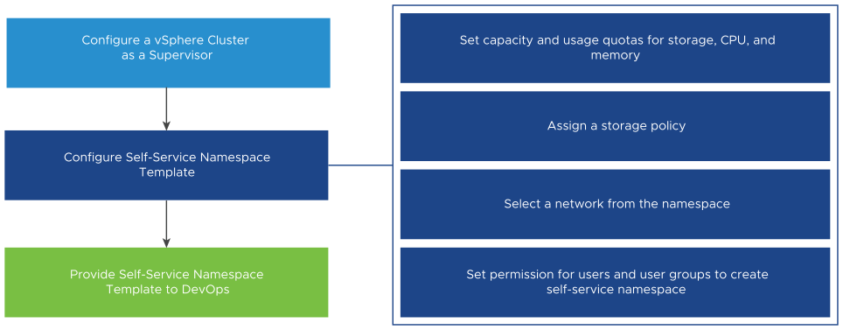
As a DevOps engineer, you can create a vSphere Namespace in a self-service manner and deploy workloads within it. You can share it with other DevOps engineers or delete it when it is no longer required. To share the namespace with other DevOps engineers, contact the vSphere administrator.
Figure 4-3. Self-service Namespace Creation Workflow
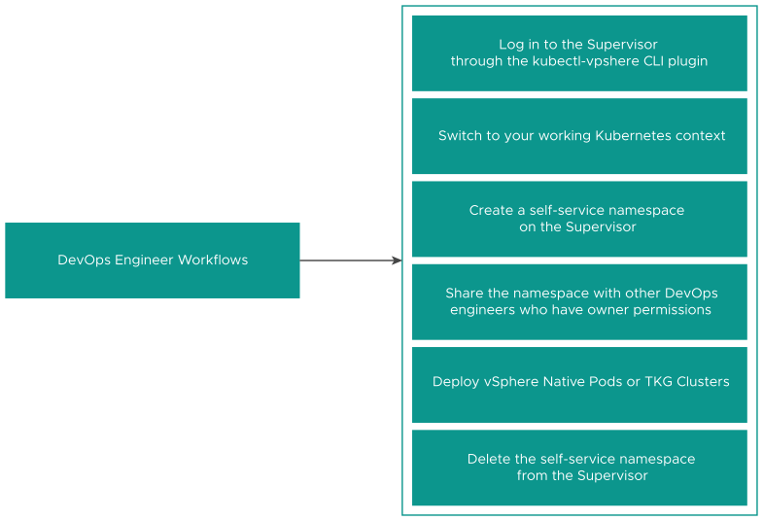

Create and Configure a Self-Service Namespace Template
As a vSphere administrator, you can create and configure a Supervisor Namespace as a self-service namespace template. DevOps engineers can then create and delete Supervisor Namespaces using the kubectl command line.
Prerequisites
Enable a Supervisor.
Procedure
- In the vSphere Client, navigate to the Supervisor.
- Click the Configure tab, and select General under Supervisor.
- Select Namespace Service.
- Toggle the Status switch to enable the feature.
The Create Namespace Template page appears.
- In the Configuration pane, configure resources for the namespace.
Option | Description
CPU | The amount of CPU resources to reserve for the namespace.
Memory | The amount of memory to reserve for the namespace.
Storage | The total amount of storage space to reserve for the namespace.
Storage Policy | Storage policies to use with workloads that require persistent storage.
Network | From the Network drop-down menu, select a network for the namespace.
VM Classes | VM classes to deploy stand-alone VMs.
Content Libraries | Content libraries with VM images to use for VM deployments.
- Click Next.
- In the Permissions pane, add DevOps engineers and groups to empower them to use the template to create namespaces.
Select an identity source and a user or a group and click Next.
- In the Review and Confirm pane, the properties you configure are displayed.
Review the properties and click Done.
Results
A namespace template is configured and is in Active state. As a vSphere administrator, you can edit the template. DevOps engineers can use the template to create namespaces.

Deactivate a Self-Service Namespace
As a vSphere administrator, you can deactivate a self-service namespace on the cluster.
When you deactivate a self-service namespace template, DevOps engineers cannot use the template to create new namespaces on the cluster. They can delete the namespaces that they have already created.
Procedure
- In the vSphere Client, navigate to the Supervisor.
- Click the Configure tab, and select General under Supervisor.
- In the Namespace Service pane, toggle the Status switch to deactivate the template.
- To activate the template again, toggle the Status switch.
You can either create another self-service namespace or use the existing one.

Create a Self-Service Namespace
As a DevOps Engineer, you can create a self-service namespace and run workloads within it. Once you create the namespace, you can share it with other DevOps Engineers or delete it when it is no longer required.
Prerequisites
- Verify that a vSphere administrator has created and activated a self-service namespace template on the cluster. See Create and Configure a Self-Service Namespace Template.
- Verify that you are added to the permissions list in the self-service namespace template either individually or as a member of a group .
- Get the IP address of the Supervisor control plane.
Procedure
- Using the VCF CLI, authenticate with the Supervisor. See Connect to the Supervisor as a vCenter Single Sign-On User.
kubectl vsphere login --server=IP-ADDRESS--vsphere-usernameUSERNAME
- Switch context to the Supervisor.
kubectl config use-contextSUPERVISOR-CLUSTER-IP
- Create a self-service namespace on the cluster.
kubectl create namespaceNAMESPACE NAME
For example
kubectl create namespace test-ns
Note Owner permissions are available to DevOps Engineers after you enable the Supervisor and upgrade the cluster. If you have only upgraded vCenter and not the cluster, the DevOps engineers will only have edit permissions on the namespaces.
The namespace that you create appears in the cluster. To share the namespace with other DevOps engineers, contact the vSphere administrator.

Create a Self-Service Namespace with Annotations and Labels
DevOps engineers can create self-service namespaces with annotations and labels using the kubectl command line.
DevOps engineers can use a YAML manifest with user-defined annotations and labels.
Procedure
- Log in to the Supervisor.
kubectl vsphere login --server IP-ADDRESS-SUPERVISOR-CLUSTER --vsphere-username VCENTER-SSO-USERNAME
- Create a namespace YAML manifest file with annotations and labels.
kubectl create -f ns-create.yaml
For example, create the following ns-create.yaml file:
apiVersion: v1
kind: Namespace
metadata:
name: test-ns-yaml
labels:
my-label: "my-label-val-yaml"
annotations:
my-ann-yaml: "my-ann-val-yaml"
- Apply the YAML manifest.
kubectl create -f ns-create.yaml
Or
kubectl apply -f ns-create.yaml
- Describe the namespace that you created to see the changes.
root@localhost [ /tmp ]# kubectl describe ns test-ns-yaml
Name: test-ns-yaml
Labels: my-label=my-label-val-yaml
vSphereClusterID=domain-c50
Annotations: my-ann-yaml: my-ann-val-yaml
vmware-system-namespace-owner-count: 1
vmware-system-resource-pool: resgroup-171
vmware-system-resource-pool-cpu-limit: 0.4770
vmware-system-resource-pool-memory-limit: 2000Mi
vmware-system-self-service-namespace: true
vmware-system-vm-folder: group-v172
Status: Active
Resource Quotas
Name: test-ns-yaml
Resource Used Hard
-------- --- ---
requests.storage 0 5000Mi
Name: test-ns-yaml-storagequota
Resource Used Hard
-------- --- ---
namespace-service-storage-profile.storageclass.storage.k8s.io/requests.storage 0 9223372036854775807
No LimitRange resource.

Update a Self-Service Namespace Using kubectl annotate and kubectl label
As a DevOps engineer you can update or delete self-service namespace annotations and labels using the kubectl annotate and kubectl label commands.
Prerequisites
Verify that you have owner permissions on the namespace that you want to update.
Procedure
- Log in to the Supervisor.
kubectl vsphere login --server IP-ADDRESS-SUPERVISOR-CLUSTER --vsphere-username VCENTER-SSO-USERNAME
- Describe the namespace that you want to update.
root@localhost [ /tmp ]# kubectl describe ns testns
Name: testns
Labels: my-label=test-label-2
vSphereClusterID=domain-c50
Annotations: my-ann: test-ann-2
vmware-system-namespace-owner-count: 2
vmware-system-resource-pool: resgroup-153
vmware-system-resource-pool-cpu-limit: 0.4770
vmware-system-resource-pool-memory-limit: 2000Mi
vmware-system-self-service-namespace: true
vmware-system-vm-folder: group-v154
Status: Active
Resource Quotas
Name: testns
Resource Used Hard
-------- --- ---
requests.storage 0 5000Mi
Name: testns-storagequota
Resource Used Hard
-------- --- ---
namespace-service-storage-profile.storageclass.storage.k8s.io/requests.storage 0 9223372036854775807
- Update annotations using the kubectl annotate command.
For example, kubectl annotate --overwrite ns testns my-ann="test-ann-3"
To delete an annotation, run the command kubectl annotate --overwrite ns testns my-ann-
- Update labels using the kubectl label command.
For example, kubectl label --overwrite ns testns my-label="test-label-3"
To delete a label, run the command kubectl label --overwrite ns testns my-label-
- Describe the namespace to see the updates.
root@localhost [ /tmp ]# kubectl describe ns testns
Name: testns
Labels: my-label=test-label-3
vSphereClusterID=domain-c50
Annotations: my-ann: test-ann-3
vmware-system-namespace-owner-count: 2
vmware-system-resource-pool: resgroup-153
vmware-system-resource-pool-cpu-limit: 0.4770
vmware-system-resource-pool-memory-limit: 2000Mi
vmware-system-self-service-namespace: true
vmware-system-vm-folder: group-v154
Status: Active
Resource Quotas
Name: testns
Resource Used Hard
-------- --- ---
requests.storage 0 5000Mi
Name: testns-storagequota
Resource Used Hard
-------- --- ---
namespace-service-storage-profile.storageclass.storage.k8s.io/requests.storage 0 9223372036854775807
No LimitRange resource.

Update a Self-Service Namespace Using kubectl edit
As a DevOps engineer you can update self-service namespaces using the kubectl edit command.
Prerequisites
Verify that you have owner permissions on the namespace that you want to update.
Procedure
- Log in to the Supervisor.
kubectl vsphere login --server IP-ADDRESS-SUPERVISOR-CLUSTER --vsphere-username VCENTER-SSO-USERNAME
- Describe the namespace that you want to update.
kubectl describe ns testns-1
Name: testns
Labels: vSphereClusterID=domain-c50
Annotations: my-ann: test-ann-2
vmware-system-namespace-owner-count: 2
vmware-system-resource-pool: resgroup-153
vmware-system-resource-pool-cpu-limit: 0.4770
vmware-system-resource-pool-memory-limit: 2000Mi
vmware-system-self-service-namespace: true
vmware-system-vm-folder: group-v154
Status: Active
Resource Quotas
Name: testns-1
Resource Used Hard
-------- --- ---
requests.storage 0 5000Mi
Name: testns-1-storagequota
Resource Used Hard
-------- --- ---
namespace-service-storage-profile.storageclass.storage.k8s.io/requests.storage 0 9223372036854775807
- Edit the namespace using the kubectl edit command.
For example, kubectl edit ns testns-1
The kubectl edit command opens the namespace manifest in the text editor defined by your KUBE_EDITOR or the EDITOR environment variable.
- Update the labels.
For example, my-label=test-label
- Update the annotations.
For example, my-ann: test-ann
- Describe the namespace to see the updates.
root@localhost [ /tmp ]# kubectl describe ns testns-1
Name: testns-1
Labels: my-label=test-label
vSphereClusterID=domain-c50
Annotations: my-ann: test-ann
vmware-system-namespace-owner-count: 1
vmware-system-resource-pool: resgroup-173
vmware-system-resource-pool-cpu-limit: 0.4770
vmware-system-resource-pool-memory-limit: 2000Mi
vmware-system-self-service-namespace: true
vmware-system-vm-folder: group-v174
Status: Active
Resource Quotas
Name: testns-1
Resource Used Hard
-------- --- ---
requests.storage 0 5000Mi
Name: testns-1-storagequota
Resource Used Hard
-------- --- ---
namespace-service-storage-profile.storageclass.storage.k8s.io/requests.storage 0 9223372036854775807
No LimitRange resource.

Delete a Self-Service Namespace
As a DevOps Engineer, you can delete a self-service namespace that you create.
Prerequisites
Verify that you have created a self-service namespace using the VCF CLI.
Procedure
- Using the VCF CLI, authenticate with the Supervisor. See Connect to the Supervisor as a vCenter Single Sign-On User.
- Delete the self-service namespace from the cluster.
kubectl delete namespace NAMESPACE NAME
For example:
kubectl delete namespace test-ns

Change Storage Settings on a vSphere Namespace
Storage policies assigned to a namespace in a Supervisor make persistent storage available to the DevOps team. These storage policies control how persistent volumes and VKS cluster nodes are placed within vSphere datastores. As a vSphere administrator, you typically assign storage policies when configuring the namespace. If you need to make any changes in the initial storage policy assignments, perform this task.
Prerequisites
- Before deleting a storage policy from vCenter or a vSphere Namespace, or changing the storage policy assignment, make sure that no persistent volume claim with the corresponding storage class runs in the namespace. Also, ensure that no VKS cluster is using the storage class.
- If the namespace is in a three-zone Supervisor, use topology aware policies. You cannot assign storage policies that are not topology aware to the three-zone namespace.
Procedure
- In the vSphere Client, navigate to the namespace.
  - From the vSphere Client home menu, select Supervisor Management.
  - Click the Namespaces tab and click the namespace.
- Click the Storage tab and click Storage Policies.
- Click the Edit icon to change storage policy assignments.

Add Security Policies to an NSX vSphere Namespace
A Supervisor that uses NSX networking supports network security policies configured through a security policy CRD.

Create a Security Policy
As a DevOps, you can configure the security policy CRD to apply an NSX based security policy to a Supervisor namespace. The security policy protects traffic for vSphere Pods and VMs. VMs include VKS cluster nodes and other VMs deployed in the Supervisor.
Prerequisites
Use NSX version 3.2 or later.
Procedure
- Create a security policy CRD.
For the fields to use and CRD examples, see NSX Operator Security Policy CRD documentation on GitHub.
- Access your namespace in the Kubernetes environment.
See Connecting to Supervisor and VKS Clusters.
- Apply the security policy to the namespace.
kubectl apply -f policy-name.yaml
- View your security policy.
  - View details for the security policy.
kubectl get securitypolicy policy-name
  - View a description of your security policy.
kubectl describe securitypolicy policy-name
Results
You can also use the NSX UI to view details of your policy. For information, see the VMware NSX Documentation page.

Configuring and Managing vSphere Zones
Checkout how to add vSphere clusters as vSphere Zones to a Supervisor. Once you deploy the Supervisor on one or three vSphere Zones, you can add more vSphere Zones to the Supervisor and assign them to vSphere Namespaces. For separation between the workload and management planes, you can use the vSphere Zones where the Supervisor runs for the management plane only and assign different vSphere Zones to vSphere Namespaces. You can add up to three vSphere Zone to a vSphere Namespace. You can also remove vSphere Zones from vSphere Namespaces and the Supervisor.

Add a Cluster as a vSphere Zone to a Supervisor
You can add a vSphere Cluster as a vSphere Zone to a Supervisor and assign it as a Management Zone to vSphere Namespaces.
Prerequisites
- Configure vSphere DRS in fully-automated mode to the cluster.
- Configure vSphere HA to the cluster.
- Configure shared storage with vSAN tor a different solution to the cluster.
- Add the cluster to the same VDS where the Supervisor is connected.
- Required privileges:
  - Namespaces > Modify cluster-wide configuration
  - Namespaces > Modify namespace configuration
- In NSX based setup, the cluster must have connectivity to the same NSX overlay network as the Supervisor.
- In a VDS networking setup, verify that the cluster is connected to distributed port group that is configured as Workload Network to the Supervisor.
Procedure
- In the vSphere Client, navigate to the cluster that you want to add as a vSphere Zone to a Supervisor.
- Select Actions > Add as a Zone to a Supervisor
- Select New Zone and click Next.
- Enter a vSphere Zone name and click Next.
- Select the Supervisor where you want to add the zone and click Next.
- Review your settings and click Finish.
Results
The new zone is added to the Supervisor and you can add to vSphere Namespaces.

Add a vSphere Zone to a vSphere Namespace
You can configure up to three vSphere Zones to a vSphere Namespace in a Supervisor to increase the capacity for running workarounds on the vSphere Namespace.
Prerequisites
- Add a vSphere cluster as a zone to the Supervisor.
- Required privileges:
  - Namespaces > Modify cluster-wide configuration
  - Namespaces > Modify namespace configuration
Procedure
- In the vSphere Client, navigate to Supervisor Management.
- Select Namespaces, and select the vSphere Namespace where you want to add the zone.
- Select Zones and select Add Zone.
- Select a zone that you want to add as a vSphere Zone to the vSphere Namespace and click Add Zone.

Remove a vSphere Zone from a vSphere Namespace
Check out how to remove a vSphere Zone from a vSphere Namespace in case you want to move it another vSphere Namespace or stop using the zone for running containerized workloads.
Prerequisites
- Migrate all the workloads currently running on the zone to a different zone or vSphere Namespace.
- Verity that there's at least one vSphere Zone assigned with the vSphere Namespace. You cannot remove a Zone if it's the only zone assigned to the vSphere Namespace.
Procedure
- In the vSphere Client, navigate to Supervisor Management.
- Select Namespaces, and select the vSphere Namespace that is associated with the Workload Zone that you want to remove.
- Select Zones.
- Select the vSphere Zone that you want to remove and click Mark for Removal.
Results
The vSphere Zone is marked for removal and you are unable to run any new workloads on it. The zone will be automatically removed once it's empty of workloads, or after a few seconds in case it's emptied of workloads already.

Remove a vSphere Zone from a Supervisor
Remove a vSphere Zone from the Supervisor and respectively from all the vSphere Namespaces that are part of the Supervisor. You cannot remove the vSphere Zone marked as Management where the Supervisor is running.
Prerequisites
- Migrate all the workloads currently running on the zone to a different zone.
Note Migration of Persistent Volume Claims (PVCs) and Persistent Volumes (PVs) to a different zone is not supported. If you remove a zone, the PVC or PV from the removed zone cannot be used by a pod in a different zone.
- Verify that all vSphere Namespaces with which the vSphere Zone is associated have at least one different zone configured.
Procedure
- In the vSphere Client, navigate to Supervisor Management.
- Select Supervisors, and select the Supervisor from which you want to remove the vSphere Zone.
- Select Zones.
- Select the vSphere Zone that you want to remove and click Mark for Removal.
Results
The vSphere Zone is marked for removal, and you are unable to run new workloads on it. The zone will be automatically removed once it is removed from any other vSphere Namespaces it is associated with, or after a few seconds if there are no vSphere Namespaces using it.

Configuring and Managing a Supervisor
As a vSphere Administrator, you enable a vSphere cluster as a Supervisor. You can select between creating the Supervisor with the vSphere networking stack or with VMware NSX® (NSX) as the networking solution. A cluster configured with NSX supports running a vSphere Pod and a VKS cluster created through the vSphere Kubernetes Service. A Supervisor that is configured with the vSphere networking stack only supports VKS clusters.
After you enable the Supervisor, you can use the vSphere Client to manage and monitor the cluster.

Replace the VIP Certificate to Securely Connect to the Supervisor API Endpoint
As a vSphere administrator, you can replace the certificate for the virtual IP address (VIP) to securely connect to the Supervisor API endpoint with a certificate signed by a CA that your hosts already trust. The certificate authenticates the Kubernetes control plane to DevOps engineers, both during login and subsequent interactions with the Supervisor.
Prerequisites
Verify that you have access to a CA that can sign CSRs. For DevOps engineers, the CA must be installed on their system as a trusted root.
For more information about the Supervisor certificate, see Supervisor CA Certificate.
Procedure
- In the vSphere Client, navigate to Supervisor Management.
- Select Supervisors and the select the Supervisor from the list.
- Click Configure and select Certificates.
- In the Supervisor Management Platform pane, select Actions > Generate CSR.
Figure 4-4. Replacing Supervisor default certificate
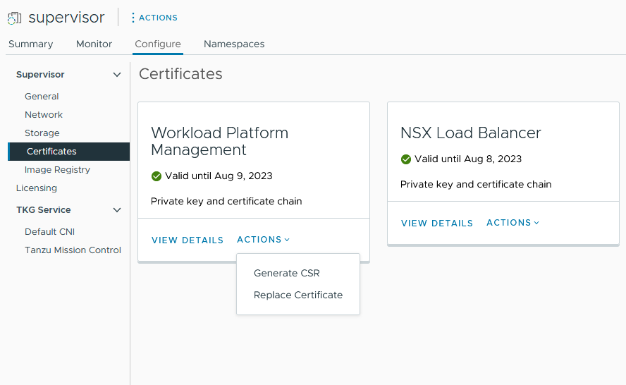
- Provide the details for the certificate.
Note If you use an identity provider service, you must also include the entire certificate chain. The chain is not required for standard HTTPS traffic, however.
- Once the CSR is generated, click Copy.
- Sign the certificate with a CA.
- From the Workload Platform Management pane, select Actions > Replace Certificate.
- Upload the signed certificate file and click Replace Certificate.
- Validate the certificate on the IP address of the Kubernetes control plane.
For example, you can open the VCF Consumption CLI download page and confirm that the certificate is replaced successfully by using the browser. On a Linux or Unix system you can also use echo | openssl s_client -connect https://ip:6443.

Integrate the on the Supervisor with Tanzu Mission Control
You can integrate that runs on the Supervisor with Tanzu Mission Control. Doing so allows you to provision and manage VKS clusters using Tanzu Mission Control.
For more information on Tanzu Mission Control, see Managing the Lifecycle of Tanzu Kubernetes Clusters in the VMware Tanzu Mission Control Product Documentation. To watch a demonstration, check out the video Tanzu Mission Control Integrated with Tanzu Kubernetes Grid Service.

View the Tanzu Mission Control Namespace on the Supervisor
vSphere Supervisor v7.0.1 U1 and later ships with a vSphere Namespace for Tanzu Mission Control. This namespace exists on the Supervisor where you install the Tanzu Mission Control agent. Once the agent is installed, you can provision and manage clusters using the Tanzu Mission Control web interface.
- Log in to the Supervisor and list the namespaces.
See Connect to the Supervisor as a vCenter Single Sign-On User.
The vSphere Namespace provided for Tanzu Mission Control is identified as svc-tmc-cXX (where XX is a number).
- Install the Tanzu Mission Control agent in this namespace. See Install the Tanzu Mission Control Agent on the Supervisor.

Install the Tanzu Mission Control Agent on the Supervisor
To integrate the with Tanzu Mission Control, install the agent on the Supervisor.
Note The following procedure requires at least vSphere 7.0 U3 with the Supervisor version 1.21.0 or later.
- Using the Tanzu Mission Control web interface, register the Supervisor with Tanzu Mission Control. See Register a Management Cluster with Tanzu Mission Control.
- Using the Tanzu Mission Control web interface, obtain the Registration URL by navigating to Administration > Management Clusters.
- Open a firewall port in your vSphere Supervisor environment for the port required by Tanzu Mission Control (typically 443). See Outbound Connections Made by the Cluster Agent Extensions in the VMware Tanzu Mission Control Product Documentation.
- Log in to your vSphere Supervisor environment using the vSphere Client.
- Select Supervisor Management and select the Supervisor .
- Select Configure and select Kubernetes Service > Tanzu Mission Control.
- Provide registration URL in the Registration URL field.
- Click Register.
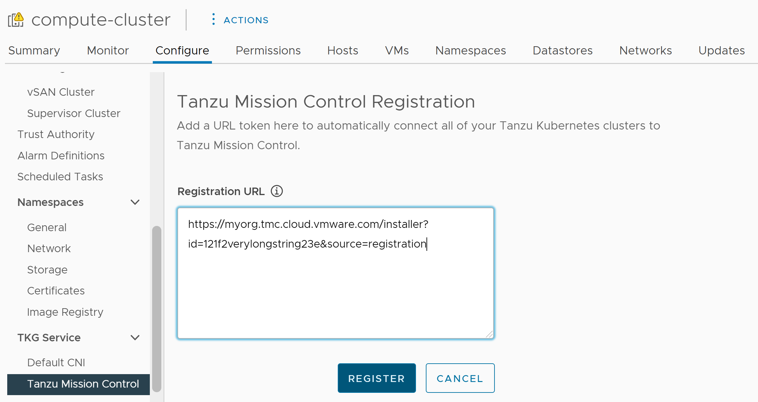

Uninstall the Tanzu Mission Control Agent
To uninstall the Tanzu Mission Control agent from the Supervisor, see Manually Remove the Cluster Agent from a Supervisor Cluster in vSphere Supervisor in the VMware Tanzu Mission Control Product Documentation.

Set the Default CNI for VKS Clusters
As a vSphere administrator, you can set the default container network interface (CNI) for VKS clusters.

Default CNI
VKS supports two CNI options for VKS clusters: Antrea and Calico.
The system-defined default CNI is Antrea. For more information on the default CNI setting, see Using TKG Service with vSphere Supervisor.
You can change the default CNI by using the vSphere Client. To set the default CNI, complete the following procedure.
Caution Changing the default CNI is a global operation. The newly set default applies to all new clusters created by the service. Existing clusters are unchanged.
- Log in to your vSphere Supervisor environment using the vSphere Client.
- Select Supervisor Management and select Supervisors .
- Select the Supervisor instance from the list.
- Select Configure and select Kubernetes Service > Default CNI
- Choose the default CNI for new clusters.
- Click Update.
The following image shows the default CNI selection.
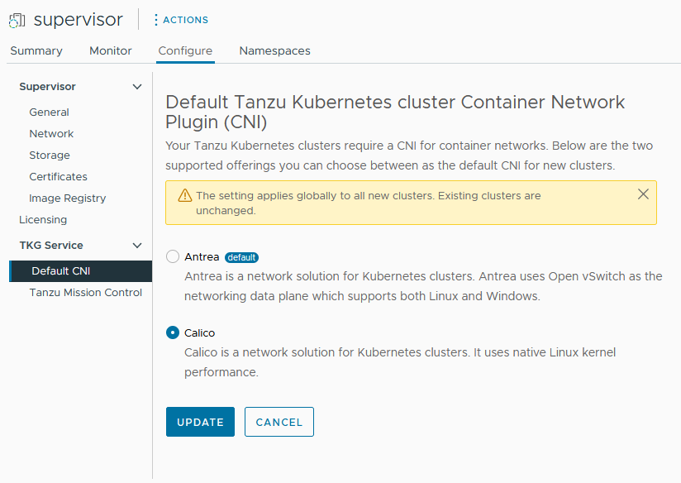
The following image shows changing the CNI selection from Antrea to Calico.
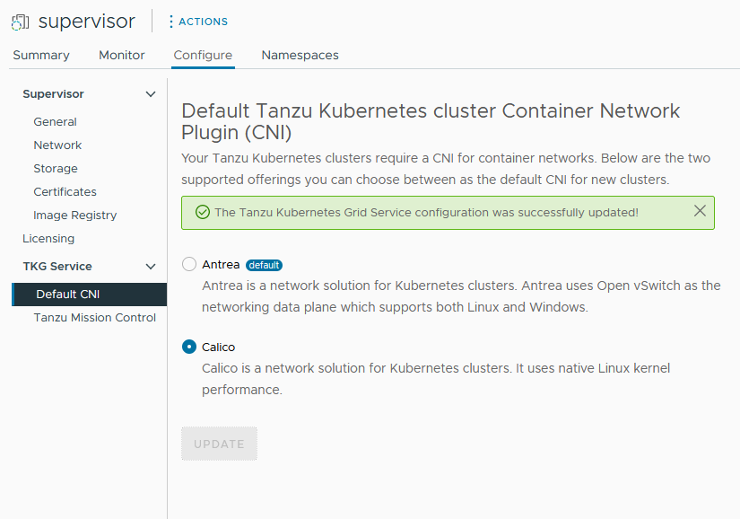

Change the Control Plane Size of a Supervisor
Check out how to change the size of the Kubernetes control plane VMs of a Supervisor in your vSphere Supervisor environment.
Prerequisites
- Verify that you have the Modify cluster-wide configuration privilege on the cluster.
Procedure
- In the vSphere Client, navigate to the Supervisor Management.
- Under Supervisors select the Supervisor.
- Select Configure and select General .
- Expand Control Plane Size.
- Click Edit and select new control plane size from the drop-down menu.
Tiny | 2 CPUs, 8-GB Memory, 32-GB Storage
Small | 4 CPUs, 16-GB Memory, 32-GB Storage
Medium | 8 CPUs, 24-GB Memory, 32-GB Storage
Large | 16 CPUs, 32-GB Memory, 32-GB Storage
Note Once you select a control plane size, you cannot scale down. For example, if you have already set the Tiny option during Supervisor activation, you can only scale up from it.
- Click Save.
You can only scale up the control plane size.

Change Load Balancer Settings on a Supervisor Configured with VDS Networking
Checkout how to change the settings of the load balancer configured with the VDS networking stack on your Supervisor. You can change settings such as user name and password, add new IP ranges, and update the certificate used with the load balancer.
Prerequisites
- Verify that you have the Modify cluster-wide configuration privilege on the cluster.
Procedure
- In the vSphere Client, navigate to the Supervisor Management.
- Under Supervisors, select the Supervisor, and select Configure.
- Select Network and expand Workload Network.
  - For Foundation Load Balancer, click Edit and change any of the settings.
Option | Description
Network Topology | Change the network topology from one-arm to two-arm. The opposite is not supported.
Size | Change the deployment footprint of Foundation Load Balancer in case there's resource over-utilization which leads to unhealthy status of the Foundation Load Balancer VMs. See Monitor Foundation Load Balancer.
High Availability | Change the HA mode Foundation Load Balancer.
Networks | Click Create and add new networks to Foundation Load Balancer.
Management Network | Change the Management Network of Foundation Load Balancer.
Virtual Server Network | Change the Virtual Server Network of Foundation Load Balancer.
Transit Network | Change the Transit Network of Foundation Load Balancer.
  - HA Proxy Load Balancer.
Option | Description
User name | Edit the user name that the Supervisor uses to authenticate with the load balancer end point.
Password | Change the password the Supervisor uses to authenticate with the load balancer endpoin
Virtual IP Ranges | Add IP ranges that are a subset of the virtual IP CIDR range that you have initially configured with the load balancer.  Note You can only add new IP ranges. You cannot remove or change existing IP ranges.
TLS Certificate | Change the TLS certificate that is use to ensure secure connection between the Supervisor and the load balancer.

Add Workload Networks to a Supervisor Configured with vSphere VLAN Port Groups
For a Supervisor that is configured with the vSphere networking stack, you can provide Layer 2 isolation for your Kubernetes workloads by creating Workload Networks and assigning them to namespaces. Workload Networks provide connectivity to VKS clusters in the namespace and are backed by distributed port groups on the switch that is connected to the hosts in the Supervisor.
For more information on the topologies that you can implement for the Supervisor, see Supervisor Architecture and Deployment Options.
Note If you have configured the Supervisor with a DHCP server providing networking settings for Workload Networks, you cannot create new Workload Networks post Supervisor configuration.
Prerequisites
- Create a distributed port group that will back the Workload Network.
- Verify that the IP range that you will assign to the Workload Network is unique within all Supervisors available in your environment.
Procedure
- In the vSphere Client, navigate to the Supervisor Management.
- Under Supervisors and select the Supervisor.
- Select Configure and select Network.
Figure 4-5. Adding a Supervisor workload network
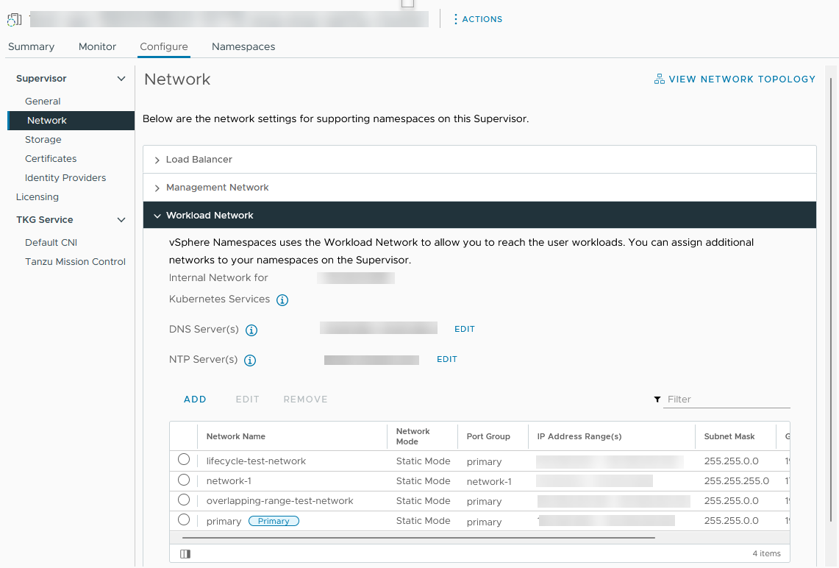
- Select Workload Network and click Add.
Port Group | Select the distributed port group to be associated with this Workload Network. The vSphere Distributed Switch (VDS) that is configured for the Supervisor networking contains the port groups from which you can select.
Network Name | The network name that identifies the Workload Network when assigned to namespaces. This value is automatically populated from the name of the port group that you select, but you can change it as appropriate.
IP Address Ranges | Enter an IP range for allocating IP addresses of cluster nodes. . The IP range must be in the subnet indicated by the subnet mask.  Note You must use a unique IP address ranges for each Workload Network. Do not configure the same IP address ranges for multiple networks.
Subnet Mask | Enter the IP address of the subnet mask for the network on the port group.
Gateway | Enter the default gateway for the network on the port group. The gateway must be in the subnet indicated by the subnet mask.  Note Do not use the gateway that is assigned to the HAProxy loadbalancer.
- Click Add.
What to do next
Assign the newly-created Workload Network to vSphere Namespaces.

Change the Management Network Settings on a Supervisor
Learn how to update the DNS and NTP settings on the Supervisor management network on your vSphere Supervisor environment.
Prerequisites
- Verify that you have the Modify cluster-wide configuration privilege on the cluster.
Procedure
- In the vSphere Client, select Supervisor Management.
- Under Supervisors, select the Supervisor, and select Configure.
- Select Network and expand Management Network.
Figure 4-6. Updating Supervisor management network settings
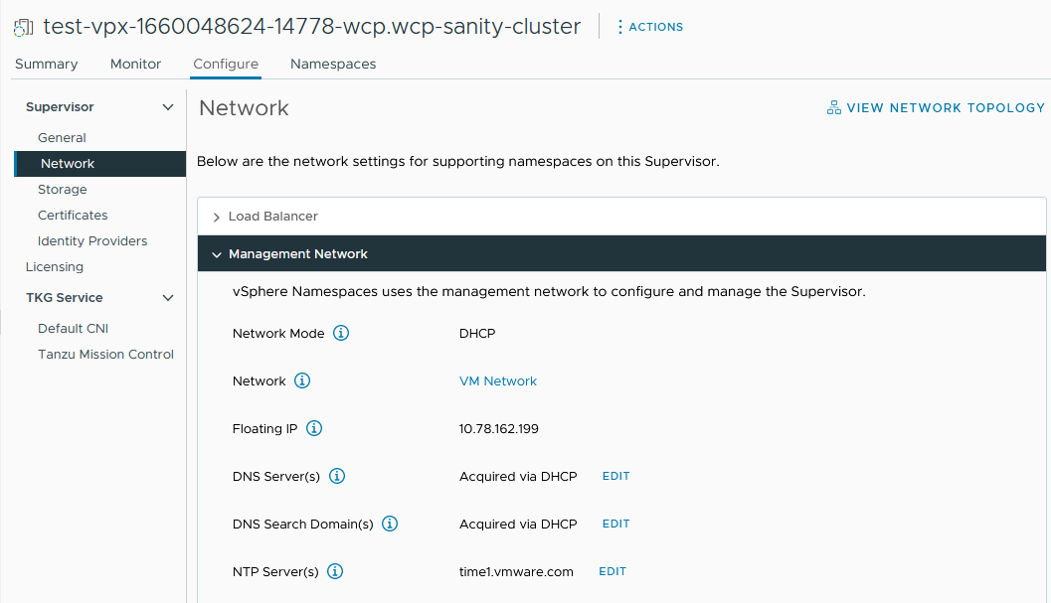
- Edit the DNS and NTP settings.
DNS Server(s) | Enter the addresses of the DNS servers that you use in your environment. If the vCenter system is registered with an FQDN, you must enter the IP addresses of the DNS servers that you use with the vSphere environment so that the FQDN is resolvable in the Supervisor.
DNS Search Domain(s) | Enter domain names that DNS searches inside the Kubernetes control plane nodes, such as corp.local, so that the DNS server can resolve them.
NTP Server(s) | Enter the addresses of the NTP servers that you use in your environment, if any.

Change the Workload Network Settings on a Supervisor Configured with VDS Networking
Checkout how to change the NTP and DNS server settings for the Workload Networks of a Supervisor configured with the VDS networking stack. The DNS servers that you configure for Workload Networks are external DNS servers exposed to Kubernetes workloads and they resolve default domain names that are hosted outside of the Supervisor.
Prerequisites
- Verify that you have the Modify cluster-wide configuration privilege on the cluster.
Procedure
- In the vSphere Client, select Supervisor Management.
- Under Supervisors, select the Supervisor, and select Configure.
- Select Network and expand Workload Network.
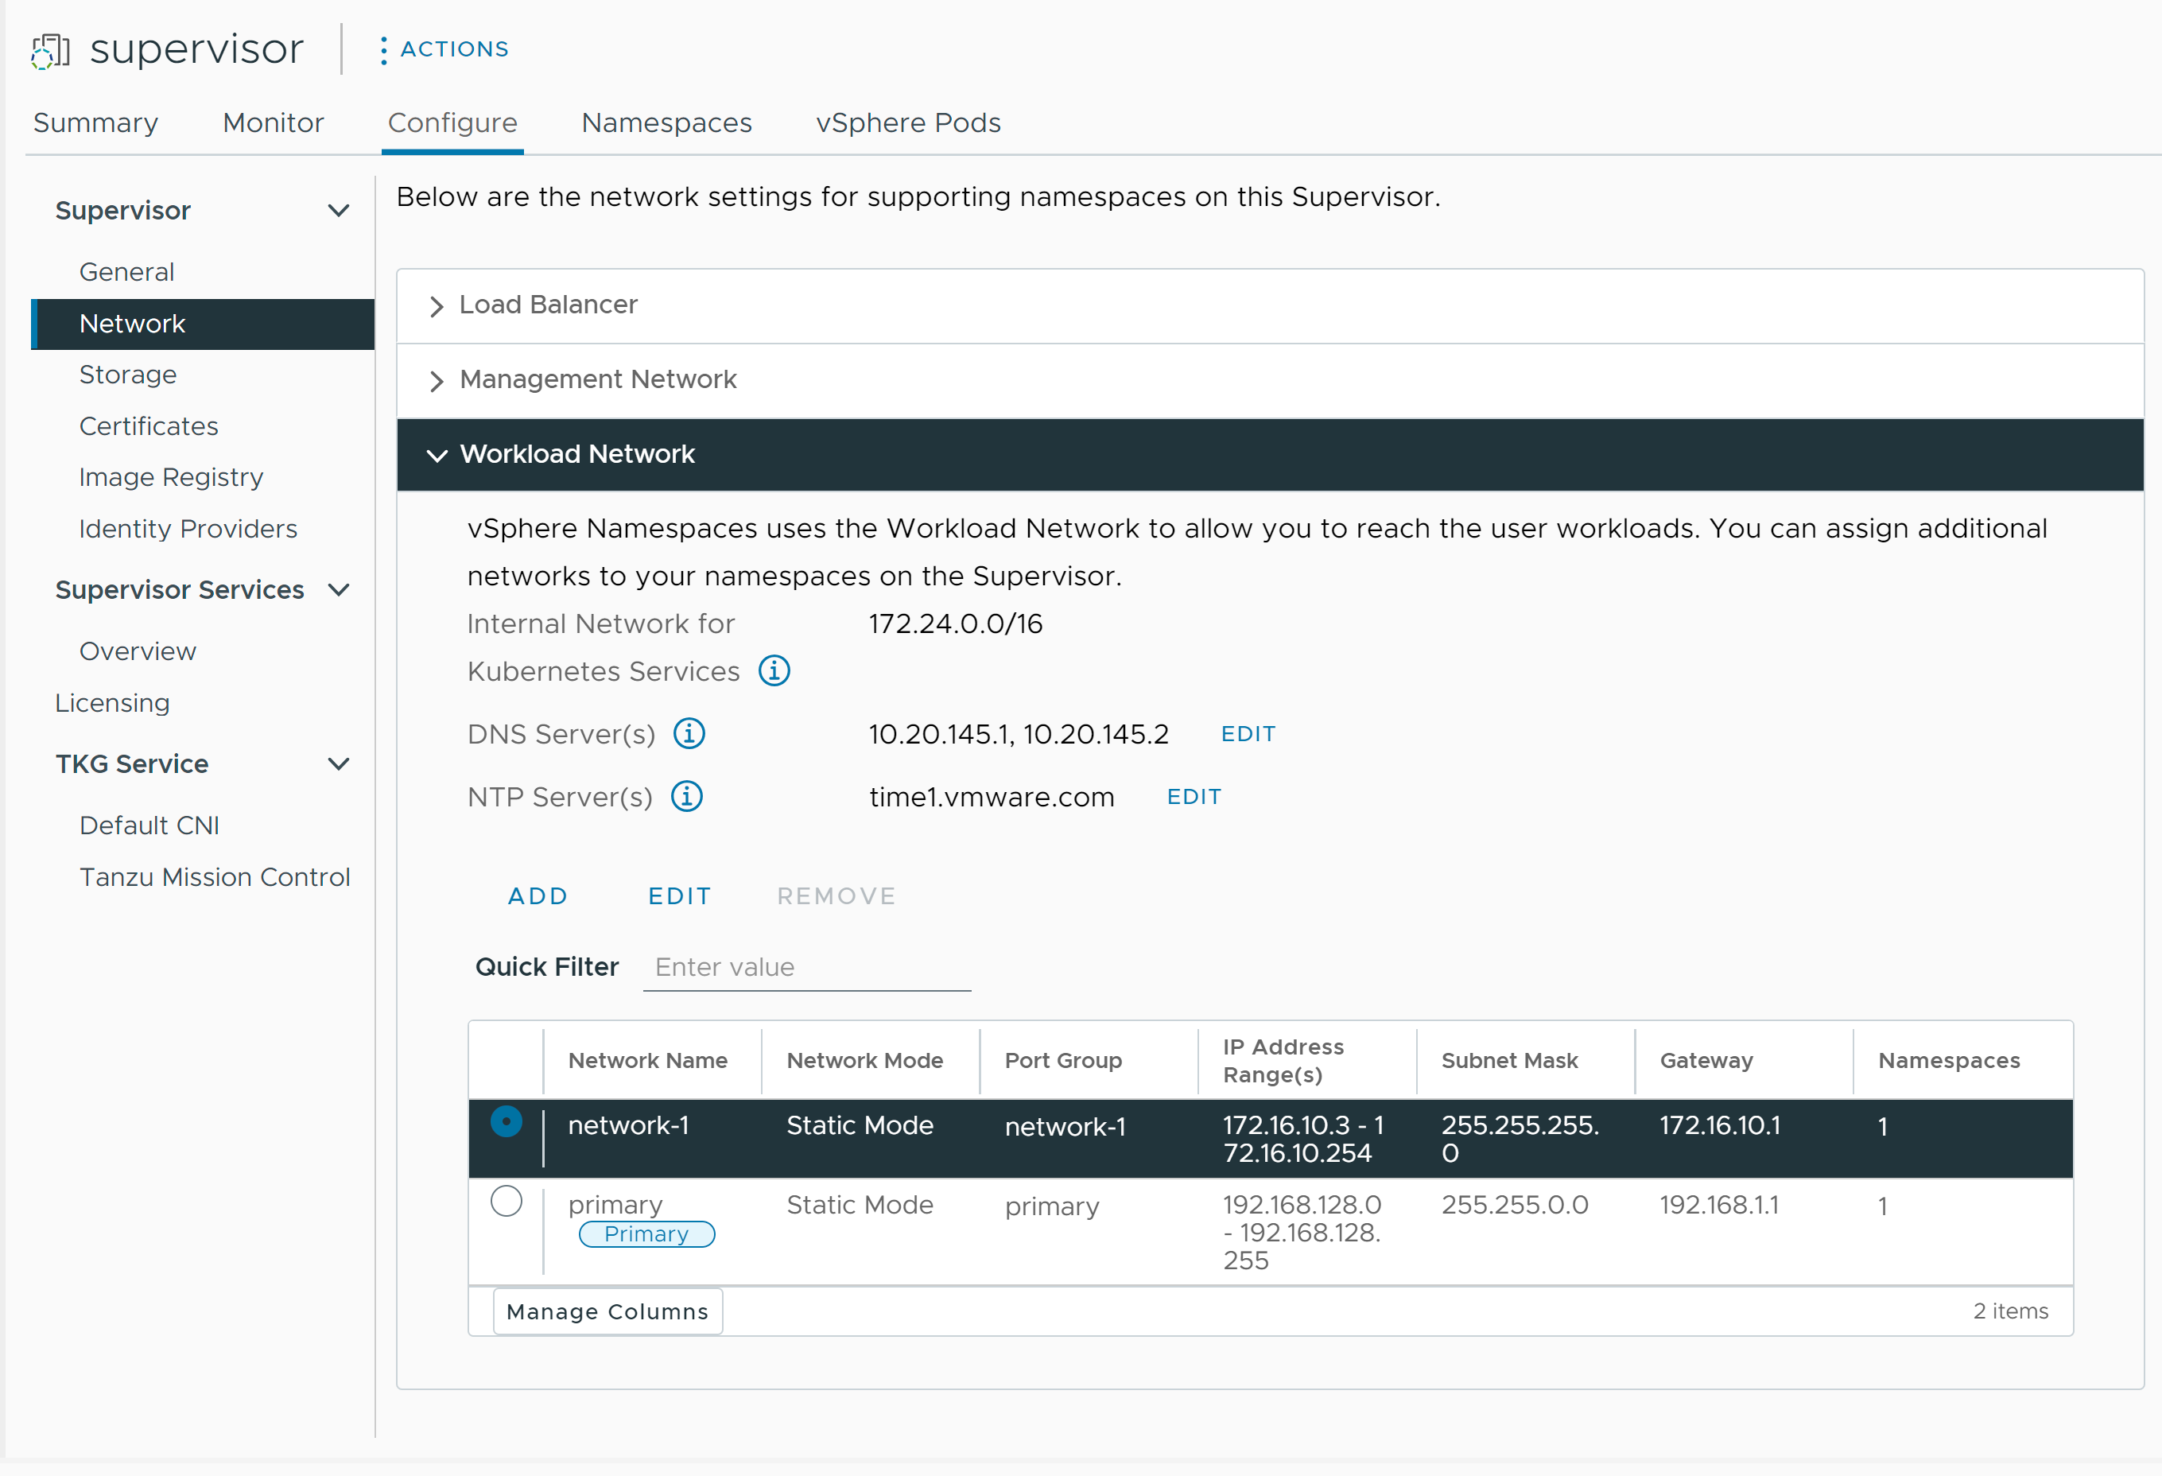
Note You cannot remove a workload network that is already assigned to a vSphere Namespace. If you need to remove a workload network, you must delete all vSphere Namespaces attached to that network. Also you cannot edit or remove the primary workload network.
- Edit the DNS server settings.
Enter the addresses of DNS Servers that can resolve the domain names of the vSphere management components, such as vCenter .
For example, 10.142.7.1.
When you enter the IP address of the DNS server, a static route is added on each control plane VM. This indicates that the traffic to the DNS servers goes through the workload network.
If the DNS servers that you specify are shared between the management network and workload network, the DNS lookups on the control plane VMs are routed through the Workload Network after initial setup.
- Edit the NTP settings as needed.
- Edit workload network settings.
  - Select a workload network and click Edit.
  - Click Add next to IP Address Range(s) to add new IP ranges to be used with workloads on that network.
The IP ranges must to be in the subnet indicated by the subnet mask.
Note The IP ranges that you add must not overlap with the Virtual IPs of the Frontend Network configuration of the load balancer.

Change Workload Network Settings on a Supervisor Configured with NSX
Learn how to change the networking settings for DNS server, namespace networks, ingress and egress of a Supervisor configured for NSX as the networking stack.
Prerequisites
- Verify that you have the Modify cluster-wide configuration privilege on the cluster.
Procedure
- In the vSphere Client, navigate to Supervisor Management.
- Under Supervisors, select the Supervisor, and select Configure.
- Select Network and expand Workload Network.
Figure 4-7. Updating Supervisor workload network settings
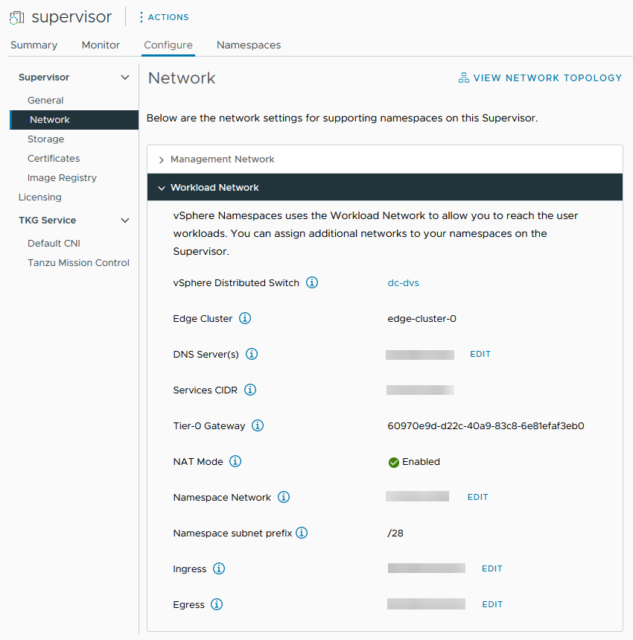
- Change networking settings as needed.
DNS Server(s) | Enter the addresses of DNS Servers that can resolve the domain names of the vSphere management components, such as vCenter .  For example, 10.142.7.1.  When you enter IP address of the DNS server, a static route is added on each control plane VM. This indicates that the traffic to the DNS servers go through the workload network.  If the DNS servers that you specify are shared between the management network and workload network, the DNS lookups on the control plane VMs are routed through the workload network after initial setup.
Namespace Network | Enter a CIDR annotation to change the IP range for Kubernetes workloads that are attached to the namespace segments of the Supervisor. If NAT Mode is not configured, then this IP CIDR range must be a routable IP Address.
Ingress | Enter a CIDR annotation to change the ingress IP range for the Kubernetes services. This range is used for services of type load balancer and ingress. For clusters, publishing services through ServiceType loadbalancer will also get the IP addresses from this IP CIDR block.  Note You can only add CIDRs to ingress and workload network fields, but you cannot edit or remove existing ones.
Egress | Enter a CIDR annotation for allocating IP addresses for SNAT (Source Network Address Translation) for traffic exiting the Supervisor to access external services. Only one egress IP address is assigned for each namespace in the Supervisor. The egress IP is the IP address that the vSphere Pods in the particular namespace use t o communicate outside of NSX.

Configuring HTTP Proxy Settings in vSphere Supervisor
Checkout how to configure HTTP proxy settings to the Supervisor and VKS clusters and what is the workflow for configuring a proxy when you register the Supervisor and VKS clusters with Tanzu Misson control.
You can configure a proxy to the Supervisor through the vSphere Client, the Cluster Management API, or DCLI commands. You can use a proxy if you need to handle container traffic or image pulling from networks external to the Supervisor. For on-premises Supervisors that you register as management clusters in Tanzu Mission Control, you use an HTTP proxy for image pulling and container traffic .

Configuring Proxy Settings on Newly-Created vSphere 7.0 Update 3 and Later Supervisors
For newly-created Supervisors on a vSphere 7.0 Update 3 and later environment, HTTP proxy settings are inherited from vCenter. No matter if you create the Supervisors before or after you configure HTTP proxy settings on vCenter, the settings are inherited by the clusters.
See Configure the DNS, IP Address, and Proxy Settings in the vSphere documentation to learn how to configure the HTTP proxy settings on vCenter.
You can also override the inherited HTTP proxy configuration on individual Supervisors through the vSphere Client, Cluster Management API, or DCLI.
Since inheriting the vCenter proxy settings is the default configuration for newly-created vSphere 7.0.3 Supervisors, you can also use the Cluster Management API or DCLI to not inherit any HTTP proxy settings in case the Supervisors don't require a proxy, but vCenter still does.

Configuring Proxy Settings on Supervisors Upgraded to vSphere 7.0 Update 3 and Later
If you have upgraded your Supervisors to vSphere 7.0 Update 3 and later, the HTTP proxy settings of vCenter are not automatically inherited. In that case, you configure proxy settings Supervisors by using the vSphere Client, vcenter/namespace-management/clusters API, or DCLI command line.

Configuring HTTP Proxy to VKS Clusters in vSphere Supervisor
Use one of the following methods to configure a proxy to your VKS clusters in vSphere Supervisor:
- Configure proxy settings to individual VKS clusters.
- Create a global proxy configuration that will be applied to all VKS clusters.
Note If you use Tanzu Mission Control to manage your VKS clusters, you do not have to configure proxy settings through the cluster YAML file in vSphere Supervisor. You can configure proxy settings when you add the VKS clusters as workload clusters to Tanzu Mission Control.

Configure HTTP Proxy Setting on the Supervisor by Using the vSphere Client
Checkout how to configure HTTP proxy settings to the Supervisor through the vSphere Client. You can override the proxy settings inherited from vCenter on individual Supervisors or select not to use any proxy settings at all.
Prerequisites
- Verify that you have the Modify cluster-wide configuration privilege on the cluster.
Procedure
- In the vSphere Client, navigate to Supervisor Management.
- Under Supervisors, select the Supervisor, and select Configure.
- Select Network, expand Proxy Configuration, and click Edit
- Select Configure proxy settings on Supervisor and enter the proxy settings.
Option | Description
TLS Certificate | The proxy TLS root CA bundle which is used to verify the proxy's certificates. Enter the bundle in plain text.
Hosts and IP addresses excluded from proxy | A comma separated list of IPv4 addresses, FQDNs, or domain names that do not require the proxy server and can be accessed directly.
HTTPS Configuration | HTTPS settings such as URL, port, user name, and password.
HTTP Configuration | HTTP settings such as URL, port, user name, and password.
- Click OK.
Results
The proxy settings you configured on this Supervisor override the settings inherited from vCenter.

Using the Cluster Management API and DCLI to Configure HTTP Proxy to Supervisors
You can configure the Supervisor proxy settings through the vcenter/namespace-management/clusters API or DCLI.
The API provides three options for proxy configuration on the Supervisor:
API Setting | Newly-Created vSphere 7.0.3 and Later Supervisors | Supervisors Upgraded to vSphere 7.0.3 and Later
VC_INHERITED | This is the default setting for new Supervisors and you don't have to use the API to configure the Supervisors proxy settings. You can just configure proxy settings on vCenter through its management interface. | Use this setting to push the HTTP proxy configuration to Supervisors upgraded to vSphere 7.0.3 and later.
CLUSTER_CONFIGURED | Use this setting to override the HTTP proxy configuration inherited from vCenter in one of the following cases:  - A Supervisor resides on a different subnet than vCenter and a different proxy server is required.  - The proxy server uses custom CA bundles. | Use this setting to configure HTTP proxy to individual Supervisors upgraded to vSphere 7.0.3 and later in one of the following cases:  - You cannot use the vCenter proxy because the Supervisor resides on a different subnet thanvCenter and a different proxy server is required.  - The proxy server uses custom CA bundles.
NONE | Use this setting when the Supervisor has direct connectivity to the internet while vCenter requires a proxy. The NONE settings prevents the proxy settings of vCenter to be inherited by Supervisors.
To set an HTTP proxy to a Supervisor or modify the existing settings, use the following commands in an SSH session with vCenter :
vc_address=<IP address>
cluster_id=domain-c<number>
session_id=$(curl -ksX POST --user '<SSO user name>:<password>' https://$vc_address/api/session | xargs -t)
curl -k -X PATCH -H "vmware-api-session-id: $session_id" -H "Content-Type: application/json" -d '{ "cluster_proxy_config": { "proxy_settings_source": "CLUSTER_CONFIGURED", "http_proxy_config":"<proxy_url>" } }' https://$vc_address/api/vcenter/namespace-management/clusters/$cluster_id
You only need to pass the domain_c<number> from the full cluster ID which. For example, take domain-c50 from the following cluster ID: ClusterComputeResource:domain-c50:5bbb510f-759f-4e43-96bd-97fd703b4edb.
When using the VC_INHERITED or NONE settings, omit "http_proxy_config:<proxy_url>" from the command.
To use a custom CA bundle, add a "tlsRootCaBundle": "<TLS_certificate>" to the command by providing the TSL CA certificate in plain text.
For HTTPS proxy settings use the following command:
curl -k -X PATCH -H "vmware-api-session-id: $session_id"
-H "Content-Type: application/json" -d '{ "cluster_proxy_config":
{ "proxy_settings_source": "CLUSTER_CONFIGURED", "https_proxy_config":"<proxy_url>" } }'
https://$vc_address/api/vcenter/namespace-management/clusters/$cluster_id

Using DCLI to Configure HTTP Proxy Settings on Supervisors
You can use the following DCLI command to configure HTTP proxy settings to Supervisors by using the CLUSTER_CONFIGURED setting.
<dcli> namespacemanagement clusters update --cluster domain-c57 --cluster-proxy-config-http-proxy-config <proxy URL> --cluster-proxy-config-https-proxy-config <proxy URL> --cluster-proxy-config-proxy-settings-source CLUSTER_CONFIGURED

Configuring HTTP Proxy Settings on the Supervisor and VKS Clusters for Tanzu Mission Control
To configure an HTTP proxy on Supervisors that you want to register as management clusters with Tanzu Mission Control, follow the steps:
- In vSphere, configure HTTP proxy on Supervisors by either inheriting the HTTP proxy settings from vCenter, or configuring proxy settings on individual Supervisors through the vSphere Client, Namespace Management Clusters APIs, or DCLI command line.
- In Tanzu Mission Control, create proxy configuration object by using the proxy settings you configured to the Supervisors in vSphere Supervisor. See Create a Proxy Configuration Object for a Tanzu Kubernetes Grid Service Cluster in the VMware Tanzu Mission Control Product Documentation.
- In Tanzu Mission Control, use this proxy configuration object when you register the Supervisors as a Management Cluster. See Register a Management Cluster with Tanzu Mission Control and Complete the Registration of a Supervisor Cluster in the in the VMware Tanzu Mission Control Product Documentation.
To configure an HTTP proxy to VKS clusters that you provision or add as workload clusters in Tanzu Mission Control:
- Create a proxy configuration object with the proxy settings that you want to use with VKS clusters. See Configure the DNS, IP Address, and Proxy Settings.
- Use that proxy configuration object when you provision or add VKS clusters as workload clusters. See Provision a Cluster and Add a Workload Cluster into Tanzu Mission Control Management in the VMware Tanzu Mission Control Product Documentation

Configure an External Identity Provider for VKS Clusters
You can configure Supervisor with any OIDC-compliant identity provider (IDP), such as Okta. To complete the integration, you configure the IDP with the callback URL for Supervisor.

Supported External Identity Provider
You can configure Supervisor with any OIDC-compliant identity provider. The table lists common ones and includes links for configuration instructions.
External IDP | Configuration
Okta | Configure Okta as an OIDC provider for Pinniped
Workspace ONE | Configure Workspace ONE Access as an OIDC provider for Pinniped
Dex | Configure Dex as an OIDC provider for Pinniped
GitLab | Configure GitLab as an OIDC provider for Pinniped
Google OAuth | Using Google OAuth 2

Configuring the IDP with the Callback URL for Supervisor
Supervisor acts as an OAuth 2.0 client to the external identity provider. The Supervisor callback URL is the redirect URL used to configure the external IDP. The callback URL takes the form https://SUPERVISOR-VIP/wcp/pinniped/callback.
If the IP portion of the callback URL is represented as a fully qualified domain name (FQDN), ensure that the DNS server used by both the Supervisor and the VKS can resolve the FQDN to the correct virtual IP (VIP).
Note When performing the IDP registration, the callback URL might be called the "redirect URL" in the OIDC provider you are configuring.
When configuring the external identity provider for use with VKS on Supervisor, you supply the external identity provider with the Callback URL that is available in vCenter at Supervisor Management > Supervisors > Configure > Identity Providers screen.

Example Identity Provider Configuration Using Okta
Okta lets users sign-in to applications using the OpenID Connect protocol. When you configure Okta as an external identity provider for VKS on Supervisor, the Pinniped pods on Supervisor and on VKS clusters control user access to both vSphere Namespaces and workload clusters.
- Copy the Identity Provider Callback URL which you need to create an OIDC connection between Okta and vCenter.
Using the vSphere Client, get the Identity Provider Callback URL at Supervisor Management > Supervisors > Configure > Identity Providers. Copy this URL to a temporary location.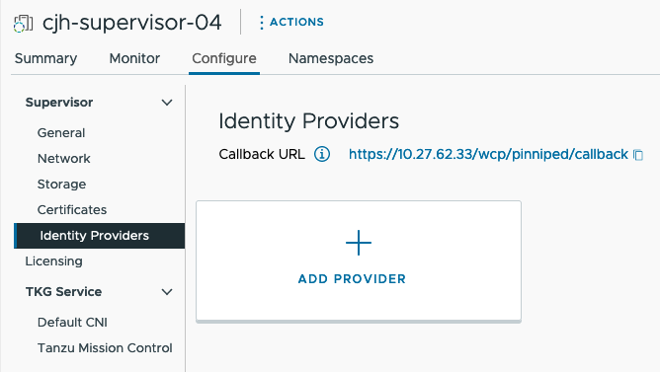
Figure 4-8. IDP Callback URL
- Log in to the Okta account for your organization, or create a trial account at https://www.okta.com/. Click the Admin button to open the Okta admin console.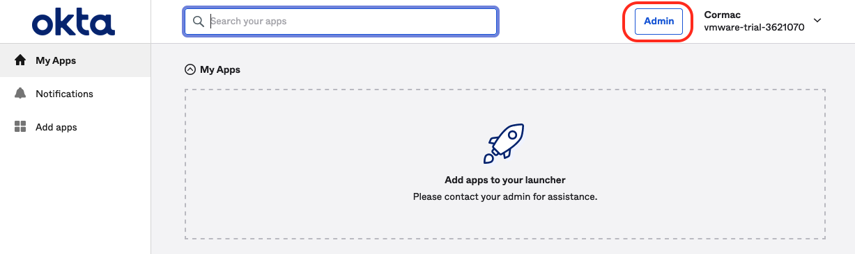
Figure 4-9. Okta Admin Console
- From the Getting Started page in the admin console, navigate to Applications > Applications.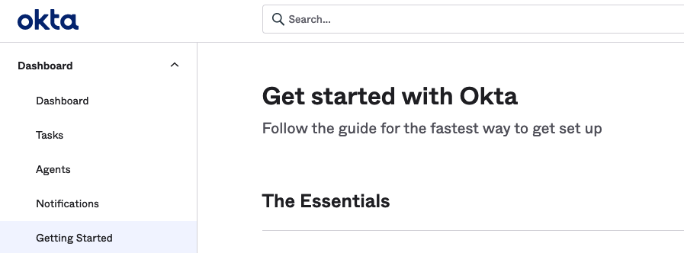
Figure 4-10. Okta Getting Started
- Select the option to Create App Integration.
Figure 4-11. Okta Create App Integration
- Create the new app integration.
  - Set the Sign-in method to OIDC - OpenID Connect
  - Set the Application type to Web Application
Figure 4-12. Okta Sign-On Method and Application Type
- Configure the Okta web application integration details.
  - Provide an App integration name, which is a user-defined string.
  - Specify the Grant type: Select Authorization Code and also select Refresh Token.
  - Sign-in redirect URIs: Enter the Identity Provider Callback URL that you copied from Supervisor (see Step 1), such as https://10.27.62.33/wcp/pinnipend/callback.
  - Sign-out redirect URIs: Enter the Identity Provider Callback URL that you copied from Supervisor (see Step 1), such as https://10.27.62.33/wcp/pinnipend/callback.
Figure 4-13. Okta Web Application Integration Details
- Configure user access control.
In the Assignments > Controlled access section, you can optionally control which of the Okta users that exist in your organization can access VKS clusters. In the example, allow everyone defined in the organization has access.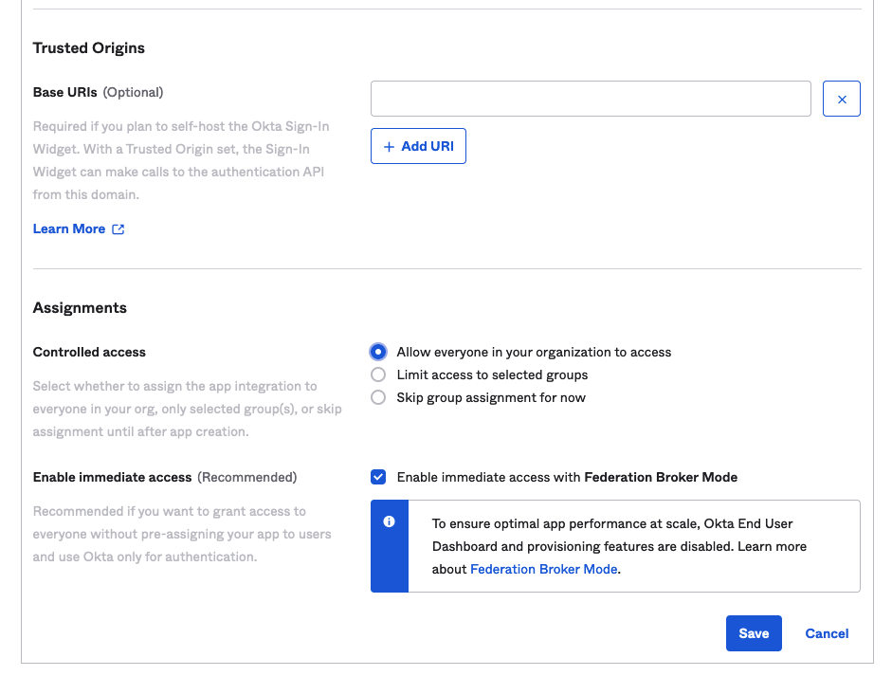
Figure 4-14. Okta Access Control
- Click Save and copy the Client ID and Client Secret that are returned.
When you save the OKTA configuration, the admin console provides you with a Client ID and Client Secret. Copy both pieces of data because you need them to configure Supervisor with an external identity provider.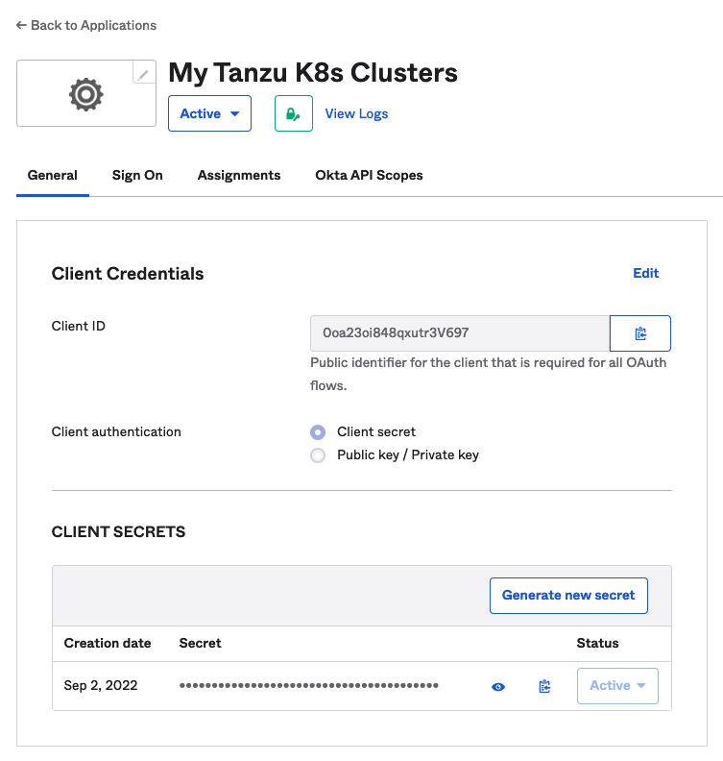
Figure 4-15. OIDC Client ID and Secret
- Configure the OpenID Connect ID Token.
Click the Sign On tab. In the OpenID Connect ID Token section, click the Edit link, fill in the Groups claim type filter, and Save the settings.
For example, if you want the claim name "groups" to match all groups, select groups > Matches regex > *.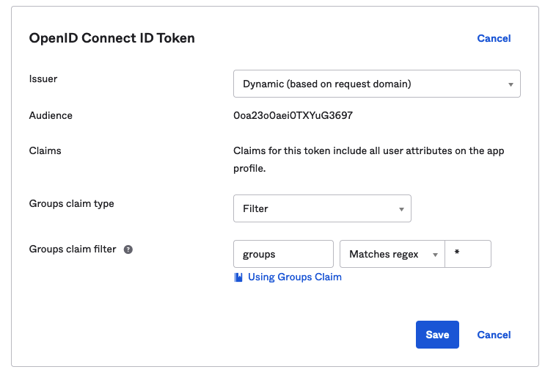
Figure 4-16. OpenID Connect ID Token
- Copy the Issuer URL.
To configure Supervisor, you need Issuer URL, in addition to the Client ID and Client Secret.
Copy the Issuer URL from the Okta admin console.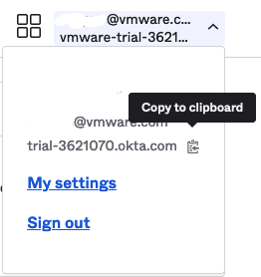
Figure 4-17. Okta Issuer URL

Register an External Identity Provider with Supervisor
To connect to VKS clusters on Supervisor using an external identity provider, register your identity provider with Supervisor.

Prerequisites
Before you register an external identity provider with Supervisor, complete the following prerequisites:
- Enable Supervisor Management and deploy a Supervisor instance.
- Configure an external OpenID Connect identity provider with the Supervisor callback URL. See Configure an External Identity Provider for VKS Clusters.
- Get the Client ID, Client Secret, and Issuer URL from the external IDP. See Configure an External Identity Provider for VKS Clusters.

Register an External Identity Provider with Supervisor
Supervisor runs as pods the Pinniped Supervisor and the Pinniped Concierge components. VKS clusters run as pods the Pinniped Concierge component only. For more information about these components and how they interact, refer to the Pinniped authentication service documentation.
Once you register an external identity provider with Supervisor, the system updates the Pinniped Supervisor and Pinniped Concierge pods on Supervisor and the Pinniped Concierge pods on VKS clusters. All VKS clusters running on that Supervisor instance are automatically configured with that same external identity provider.
To register an external ODIC provider with Supervisor, complete the following procedure:
- Log in to the vCenter using the vSphere Client.
- Select Supervisor Management > Supervisors > Configure > Identity Providers.
- Click the plus sign to begin the registration process.
- Configure the provider. See Identity Provider Configuration.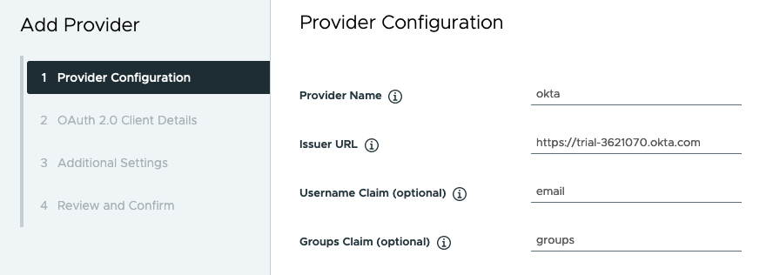
Figure 4-18. OIDC Provider Configuration
- Configure OAuth 2.0 client details. See OAuth 2.0 Client Details.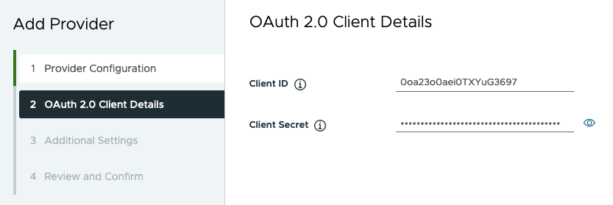
Figure 4-19. OAuth 2.0 Client Details
- Configure additional settings. See Additional Settings.
- Confirm provider settings.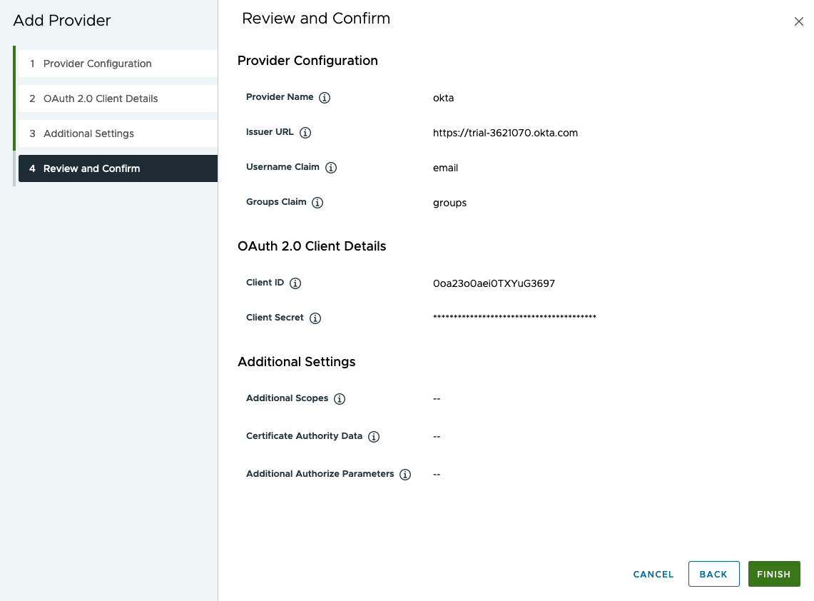
Figure 4-20. Confirm Provider Settings
- Click Finish to complete the OIDC provider registration.

Identity Provider Configuration
Refer to the following provider configuration details when registering an external provider with Supervisor.
Table 4-2. Identity Provider Configuration
Field | Importance | Description
Provider Name | Required | User-defined name for the external identity provider.
Issuer URL | Required | The URL to the identity provider issuing tokens. The OIDC discovery URL is derived from the issuer URL.  For example, the Okta Issuer URL may look like the following and can be obtained from the Admin console: https://trial-4359939-admin.okta.com.
Username Claim | Optional | The claim from the upstream identity provider ID token or user info endpoint to inspect to obtain the user name for the given user. If you leave this field empty, the upstream issuer URL is concatenated with the "sub" claim to generate the user name to be used with Kubernetes.  This field specifies what Pinniped should look at from the upstream ID token to determine to authenticate. If not provided, the user identity will be formatted as https://IDP-ISSUER?sub=UUID.
Groups Claim | Optional | The claim from the upstream identity provider ID token or user info endpoint to inspect to obtain the groups for the given user. If you leave this field empty, no groups are used from the upstream identity provider.  The Group Claims field tells Pinniped what to look at from the upstream ID token to authenticate user identity.

OAuth 2.0 Client Details
Refer to the following provider OAuth 2.0 client details when registering an external identity provider with Supervisor.
Table 4-3. OAuth 2.0 Client Details
OAuth 2.0 Client Details | Importance | Description
Client ID | Required | Client ID from the external IDP
Client Secret | Required | Client Secret from the external IDP

Additional Settings
Refer to the following additional settings when registering an external identity provider with Supervisor.
Table 4-4. Additional Settings
Setting | Importance | Description
Additional Scopes | Optional | Additional scopes to be requested in tokens
Certificate Authority Data | Optional | TLS certificate authority data for secure external IDP connection
Additional Authorize Parameters | Optional | Additional parameters during the OAuth2 Authorization request

Change Storage Settings on the Supervisor
Storage policies assigned to the Supervisor manage how such objects as a control plane VM, vSphere Pod ephemeral disk, and container image cache are placed within datastores in the vSphere storage environment. As a vSphere administrator, you typically configure storage policies when enabling the Supervisor. If you need to make any changes in the storage policy assignments after initial Supervisor configuration, perform this task. You can also use this task to activate or deactivate file volume support for ReadWriteMany persistent volumes in VKS clusters.
Generally, the changes you make to the storage settings apply only to new objects in Supervisor. If you use this procedure to activate file volume support in VKS clusters, you can do it for the existing clusters.
Prerequisites
If you plan to activate file volume support on VKS clusters for persistent volumes in ReadWriteMany mode, follow guidelines in Using vSAN File Service to Create ReadWriteMany Volumes in Supervisor Environment in the vSphere Supervisor Services and Workloads documentation.
Procedure
- In the vSphere Client, navigate to Supervisor Management.
- Click the Supervisors tab and select the Supervisor to edit from the list.
- Click the Configure tab and click Storage.
Figure 4-21. Updating Supervisor storage settings
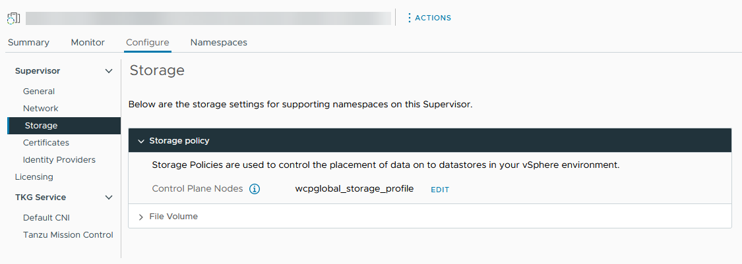
- Change storage policy assignments for the control plane VMs.
If your environment supports a vSphere Pod, you can also change storage policies for an ephemeral virtual disk and container image cache.
Control Plane Node | Select the storage policy for placement of the control plane VMs.
Pod Ephemeral Disks | Select the storage policy for placement of the vSphere Pods.
Container Image Cache | Select the storage policy for placement of the cache of container images.
- Enable file volume support to deploy ReadWriteMany persistent volumes.
This option is available only if your environment has been configured with vSAN File Service. See Enable vSAN File Service in the vSAN Administration guide.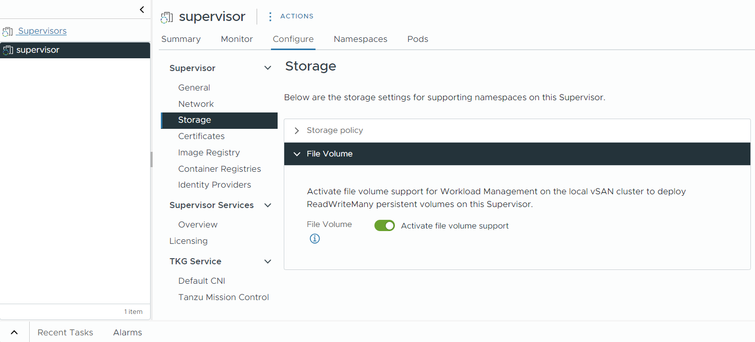

Modify the List of Supervisor Control Plane DNS Names
Checkout how to modify the list of FQDNs for accessing the Supervisor control plane. You can provide a list of Supervisor FQDNs during the Supervisor enablement and later update that list. You can also set a list Supervisor FQDNs if you did not provide one during the Supervisor enablement.
Procedure
- Use the following DCLI command to update the list of FQDNs for the Supervisor control plane:
dcli com vmware vcenter namespacemanagement clusters update --cluster <cluster_ID> --master-dns-name <FQDN 1> --master-dns-name <FQDN_2>
  - To add a new FQDN to the list you pass the already existing names as arguments as well as add the new FQDN.
  - To remove an FQDN from the list, you call the update command by omitting the FQDN that you want to remove and passing the rest of the FQDNs that you want to keep.
For a three-zone Supervisor you can pass the ID of any of the clusters that are part of the Supervisor.
In the following example, the Supervisor running on cluster domain-c50 is already configured with an FQDN supervisor.acme.com. You are adding a new supervisor.vmware.com FQDN to the list of DNS names for the Supervisor:
dcli com vmware vcenter namespacemanagement clusters update --cluster domain-c50 --master-dns-name supervisor.acme.com --master-dns-name supervisor.vmware.com
What to do next
- The VIP certificate to securely connect to the Supervisor is not automatically updated with the new FQDNs. Therefore, you need to do that manually, see Replace the VIP Certificate to Securely Connect to the Supervisor API Endpoint.
- Once you update the VIP certificate to connect to the Supervisor, log in to the Supervisor control plane by using the newly-added FQDNs. See Connect to the Supervisor as a vCenter Single Sign-On User

Maintenance Mode for a Datastore Used by Supervisor
Starting with vSphere 9.0, you can decommission a datastore that is used for different Supervisor workloads. To do this, you need to place the datastore in maintenance mode.

Requirements
- vSphere 9.0 or later.
- Supervisor is enabled.
- Storage DRS is enabled.
- The datastore is not part of a vSAN cluster or shared across multiple vCenter instances.

Prerequisites
Before putting the datastore in maintenance mode, make sure to follow these guidelines.
- Wait for ongoing operations on the datastore to complete, or cancel them manually.
- Do not create new content libraries on the datastore.
- Stop adding new items to any content library that resides on the datastore.
- Identify any applications that create First Class Disks (FCDs) independently, for example, OpenStack or direct API use. Prepare to migrate, back up and restore, or delete these FCDs as needed.
- For vSphere Pods not managed by deployments or stateful sets, prepare to recreate them manually from spec or pipeline.
- Unmount all ISO or shared images attached to VMs, VM Service VMs, vSphere Pods, and content libraries on the datastore.

Automatic Migrations
When the datastore enters maintenance mode, the system automatically migrates the following items. No administrator actions are required.
- VMs with attached VMDKs.
- Supervisor VM Service VMs.
- VKS clusters.

Manual Migration
The following items require manual handling by an administrator. After the datastore enters the maintenance mode, you must perform a number of tasks to migrate several of these items manually.
- Content library images.
- Standalone FCDs not attached to any VMs.
- vSphere Pods
- Orphaned or unused items in the datastore:
  - Unregistered or orphaned VMs.
  - Orphaned VMDKs.
  - Stale VM snapshots.
  - Orphaned Supervisor images and snapshots.
  - Orphaned vSphere Pods image disks.
  - ISO images.

Place a Datastore Used by Supervisor in Maintenance Mode
Begin the process by placing the Supervisor datastore into maintenance mode. This action triggers automatic migration for supported workloads.
Procedure
- Browse to the datastore in the vSphere Client.
- Right-click the datastore and select Maintenance Mode > Enter Maintenance Mode.
A list of recommendations appears for datastore maintenance mode migration.
- (Optional) On the Recommendations tab, review the recommendations and deselect any recommendations you do not want to apply.
Note The datastore cannot enter maintenance mode without evacuating all disks. If you deselect recommendations, you must manually move all disks before entering maintenance mode.
- Check the Faults tab for any the VM artifacts that cannot be migrated.
- Click Continue to initiate migration using Storage vMotion.
After you place the datastore in maintenance mode, perform additional manual migration tasks.

Migrate vSphere Pods
Manually delete and prepare to recreate vSphere Pods that are not automatically handled during datastore maintenance.
Procedure
- Identify the datastore MoID.
- Go to the following URL to list all vSphere Pods using the datastore.
https://<VC>/mob/?moid=<datastore-moid>
- Use the kubectl delete command to remove the vSphere Pods.
kubectl delete pods <pod-name> --namespace <namespace>
- Delete dangling image disks after vSphere Pods deletion.
kubectl delete imagedisk <imagedisk>
vSphere Pods that are part of a deployment or stateful set will restart automatically. vSphere Pods that are deployed outside of deployments or stateful sets are not recreated. You must manually recreate them.

Migrate Content Library Images
Move all content library data from the datastore and ensure no ISO images remain mounted to dependent VMs.
Procedure
- In the vSphere Client, select the datastore and click the Files tab.
- Filter by folder name: contentlib-.
- Identify all content libraries present on the datastore.
- For each library, perform the following steps.
Ensure the correct source and destination datastores are selected. Unmount any ISOs from VMs or VM Service VMs before migration.
  - Click Actions > Migrate.
  - Ensure the correct source and destination datastores are selected.
  - Unmount any ISOs from VMs or VM Service VMs before migration.

Migrate Detached FCDs
Manually migrate First Class Disks (FCDs) that are not attached to VMs, using different methods depending on whether they are managed by CNS or not.
Note FCDs that are attached to VM Service VMs or vSphere Pods are migrated automatically with a corresponding VM and placed in the VM folder.
Prerequisites
To access and migrate CNS-managed FCDs, make sure that you have the ServiceProviderUsers role.
Procedure
- Migrate FCDs managed by CNS.
  - In the vSphere Client, navigate to the datastore cluster, and click Monitor > Container Volumes.
  - Select the volumes and click Migrate.
  - Select the destination datastore, and confirm.
- Migrate FCDs not managed by CNS.
  - Go to the following URL:
https://<VC>/mob/?moid=VStorageObjectManager
  - Use the ListVStorageObject method with the datastore MoID to get a list of FCD IDs.
  - Use the RelocateVStorageObject_Task method to move each FCD.
Enter the FCD ID, source, and destination datastore MoIDs.

Monitoring vSphere Supervisor
You can use different tools to monitor the vSphere Supervisor state and workloads.
You can use VCF Operations to monitor the state and the resources of vSphere Supervisor. See vSphere Supervisor Monitoring.

Monitor and Manage Resources in a vSphere Namespace
You can monitor and manage different aspects of a vSphere Namespace, such as resource consumption for the namespace as well as the number of different objects that exist in a namespace and their states.
Prerequisites
Create and Configure a vSphere Namespace.
Procedure
- Log in to the vCenter using the vSphere Client.
- In the inventory, navigate to the Menu > Hosts and Clusters view.
- Select the host cluster where you have enabled Supervisor Management.
- Expand the Namespaces resource pool.
The Supervisor control plane nodes are located in the Namespaces resource pool. In addition, you can see individual resource pools created for each namespace on this Supervisor.
- Select the namespace resource pool you want to review, click the Summary tab, and click Manage on the Namespace pane.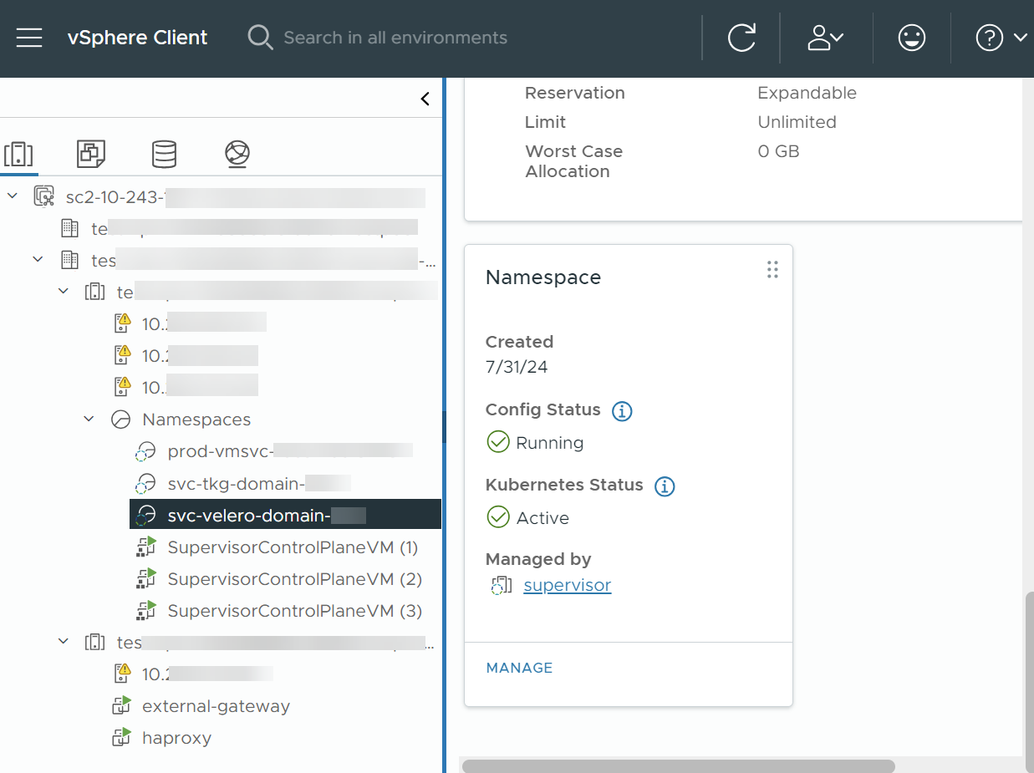
Results
In the Summary tab for this namespace you see the various configuration sections for the vSphere Namespace, including Status, Permissions, Storage, Capacity and Usage, and so on. From this screen, you can manage any of these settings.
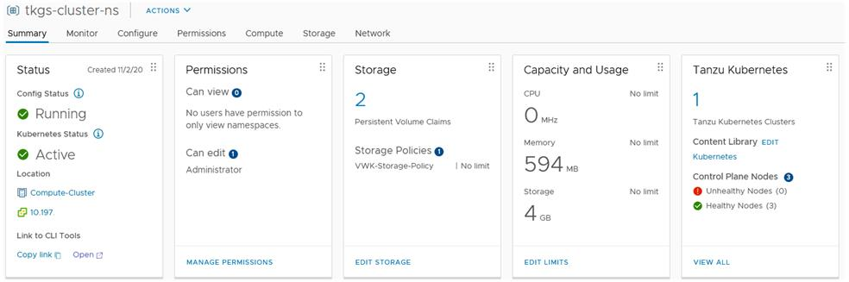

Forwarding Supervisor Logs to External Monitoring Systems
Checkout how to configure forwarding of Supervisor control plane logs to external monitoring systems, such as Grafana Loki, or Elastic Search, by using Fluent Bit.
Supervisor control plane logs are automatically forwarded to the syslog server configured to the vCenter appliance by using Fluent Bit. Fluent Bit is an open-source lightweight logging and metrics processor and forwarder that provides configurations to support various log data types, filtering and log tag enhancements.
During Supervisor activation or upgrade, bootstrap logs are still forwarded by rsyslog to the syslog servers that are configured to the vCenter appliance. Once the Supervisor control plane VMs are up and running, Fluent Bit becomes the default log forwarder for the Supervisor control plane logs.
As a vSphere administrator, you can use Fluent Bit to:
- Forward Supervisor control plane logs and system journal logs to major external log monitoring platforms such as Loki, Elastic Search, Grafana, and other platforms that are supported by Fluent Bit.
- Update or reset the log forwarding configuration for the Supervisor control plane by using the k8s API.
Fluent Bit runs as a DeamonSet on Supervisor control plane nodes. It exposes the fluentbit-config-custom ConfigMap under the vmware-system-logging namespace that vSphere administrators can edit to configure log forwarding to external platforms by defining log servers.
inputs-custom.conf: |
[INPUT]
Name tail
Alias audit_apiserver_tail
Tag audit.apiserver.*
Path /var/log/vmware/audit/kube-apiserver.log
DB /var/log/vmware/fluentbit/flb_audit_apiserver.db
Buffer_Max_Size 12MBb
Mem_Buf_Limit 32MB
Skip_Long_Lines On
Refresh_Interval 10
filters-custom.conf: |
[FILTER]
Name record_modifier
Alias audit_apiserver_modifier
Match audit.apiserver.*
Record hostname ${NODE_NAME}
Record appname audit-kube-apiserver
Record filename kube-apiserver.log
outputs-custom.conf: |
[OUTPUT]
Name syslog
Alias audit_apiserver_output_syslog
Match audit.apiserver.*
Host <syslog-server-host>
Port <syslog-server-port>
Mode tcp
Syslog_Format rfc5424
Syslog_Message_key log
Syslog_Hostname_key hostname
Syslog_Appname_key appname
Syslog_Msgid_key filename

Customize Fluent Bit Log Forwarding
Follow the steps to customize the Fluent Bit log forwarding configuration:
- Log in to the Supervisor.
For information, see Connecting to Supervisor and VKS Clusters.
- Update or add a syslog output in the outputs-custom.conf section in the fluentbit-config-custom ConfigMap, which will forward all control plane VM system logs to an external server.
[OUTPUT]
Name syslog
Alias syslog_system
Match system*
Host <syslog-server-host>
Port <syslog-server-port>
Mode tcp
Syslog_Format rfc5424
Syslog_Message_key log
Syslog_Hostname_key hostname
Syslog_Appname_key appname
Syslog_Msgid_key filename
# add the following if the mode is TLS
Tls on
Tls.verify off
Tls.ca_file /etc/ssl/certs/vmca.pem
- Apply the changes to the fluentbit-config-custom ConfigMap.
> kubectl -n vmware-system-logging edit cm fluentbit-config-custom
# use the below command if the change is stored in outputs-custom.conf file
> kubectl -n vmware-system-logging create configmap fluentbit-config-custom --from-file=filters-custom.conf --from-file=inputs-custom.conf --from-file=outputs-custom.conf -o yaml --from-file=parsers-custom.conf --dry-run | kubectl replace -f -
- Monitor the Fluent Bit pod to apply the configuration changes automatically, and query Supervisor logs on the syslog server. If the Fluentbit DaemonSet runs to an error after updated configuration isreloaded, repair or reset the configuration in the fluentbit-config-custom ConfigMap to ensure that the Fluentbit DaemonSet healthy.
> kubectl -n vmware-system-logging get pod
> kubectl -n vmware-system-logging logs <fluentbit-pod-name>

Forward Kubernetes API Server Audit Logs to a Grafana Loki Server
Follow the steps to configure log forwarding to an external Grafana Loki server:
- Log in to the Supervisor.
For information, see Connecting to Supervisor and VKS Clusters.
- Update or add a Loki output in the outputs-custom.conf section in the fluentbit-config-custom ConfigMap, which will forward all control plane VM system logs to the Loki log server.
[OUTPUT]
Name loki
Alias system_output_loki
Match system*
Host <loki-server-host>
Port <loki-server-port>
Labels $hostname,$appname,$filename,$procid,$labels
- Apply the changes to the fluentbit-config-custom ConfigMap.
> kubectl -n vmware-system-logging edit cm fluentbit-config-custom
# use the below command if the change is stored in outputs-custom.conf file
> kubectl -n vmware-system-logging create configmap fluentbit-config-custom --from-file=filters-custom.conf --from-file=inputs-custom.conf --from-file=outputs-custom.conf -o yaml --from-file=parsers-custom.conf --dry-run | kubectl replace -f -
- Monitor the Fluent Bit pod to apply the configuration changes automatically, and query Supervisor logs on the syslog server. If the Fluentbit DaemonSet runs to an error after updated configuration isreloaded, repair or reset the configuration in the fluentbit-config-custom ConfigMap to ensure that the Fluentbit DaemonSet healthy.
> kubectl -n vmware-system-logging get pod
> kubectl -n vmware-system-logging logs <fluentbit-pod-name>

Forward Logs to Elastic Search
Follow the steps to configure log forwarding to an external Elastic Search server:
- Log in to the Supervisor.
For information, see Connecting to Supervisor and VKS Clusters.
- Update or add a Elastic Search output in the outputs-custom.conf section in the fluentbit-config-custom ConfigMap, which will forward all control plane VM system logs to the ES log server.
[OUTPUT]
Name es
Alias system_output_es
Match system*
Host <es-server-host>
Port <es-server-port>
Index supervisor
Type controlplanevm
- Apply the changes to the fluentbit-config-custom ConfigMap.
> kubectl -n vmware-system-logging edit cm fluentbit-config-custom
# use the below command if the change is stored in outputs-custom.conf file
> kubectl -n vmware-system-logging create configmap fluentbit-config-custom --from-file=filters-custom.conf --from-file=inputs-custom.conf --from-file=outputs-custom.conf -o yaml --from-file=parsers-custom.conf --dry-run | kubectl replace -f -
- Monitor the Fluent Bit pod to apply the configuration changes automatically, and query Supervisor logs on the syslog server.
> kubectl -n vmware-system-logging get pod
> kubectl -n vmware-system-logging logs <fluentbit-pod-name>

Forward Supervisor Auth Logs to a Syslog Server
Follow the steps to configure forwarding of Supervisor Auth logs to an external syslog server:
- Add kubectl-plugin-vsphere and authproxy input to fluentbit-config-custom ConfigMap:
[INPUT]
Name tail
Tag auth.kubectl-plugin.*
Path /var/log/containers/kubectl-plugin-vsphere*.log
DB /var/log/vmware/fluentbit/flb_auth_kubectl-plugin.db
Skip_Long_Lines Off
Refresh_Interval 10
[INPUT]
Name tail
Tag auth.authproxy.*
Path /var/log/containers/wcp-authproxy*.log
DB /var/log/vmware/fluentbit/flb_auth_authproxy.db
Skip_Long_Lines Off
Refresh_Interval 10
- Add kubectl-plugin-vsphere and authproxy filter to the fluentbit-config-custom ConfigMap:
[FILTER]om
Name kubernetes
Match auth.*
Kube_URL https://localhost:6443
Tls.verify Off
K8S-Logging.Parser On
K8S-Logging.Exclude On
[FILTER]
Name record_modifier
Match auth.*
Operation lift
Nested_under kubernetes
[FILTER]
Name modify
Match auth.*
Rename container_name appname
Rename host hostname
Rename pod_name procid
- Add kubectl-plugin-vsphere and authproxy output to syslog server to the fluentbit-config-custom ConfigMap:
[OUTPUT]
Name syslog
Match auth.*
Host <syslog-server-host>
Port <syslog-server-port>
Mode tcp
Syslog_Format rfc5424
Syslog_Message_key log
Syslog_Hostname_key hostname
Syslog_Appname_key appname
Syslog_Msgid_key filename
- Monitor the Fluent Bit pod to apply the configuration changes automatically, and query the Supervisor auth logs on the syslog server.
> kubectl -n vmware-system-logging get pod
> kubectl -n vmware-system-logging logs <fluentbit-pod-name>

Streaming Supervisor Metrics to a Custom Observability Platform
Learn how to stream Supervisor metrics gathered by Telegraf to a custom observability platform. Telegraf is enabled by default on the Supervisor and it collects metrics in Prometheus format from Supervisor components, such as the Kubernetes API server, VM service, VKS, and others. As a vSphere Administrator, you can configure an observability platform such as VCF Operations, Grafana, and others to view and analyse the collected Supervisor metrics.
Telegraf is a server-based agent for collecting and sending metrics from different systems, data bases, and IoT. Each Supervisor component exposes an endpoint where Telegraf connects. Telegraf then sends the collected metrics to an observability platform of your choice. You can configure any of the output plug-ins that Telegraf supports as an observability platform for aggregating and analyzing Supervisor metrics. See the Telegraf documentation for the supported output plug-ins.
The following components expose endpoints where Telegraf connects and gathers metrics: Kubernetes API server, etcd, kubelet, Kubernetes controller manager, Kubernetes scheduler, VKS, VM service, VM image service, NSX Container Plug-in (NCP), Container Storage Interface (CSI), certificate manager, NSX, and various host metrics such as CPU, memory, and storage.

View the Telegraf Pods and Configuration
Telegraf runs under the vmware-system-monitoring system namespace on the Supervisor. To view the Telegraf pods and ConfigMaps:
- Log in to the Supervisor.
For information, see Connecting to Supervisor and VKS Clusters.
- Use the following command to view the Telegraf pods:
kubectl -n vmware-system-monitoring get pods
The resulting pods are the following:
telegraf-csqsl
telegraf-dkwtk
telegraf-l4nxk
- Use the following command to view the Telegraf ConfigMaps:
kubectl -n vmware-system-monitoring get cm
The resulting ConfigMaps are as follows:
default-telegraf-config
kube-rbac-proxy-config
kube-root-ca.crt
telegraf-config
The default-telegraf-config ConfigMap holds the default Telegraf configuration and it is read-only. You can use it as fallback option to restore the configuration in telegraf-config in case the file is corrupt or you want to just restore to the defaults. The only ConfigMap that you can edit is telegraf-config, it defines which components are sending metrics to the Telegraf agents, and to which platforms.
- View the telegraf-config ConfigMap:
kubectl -n vmware-system-monitoring get cm telegraf-config -o yaml
The inputs section of the telegraf-config ConfigMap defines all the endpoints of Supervisor components from which Telegraf gathers metrics as well as the types of metrics themselves. For example the following input defines the Kubernetes API server as an endpoint :
[[inputs.prometheus]]
# APIserver
## An array of urls to scrape metrics from.
alias = "kube_apiserver_metrics"
urls = ["https://127.0.0.1:6443/metrics"]
bearer_token = "/run/secrets/kubernetes.io/serviceaccount/token"
# Dropping metrics as a part of short term solution to vStats integration 1MB metrics payload limit
# Dropped Metrics:
# apiserver_request_duration_seconds
namepass = ["apiserver_request_total", "apiserver_current_inflight_requests", "apiserver_current_inqueue_requests", "etcd_object_counts", "apiserver_admission_webhook_admission_duration_seconds", "etcd_request_duration_seconds"]
# "apiserver_request_duration_seconds" has _massive_ cardinality, temporarily turned off. If histogram, maybe filter the highest ones?
# Similarly, maybe filters to _only_ allow error code related metrics through?
## Optional TLS Config
tls_ca = "/run/secrets/kubernetes.io/serviceaccount/ca.crt"
The alias property indicates the component from where metrics are gathered. The namepass property specifies which component metrics are exposed and respectively collected by the Telegraf agents.
Although the telegraf-config ConfigMap already contains a broad range of metrics, you can still define additional ones. See Metrics For Kubernetes System Components and Kubernetes Metrics Reference.

Configure Observability Platform to Telegraf
In the outps section of telegraf-config you configure where Telegraf streams the metrics that it gathers. Several options exist such as outputs.file, outputs.wavefront, outputs.prometheus_client, and outps-https. The outps-https section is where you can configure the observability platforms that you want to use for aggregation and monitoring of the Supervisor metrics. You can configure Telegraf to send metrics to more than one platform. To edit the telegraf-config ConfigMap and configure an observability platform for viewing Supervisor metrics, follow the steps:
- Log in to the Supervisor.
For information, see Connecting to Supervisor and VKS Clusters.
- Save the telegraf-config ConfigMap to the local kubectl folder:
kubectl get cm telegraf-config -n vmware-system-monitoring -o jsonpath="{.data['telegraf\.conf']}">telegraf.conf
Make sure to store the telegraf-config ConfigMap in a version control system before you make any changes to it in case you want to restore to a previous version of the file. In case you want to restore to the default configuration, you can use the values from the default-telegraf-config ConfigMap.
- Add outputs.http sections with the connection settings of the observability platforms of your choice by using a text editor, such as VIM:
vim telegraf.config
You can directly uncomment the following section and edit the values accordingly, or add a new outputs.http sections as needed.
#[[outputs.http]]
# alias = "prometheus_http_output"
# url = "<PROMETHEUS_ENDPOINT>"
# insecure_skip_verify = <PROMETHEUS_SKIP_INSECURE_VERIFY>
# data_format = "prometheusremotewrite"
# username = "<PROMETHEUS_USERNAME>"
# password = "<PROMETHEUS_PASSWORD>"
# <DEFAULT_HEADERS>
For example, here's how an outputs.http configuration for Grafana looks like:
[[outputs.http]]
url = "http://<grafana-host>:<grafana-metrics-port>/<prom-metrics-push-path>"
data_format = "influx"
[outputs.http.headers]
Authorization = "Bearer <grafana-bearer-token>"
See Stream metrics from Telegraf to Grafana for more information on configuring dashboards and consuming metrics from Telegraf.
And here's an example with VMware Aria Operations for Applications (former Wavefront):
[[outputs.wavefront]]
url = "http://<wavefront-proxy-host>:<wavefront-proxy-port>"
The recommended way of ingesting metrics to Aria Operations for Applications is through a proxy. See Wavefront Proxies for more information.
- Replace the existing telegraf-config file on the Supervisor with the one that you edited on your local folder:
kubectl create cm --from-file telegraf.conf -n vmware-system-monitoring telegraf-config --dry-run=client -o yaml | kubectl replace -f -
- Check if the new configuration is saved successfully:
  - View the new telegraf-config ConfigMap:
kubectl -n vmware-system-monitoring get cm telegraf-config -o yaml
  - Check if all the Telegraf pods are up and running:
kubectl -n vmware-system-monitoring get pods
  - In case some of the Telegraf pods is not running, check the Telegraf logs for that pod to troubleshoot:
kubectl -n vmware-system-monitoring logs <telegraf-pod>

Migrate Telegraf Configuration after Upgrading to VCF 9
Learn how to migrate the Telegraf configuration values after upgrading your environment to VCF 9 so that you can keep collecting metrics with the same configuration values prior the upgrade.
When you upgrade the Supervisor from version 8.x to 9.0, the telegraf-user-config configmap is created to maintain user managed configuration. The data from the telegraf-config configmap is automatically backed up to the telegraf-config-backup configmap and you need to copy your configuration data from the backup to the telegraf-user-config.
Procedure
- Log in to the Supervisor as a vCenter Single Sign-On user.
vcf context create --endpoint <SUPERVISOR-ADDRESS> --username <VCENTER-SSO-USER> --ca-certificate <PATH-TO-CERTIFICATE-FILE>
- Switch to the context of the Supervisor.
kubectl config use-context <SUPERVISOR-ADDRESS>
- Verify if your vCenter Single Sign-On user has edit permission on the telegraf-user-config configmap.
kubectl auth can-i update cm/telegraf-user-config -n vmware-system-monitoring
The command returns yes if the role assigned to the user has Namespaces.Observe privilege.
- Copy the required configuration from the telegraf-config-backup configmap.
kubectl get cm/telegraf-config-backup -n vmware-system-monitoring -o yaml
- Update the telegraf-user-config configmap with the data copied from the telegraf-config-backup configmap.
kubectl edit cm/telegraf-user-config -n vmware-system-monitoring
You have to copy the telegraf-config-backup information in an appropriate section in the telegraf-user-config configmap. Following are the different configuration sections that are available in the telegraf-user-config configmap that are mounted as separate files on the Telegraf pods.
  - telegraf.conf-
The base configuration that is mounted on both deamonset and deployment instances. It provides the common configurations to both the instances like agent config, output plug-ins, and others.
  - telegraf-deployment.conf-
This configuration is mounted on the Telegraf deployment pods. It provides input plug-in configuration for collecting metrics from IaaS controllers running in the Supervisor.
  - telegraf-daemonset.conf-
This configuration file is mounted on Telegraf daemonset instance pods. It provides input plug-in configuration for collecting metrics from kube-system and node metrics.
kubectl get cm/telegraf-user-config -n vmware-system-monitoring -o yaml
apiVersion: v1
data:
telegraf-daemonset.conf: ""
telegraf-deployment.conf: ""
telegraf.conf: ""
Results
Once the telegraf-user-config configmap is updated, the Telegraf daemonset and deployment pods will sync the new changes and start collecting and pushing metrics.

Monitor Foundation Load Balancer
Learn how to monitor the state of the Foundation Load Balancer instances in vCenter, put load balancer VMs in maintenance mode, track their resource utilization, or redeploy any of the Foundation Load Balancer VMs.
Procedure
- From the vSphere Client Home menu select Administration > Solutions > Foundation Load Balancers.
The available Foundation Load Balancer instances are displayed: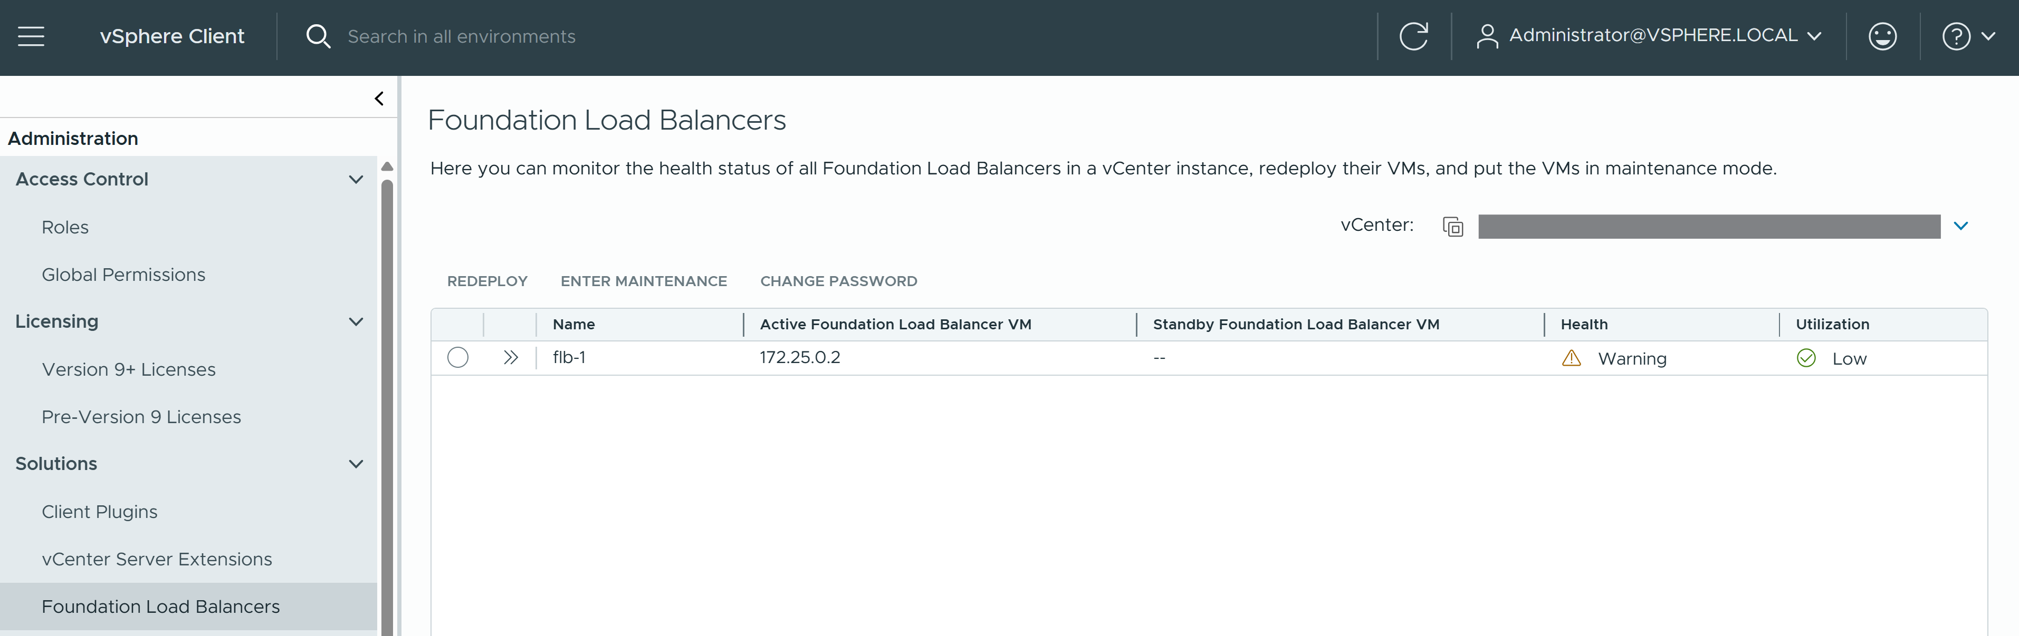
- Track the status of the Foundation Load Balancer instances in vCenter.
  - Name - The Foundation Load Balancer instance name.
  - Active Foundation Load Balancer VM - The VM that is active in the active-passive Foundation Load Balancer configuration.
  - Standby Foundation Load Balancer VM - The VM that is standby in an active-passiveFoundation Load Balancer configuration.
  - Health - The health status of the Foundation Load Balancer VM. The possible status are Healthy and Unhealthy. In case a VM is in Unhealthy state, the possible reason could be a resource over-utilization. In such case, you can increase the deployment footprint of the Foundation Load Balancer VMs to provide additional resources. See Change Load Balancer Settings on a Supervisor Configured with VDS Networking See Troubleshooting Foundation Load Balancer Heath Errors for other errors and how to troubleshoot them.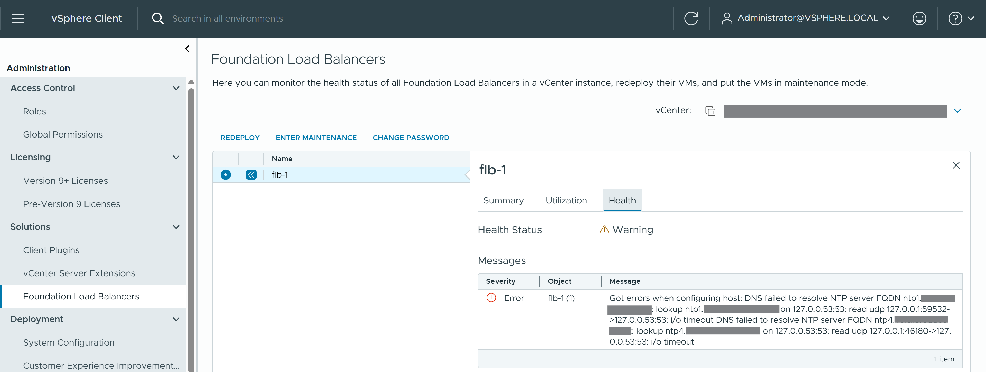
  - Utilization - The resource utilization of the Foundation Load Balancer VM.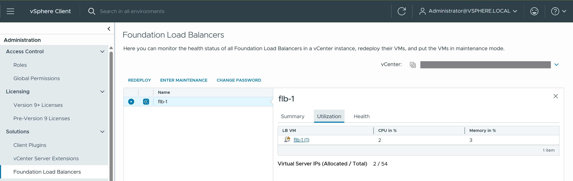
- View the topology of a Foundation Load Balancer instance.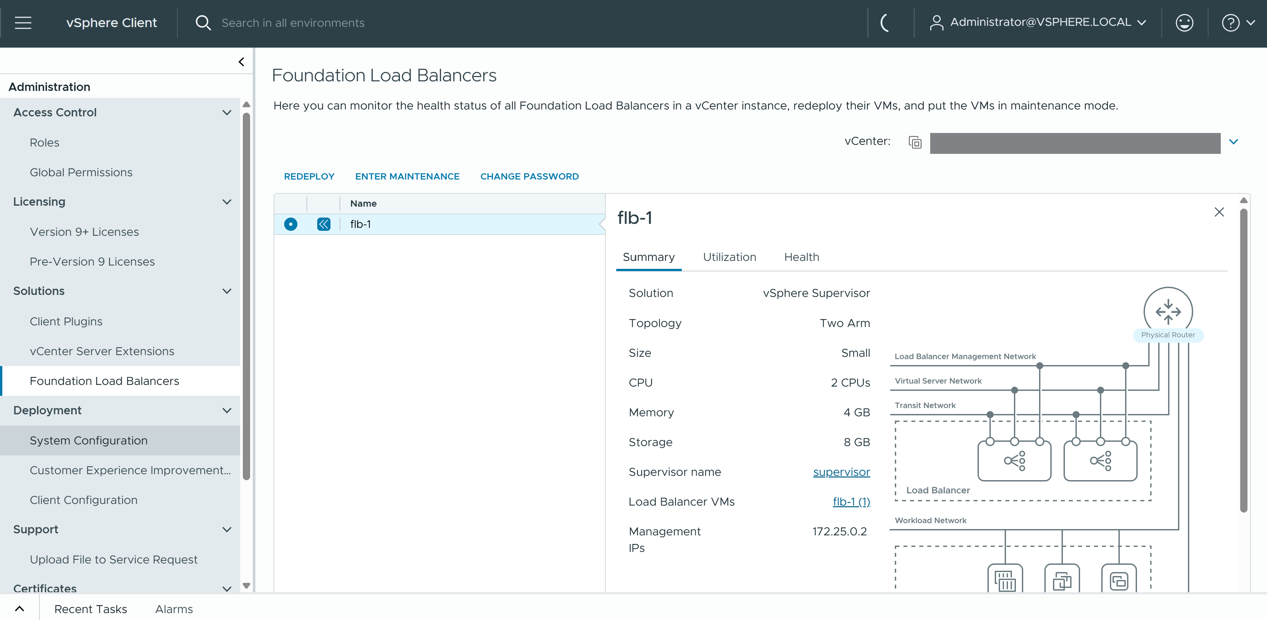

Running VKS Clusters
This section describes the components and lists the requirements for running VKS clusters.

VKS Components
VKS (formerly called TKG Service or TKGS) provides self-service life cycle management of Kubernetes workload clusters. VKS with Supervisor is optimized for the vSphere environment and integrates with the underlying infrastructure, including vCenter, ESX, virtual networking, and cloud native storage. With VKS, you can provision conformant Kubernetes clusters and maintain upstream concurrency.
The VKS includes several components integrated with the vSphere Supervisor.

vSphere Supervisor
Supervisor is a critical control plane built into vSphere that integrates desired state and a single consistent API directly into the hypervisor, enabling native deployment and management of Kubernetes clusters, declarative Virtual Machines, and vSphere Pods alongside traditional workloads. It transforms vSphere into a extensible platform providing a declarative API surface for self-service provisioning of modern infrastructure services within a resource boundary enabled by a vSphere Namespace.

Supervisor Deployment: vSphere Zones
You can assign vSphere clusters to vSphere Zones to provide high availability and fault tolerance for Supervisor. Deploying Supervisor across vSphere Zones lets you provision VKS clusters in specific availability zones.
In a deployment of Supervisor on a single vSphere cluster, there is a one-to-one relationship between the Supervisor and the vSphere cluster. In a zoned Supervisor deployment, Supervisor stretches across three vSphere clusters to provide high-availability and failure domains for VKS clusters on Supervisor.
A vSphere administrator creates the three vSphere Zone and associates them with a vSphere cluster. A Supervisor deployment on three vSphere Zones has special requirements in addition to vSphere cluster requirements, including:
- Three vSphere Zones connected by a vSphere Distributed Switch (VDS)
- Each vSphere Zone contains a single vSphere cluster
- A Supervisor must deploy on exactly 3 vSphere Zones
- A vSphere storage policy is available on vSphere Zone

vSphere Namespace
A vSphere Namespace is a tenancy boundary that enables self-service consumption of 3 runtimes to include Virtual Machines, VKS clusters, vSphere Pods and a number of other infra services. For each vSphere Namespace, you configure role-based access control, persistent storage, resource limits, images library, and virtual machine classes.

vSphere Kubernetes Service (VKS)
VKS is an implementation of the open source Cluster API project that defines a set of custom resources and controllers to manage the life cycle of Kubernetes clusters. VKS is a component of Supervisor.
VKS has three layers of controllers to manage the life cycle of VKS clusters, including Virtual Machine Service, Cluster API, and Cloud Provider Plugin.
VM Operator
Cluster API
Cloud Provider Plugin

vSphere Kubernetes release
A vSphere Kubernetes release (VKr) provides the Kubernetes software distribution and add-ons signed and supported by VMware for use with VKS clusters.
Each VKr is distributed as a virtual machine template (OVA file). VKS uses the OVA format to construct the virtual machine nodes for VKS clusters. VKrs are versioned according to Kubernetes versioning, and include OS customizations and optimizations for vSphere infrastructure.
For a list of VKrs and compatibility with Supervisor, refer to the VKr Release Notes.
Content Library

VKS Cluster Components
The components that run in a VKS cluster provide functionality for four areas of the product: authentication, storage, networking, and load balancing.
Authentication Webhook
Container Storage Interface (CSI)
Container Network Interface (CNI)
Cloud Provider Implementation

VKS Cluster API
VKS provides an API for provisioning and managing the life cycle of VKS clusters. The API lets you create conformant Kubernetes clusters of type Cluster based on a default ClusterClass provided by VMware.

VKS Cluster Clients
VKS on Supervisor supports various client interfaces for provisioning, monitoring, and managing VKS clusters.
- vSphere Client for configuring Supervisor and monitoring deployed VKS clusters.
- VCF CLI for authenticating with Supervisor and VKS clusters using vCenter Single Sign-On.
- kubectl to provision and manage the life cycle of VKS clusters declaratively, and to interact with Supervisor.
- VCF Automation interface for managing VKS clusters.

Deploying VKS Clusters
To deploy VKS clusters, you install or upgrade the VKS, use a content library to store VKS releases, and configure one or more vSphere Namespaces to host VKS clusters.

Deploying VKS Service Clusters
To deploy VKS clusters, enable and configure a Supervisor.
Note Refer to Installing and Configuring vSphere Supervisor for instructions.
After you have enabled and deployed Supervisor, complete the following tasks in preparation for provisioning VKS clusters.
Task | Description
Install or upgrade the VKS | See Installing and Upgrading VKS.
Install the CLIs and connect to Supervisor | See Configuring Identity and Access for VKS Clusters.
Create and synchronize the content library for VKS releases (VKrs) | Content library integrates the VKS environment with the VMware content delivery network through which VKrs are delivered. You can use a subscribed or local content library depending on your requirements.  Existing VKrs must be upgraded to take advantage of new VKS features. See Administering Kubernetes Releases for VKS Clusters.
Create and configure vSphere Namespaces for hosting VKS clusters | Defining a vSphere Namespace creates the network segment for hosting VKS clusters. See Configuring vSphere Namespaces for Hosting VKS Clusters.  Each vSphere Namespace must be configured with:  - Cluster users and roles  - Synchronized content library  - Associated VM classes  - vSphere storage policy for VKS cluster nodes and persistent volumes  If you are using a Supervisor deployed on three vSphere Zones, the vSphere storage policy must specify the Zonal topology. See Create a vSphere Storage Policy for VKS Clusters.
Provision VKS clusters | See Provisioning VKS Clusters.
Operate VKS clusters | See Operating VKS Service Clusters.
Deploy cluster workloads | See Deploying Workloads on VKS Clusters.
Maintain VKS clusters | See Updating VKS Service Clusters.
Troubleshoot VKS clusters | See Troubleshooting VKS Clusters.

Reference Architectures for VKS Clusters
This topic provides a set of reference architectures for VKS clusters with various deployment topologies.

VKS Cluster with NSX Topology
The reference architecture consists of a VKS cluster on Supervisor with NSX networking. In such an environment, the management plane hosts vCenter and NSX Managers. The compute plane hosts NSX Edge Nodes and Supervisor nodes.
The following NSX network objects are present:
- Tier-1 gateway (router)
- Segment (switch) linked to the gateway
- Load balancer server
- Server pool for each VKS cluster control plane virtual server
- Virtual server for each Kubernetes service load balancer instance

VKS Cluster with VDS Topology
The reference architecture consists of a VKS cluster with VDS networking and an external load balancer. In such an environment, the following networks are present:
- Management network for Supervisor control plane VMs
- Workload network for VKS clusters
- Frontend network through which developers connect to VKS clusters

VKS Cluster with vSphere Zones Topology
The reference architecture consists of a VKS cluster deployed across vSphere Zones. Each vSphere Zone maps to a vSphere Cluster, which is a collection of ESX hosts managed by vCenter and connected by a vSphere Distributed Switch, with shared storage and qualities of service enabled.
In a zoned topology, you deploy Supervisor across three vSphere Zones. The system locates a Supervisor control plane in each vSphere Zone, providing for high-availability if a failure occurs.
When you provision a VKS cluster on Supervisor, the cluster is aware of the vSphere Zones. The zone topology supports failure domains for highly available workloads. If needed you can run a workload in a specific zone using annotations.
For more details, see Using Placement Policies to Provision VKS Clusters.

Installing and Upgrading VKS
This section provides information for installing and upgrading the VKS.

Using the vSphere Kubernetes Service
VMware vSphere Kubernetes Service (VKS) lets you deploy Kubernetes workload clusters on the vSphere Supervisor. The VKS provides independent releases and asynchronous upgrades without workload disruptions.

Introducing the VKS
In vSphere 9, VKS is installed as a Supervisor Service. This architectural change decouples VKS from vSphere Supervisor releases and lets you upgrade the VKS independent of vCenter and Supervisor.
VKS runs on Supervisor control plane nodes. The VKS is delivered as a nested collection of Carvel packages. As a Core Supervisor Service, the VKS can be upgraded, even in internet-restricted environments, but it cannot be uninstalled or downgraded. You can monitor and manage the VKS from the Supervisor Management > Services tab. See the Upgrading the VKS Service Version section below.
VKS registration and upgrade are separate processes.

Installing VKS
Installing the VKS is done automatically when you upgrade vSphere Supervisor components to their required versions. Refer to the VKS release notes for details.

Registering New VKS Versions with vCenter
The VKS package is published with vCenter and pushed to the VMware public registry. VKS registration is performed at the vCenter level. You have two options to register new versions of the VKS: synchronous and asynchronous.
Table 4-5. VKS Version Registration Options
Registration Method | Description
Synchronous with vCenter Update | Wait for an update to the latest vCenter release to auto-register a new version of the VKS, then update Supervisor to populate the embedded registry with the new versions.
Asynchronous Public | Download a new VKS version definition from the public registry, then manually register it with vCenter.
Asynchronous Private | Relocate the VKS package from the public registry to a private registry that you host, then manually register the service with vCenter.Synchronous registration requires a system update. Updating vCenter automatically registers new VKS versions with Supervisor. However, to use a auto-registered (new) version, you must then update Supervisor to the version that ships with the vSphere Namespaces release delivered by that vCenter. On update of Supervisor, the Carvel package bundle for the VKS is available in the Supervisor embedded registry and ready for deployment. A Supervisor upgrade does not automatically upgrade the VKS. You must choose to deploy the version you want.
Asynchronous registration does not require vCenter and Supervisor updates, assuming the current Supervisor version is within the support window. Asynchronous registration has the following workflow:
- Download the service definition YAML file from the public registry site for Supervisor Services.
- If air-gapped installation is required, relocate the package to your private registry.
- Register the new version of the VKS by uploading the service definition to vCenter.
The table summarizes registration details of the VKS.
Table 4-6. VKS Version Registration
VKS Property | vCenter Bundled | Registry
Registration of new versions | Auto-registered | Manual registration
Deletion of newly registered versions | Not allowed | Allowed
Image location | Supervisor control plane embedded registry | Public or private registry

Upgrading the VKS Version
VKS version upgrades are performed at the Supervisor level. Once the VKS is registered, you upgrade the VKS by deploying it as a Supervisor Service on the target Supervisor. See Upgrade the VKS Version.
When you upgrade the VKS version, the system performs pre-checks and reports two levels of severity:
- WARNING which is non-blocking
- ERROR which is blocking
A Kubernetes version check is an example of a non-blocking warning check. A Supervisor version check is an example of a blocking error. For more information, refer to the Supervisor Services documentation.

Air-Gapped Upgrades
To upgrade the VKS in an air-gapped environment, you have two choices: synchronously with a vCenter update or asynchronously when a new version is available.
For synchronous air-gapped updates, you wait for a vCenter release then register the new VKS version by updating vCenter. See the Registering New VKS Versions with vCenter section.
For asynchronous air-gapped updates, you relocate the VKS package from the public registry to a private registry, then register the new VKS version with vCenter. See Upgrade VKS from a Private Registry.
Once the new VKS version is registered, the system uses its local registry to upgrade the VKS.

Verify the VKS Status
Refer to this topic to verify the status of the VKS.
Complete this task to verify that the VKS is installed as a Core Supervisor Service and to check its status.
There are two ways to verify the status: using the vSphere Client and using kubectl. To check the status using the vSphere Client, log in to vCenter and navigate to Supervisor Management > Services.
To check the status using kubectl, complete the following steps.
Procedure
- Log in to Supervisor.
For information, see Connecting to Supervisor and VKS Clusters.
- Run the following command.
kubectl get packageinstall --namespace vmware-system-supervisor-services
You should that see the VKS is installed.
NAMESPACE NAME PACKAGE NAME PACKAGE VERSION DESCRIPTION AGE
vmware-system-supervisor-services svc-tkg.vsphere.vmware.com tkg.vsphere.vmware.com 0.0.1-b836be7 Reconcile succeeded 17h

Register a New Version of the VKS
Refer to this topic to manually register a new version of the VKS with vCenter for the purposes of upgrading the VKS asynchronously.
This task is only required if you intend to upgrade the VKS version asynchronously. See Registering New VKS Versions with vCenter.
Prerequisites
Upgrade all system components and install VKS. See Installing VKS.
Procedure
- Using a browser, navigate to the Supervisor Services distribution site: https://www.vmware.com/go/supervisor-service.
- Download the VKSpackage.yaml file from the site.
- Using the vSphere Client, log in to vCenter.
- Navigate to Supervisor Management > Services.
- Locate the service tile named Kubernetes Service.
- Select Actions > Add New Version.
- Click Upload.
- Select the package.yaml file you downloaded
- click Finish.
Results
After registering the new service definition, you may see more than one version of the VKS available for the VKS tile. You will select the target version when you upgrade VKS.
What to do next
Upgrade the VKS Version.

Upgrade the VKS Version
Refer to this topic to upgrade the version of the VKS.
VKS version upgrade is performed at the Supervisor level. If vCenter is hosting multiple Supervisors, select the target Supervisor.
Prerequisites
- Upgrade all system components and installed VKS . See Installing VKS.
- Register a new version of the VKS, either manually or Registering New VKS Versions with vCenter.
Procedure
- Using the vSphere Client, log in to vCenter.
- Navigate to Supervisor Management > Services.
- Locate the vSphere Kubernetes Service tile.
- Select Actions > Install on Supervisors.
- Select the target version of the VKS to upgrade to.
- Select the target Supervisor hosting the VKS you want to upgrade.
- Confirm service compatibility and click OK.
- Confirm that the VKS is upgraded.
The tile at the Supervisor Management > Services page displays the VKS version and status. You can also check the status using kubectl get kr. See Verify the VKS Status.

Upgrade VKS from a Private Registry
Learn how to asynchronously upgrade the VKS version by using an image hosted in a private container registry. You can use this approach to upgrade the VKS if you are operating in an air-gapped environment and you cannot or do not want to wait for the next vCenter release.

Prerequisites
- Configure Harbor Supervisor Service as the private registry. If you are using a different registry, adjust accordingly.
Note Do not host VKS images on a Harbor instance deployed on a VKS cluster. Doing so might cause VKS upgrade to fail. Configure Harbor Supervisor Service as the private registry instead.
- Verify that you have a client machine with Docker installed. See Using Private Registries with Clusters for more information.

Install Carvel
The system uses the Carvel packaging system. For more information about the Carvel imgpkg utility, see https://carvel.dev/imgpkg/docs/v0.42.x/install/.
- Install the Carvel imgpkg utility.
wget -O- https://carvel.dev/install.sh > install.sh
sudo bash install.sh
- Verify Carvel installation.
imgpkg version

Generate the VKS Binary Package
Generate the VKS binary package by downloading the VKS definition YAML from the public site and creating the binary tar file.
- Download the VKS definition YAML from the public site.
vSphere Supervisor Services.
For example, if you want to upgrade from VKS 3.2 to VKS 3.3.1, download the VKS 3.3.1 YAML.
- Open the VKS YAML and get the image path for the package.
For example, for VKS 3.3.1 it is the following.
projects.packages.broadcom.com/vsphere/iaas/tkg-service/3.3.1/tkg-service:3.3.1
Which can be located in the YAML as follows:
...
template:
spec:
fetch:
- imgpkgBundle:
image: projects.packages.broadcom.com/vsphere/iaas/tkg-service/3.3.1/tkg-service:3.3.1
- As a convenience, consider creating an environment variable for the image path named VKS_REPO_PATH or similar.
export VKS_REPO_PATH="projects.packages.broadcom.com/vsphere/iaas/tkg-service/3.3.1/tkg-service:3.3.1"
Verify the environment variable:
printenv VKS_REPO_PATH
Note The environment variable is not a requirement as long as the imgpkg copy command (used next) includes the properly replaced path.
- Generate a tar binary of the imgpkg bundle.
imgpkg copy -b ${VKS_REPO_PATH} --to-tar tkg-service-v3.1.0.tar --cosign-signatures
Or, if you did not create the environment variable, use the following command.
imgpkg copy -b projects.packages.broadcom.com/vsphere/iaas/tkg-service/3.3.1/tkg-service:3.3.1 --to-tar tkg-service-v3.3.1.tar --cosign-signatures
Important To relocate the images, you must use the copy command and not the push and pull commands because they do not pull down all referenced images.
- Verify success.
copy | exporting 31 images...
copy | will export projects.packages.broadcom.com/vsphere/iaas/tkg-service/3.3.1/tkg-service@sha256:02ffc87c3ebd2f8eed545f405e05443feb9b6675d 7835a4d30bb8a939e54dcb9
...
copy | exported 31 images
copy | writing layers...
copy | done: file 'manifest.json' (71.384µs)
copy | done: file 'sha256-0f8b424aa0b96c1c388a5fd4d90735604459256336853082afb61733438872b5.tar.gz' (32.162µs)
...
Succeeded
- Verify the local copy of the binary package tkg-service-v3.3.1.tar.

Upload the VKS Binary to the Private Registry
The next step is to upload the VKS binary to the private registry.
- Log in to Harbor and create a project for the VKS named vks or similar.
- Download the Harbor registry certificate file named ca.crt to your Ubuntu host.
- Log in to the Habor registry using Docker.
docker login harbor.example.com
Note imgpkg honors the system's trust settings and Docker's configuration for authentication. If your registry requires authentication, first log in with the Docker CLI command docker login ${registry_url}.
- Create an environment variable for the registry URL.
export REGISTRY_URL="harbor.example.com/vks"
Verify the environment variable:
printenv REGISTRY_URL
- Upload the imgpkg bundle to your private container image registry.
imgpkg copy --tar tkg-service-v3.3.1.tar --to-repo ${REGISTRY_URL}/tkg-service --cosign-signatures --registry-ca-cert-path ca.crt
Where
  - --tar tkg-service-v3.3.1.tar is the name of the binary you created
  - --to-repo harbor.example.com/vks is the registry URL
  - --registry-ca-cert-path ca.crt is the registry certificate
- Verify success.
imgpkg copy --tar tkg-service-v3.3.1.tar --to-repo harbor.example.com/vks/tkg-service --cosign-signatures --registry-ca-cert-path ca.crt
copy | importing 31 images...
337.24 MiB / 53.97 MiB [--------------------------------------------------------------------------------------] 624.91% 11.62 MiB p/s
copy |
copy | done uploading images
337.24 MiB / 53.97 MiB [--------------------------------------------------------------------------------------] 624.91% 11.62 MiB p/s
copy | Tagging images
Succeeded
- Verify that the VKS container image and tag are pushed to the registry.
An obvious method is to log into the private registry and verify that the image is present. Another method to verify the image copy succeeded is to run the following command where REGISTRY_URL is equivalent to the entry under imgpkgBundle.image in the manifest.
imgpkg describe -b ${REGISTRY_URL}/tkg-service:3.3.1
Or, depending on how you configured your Docker client, you may need to include the certificate.
imgpkg describe -b $REGISTRY_URL/tkg-service:3.3.1 --registry-ca-cert-path ca.crt

Upgrade the VKS from a Private Registry
The last step is to upgrade the VKS from the package that is stored in your private registry.
- Open with a text editor the local VKS YAML file.
- Locate the imgpkg bundle location.
- Update the path to use the path of the private registry location of the image.
template:
spec:
fetch:
- imgpkgBundle:
image: ${REGISTRY_URL}/tkg-service:3.3.1
Note The tag, 3.3.1 in this example, will vary based on the version of the service definition you downloaded.
- Register the new service definition with Supervisor.
See Register a New Version of the VKS.
- Upgrade the VKS.
See Upgrade the VKS Version.
- After upgrade to VKS 3.5, a default add-on repository will be installed with a public URL. Refer to Update an Add-on Repository Install to update the private registry URL.

Troubleshoot the VKS
Refer to this topic to troubleshoot the VKS.

VKS Support Bundle
The VKS support bundle is included with the Supervisor support bundle. For guidance, see Collect a Support Bundle for Supervisor.
Within the Supervisor support bundle, the VKS logs are located in the var/log/tkg-svs folder.
Supervisor Services and managed by the Core Service Controller, Logs for the Core Service Controller are located at /var/log/vmware/wcp/.
Application platform logs can be pulled using the following command.
kubectl logs vmware-system-appplatform-lifecycle-suffix -n vmware-system-appplatform-operator-system

Administering Kubernetes Releases for VKS Clusters
vSphere Kubernetes releases (VKrs) provide the Kubernetes software distribution for VKS clusters. VKrs are distributed as virtual machine templates which you synchronize with the platform using a vCenter Content Library.

Using Kubernetes Releases with VKS Clusters
A vSphere Kubernetes release provides the Kubernetes software distribution signed and supported by VMware for use with VKS clusters. The VKr formats and multiple operating systems.

VKr Release Notes
Refer to the VKr Release Notes for the complete list of available VKr distributions, what's new for each release, known issues, and compatibility.

VKr Distribution and Consumption
VMware distributes vSphere Kubernetes releases through a content delivery network. You use a vSphere content library to associate VKrs with vSphere Namespaces. To automate the consumption of VKrs, use a Create a Subscribed Content Library. For internet-restricted environments, use a Create a Local Content Library for the Air-Gapped Environment.
Each vSphere Kubernetes release is distributed as an OVA template. The VKr Controller on Supervisor uses the OVA template to construct the VMs for VKS cluster nodes. The VM disk size is set by the VKr OVA template. You specify CPU and RAM resources using Using VM Classes with VKS Clusters.
The VKr content library is not namespace-scoped. All vSphere Namespaces use same content library for VKS with Supervisor. Editing the content library for one vSphere Namespace will update it for all others.

VKr Name String
Use the command kubectl get kr to list the VKr images that are available for use in the vSphere Namespace. For example:
kubectl get kr
NAME VERSION READY COMPATIBLE CREATED
v1.16.14---vmware.1-tkg.1.ada4837 v1.16.14+vmware.1-tkg.1.ada4837 False False 19d
v1.17.17---vmware.1-tkg.1.d44d45a v1.17.17+vmware.1-tkg.1.d44d45a False False 19d
v1.18.19---vmware.1-tkg.1.17af790 v1.18.19+vmware.1-tkg.1.17af790 False False 19d
v1.19.16---vmware.1-tkg.1.df910e2 v1.19.16+vmware.1-tkg.1.df910e2 False False 19d
v1.20.12---vmware.1-tkg.1.b9a42f3 v1.20.12+vmware.1-tkg.1.b9a42f3 False False 19d
v1.21.6---vmware.1-tkg.1.b3d708a v1.21.6+vmware.1-tkg.1.b3d708a True True 19d
v1.22.9---vmware.1-tkg.1.cc71bc8 v1.22.9+vmware.1-tkg.1.cc71bc8 True True 19d
v1.23.8---vmware.2-tkg.2-zshippable v1.23.8+vmware.2-tkg.2-zshippable True True 19d
v1.23.8---vmware.3-tkg.1 v1.23.8+vmware.3-tkg.1 True True 19d
You use the NAME string to provision VKS clusters on Supervisor. If you are using the v1alpha3 API, you provide full NAME string in the tkr.reference.name field. If you are using the v1beta1 API, you provide the full NAME string in the topology.version field.
Note Do not use the VERSION string when referencing the VKr in the cluster specification. The format must match the VKr NAME string exactly.
The name of the VKr in the content library needs to be the full NAME string. If you are using a subscribed content library, the Name string is created for you. If you are using a local content library, make sure the name you give to the VKr matches the NAME string. See Create a Local Content Library for the Air-Gapped Environment for details.

VKr Compatibility with VKS
VKrs are released and updated independent from the VKS and from Supervisor.
To provision a VKS cluster, the VKr must be compatible with the VKS. You cannot use a VKr that is not compatible with the VKS. In addition, you must make sure that you are running a compatible VKr for the version you target for upgrade.
You can check VKr compatibility using the command kubectl get tkr. The COMPATIBLE column returns a boolean. True means the VKr is compatible, False means it is not compatible.

VKr Operating System Image Format
The VKr OS image format allows a single VKr for a specific Kubernetes version to support multiple operating systems. Currently, PhotonOS, Ubuntu 22.04, Ubuntu 24.04, Red Hat Enterprise Linux 9, and Microsoft Windows Server 2022 are supported. The default OS image format is PhotonOS.
By default, VKS cluster nodes use the PhotonOS edition of the specified VKr.
To use Ubuntu OS, add the run.tanzu.vmware.com/resolve-os-image: os-name=ubuntu annotation. For information, see VKr and OS Image Resolution Process.

VKr Packages
VKr images compatible with vSphere are updated to a package-based framework for core components, such as the container storage interface (CSI) and container network interface (CNI). If you are using the v1beta API, changing or updating these components is done using custom resource definitions.
To view the packages that comprising a VKr, run the following command:
kubectl get tkr TKR-NAME -o yaml
For example:
kubectl get tkr v1.28.8---vmware.1-fips.1-tkg.2 -o yaml
The command returns all the packages. For example:
spec:
bootstrapPackages:
- name: antrea.tanzu.vmware.com.1.13.3+vmware.3-tkg.2-vmware
- name: vsphere-pv-csi.tanzu.vmware.com.3.1.0+vmware.1-tkg.6-vmware
- name: vsphere-cpi.tanzu.vmware.com.1.28.0+vmware.1-tkg.1-vmware
- name: kapp-controller.tanzu.vmware.com.0.48.2+vmware.1-tkg.1-vmware
- name: guest-cluster-auth-service.tanzu.vmware.com.1.3.3+tkg.1-vmware
- name: metrics-server.tanzu.vmware.com.0.6.2+vmware.3-tkg.5-vmware
- name: secretgen-controller.tanzu.vmware.com.0.15.0+vmware.1-tkg.1-vmware
- name: pinniped.tanzu.vmware.com.0.25.0+vmware.2-tkg.1-vmware
- name: capabilities.tanzu.vmware.com.0.32.1+vmware.1
- name: gateway-api.tanzu.vmware.com.1.0.0+vmware.1-tkg.1-vmware
- name: calico.tanzu.vmware.com.3.26.3+vmware.1-tkg.1-vmware
See v1beta1/v1beta2 Example: Cluster with Calico CNI for an example use case.

Migrating VKr OS Types
In-place cluster updates between VKr operating systems are not supported. This means, for example, that you cannot upgrade a VKS cluster using VKr v1.27.11 Photon to VKr v1.28.8 Ubuntu.
If you want to change the VKr OS type that a VKS cluster is using, consider the following procedure. In this example, the origin cluster is using Photon and the target is Ubuntu.
- Using Velero, backup the Photon-based VKS cluster workloads.
See Backing Up and Restoring VKS Clusters and Workloads in the Supervisor documentation.
- Provision a new VKS cluster using the Ubuntu VKr.
See Provisioning VKS Clusters.
- Using Velero, restore the VKS cluster workloads to the Ubuntu cluster.
See Backing Up and Restoring VKS Clusters and Workloads in the Supervisor documentation.

VKr Hardening
Security Technical Implementation Guides (STIG) for system components, including Supervisor and VKrs, are available. See Tanzu STIG Hardening for details.

Build a Custom VKr Machine Image
You can build custom VKr machine images for VKS clusters on vSphere. A custom machine image packages a supported operating system and version, a Kubernetes version based on a released VKr, and any customizations you make.
Beginning with VKr 1.35, use Image Baker to build custom machine images for VKS cluster nodes. See Building a Custom VKr Machine Image.
For VKr 1.34 and earlier, use the Image Builder to build customer machine images for VKS cluster nodes. Refer to the documentation for details on building custom images, supported VKr versions, and supported customizations.

Building a Custom VKr Machine Image
The Kubernetes Image Baker from Broadcom is a specialized tool for creating reproducible and customizable VM images for VKS use while ensuring full compliance with VCF requirements.
Unlike traditional approaches that create exact copies of live VMs, Image Baker uses an OCI-based Buildkit backend for Linux environments to systematically curate the filesystem. This offers a more efficient and controlled alternative to the existing vSphere Tanzu Kubernetes Grid Image Builder.
The bake subcommand is integrated into the kubernetes-release (kr) plugin of the VCF CLI to enable baking vSphere Kubernetes Release (VKr) images directly from the VCF command-line interface.
The tool creates OVA files containing operating system images with Kubernetes distributions, suitable for deployment on vSphere environments. It uses a BuildKit-based Low-Level Build format to create images from:
- Base OS OCI images (Ubuntu, Photon, RHEL, Windows)
- Kubernetes Distribution OCI images
When you run the bake command, the following processes occur:
- Pre-bake checks: Validation of the configuration file, output directory, and BuildKit availability.
- Configuration Parsing: Reads and validates the YAML configuration.
- Image Baking: Creation of the OVA file with:
  - OS layer from base OCI image
  - Kubernetes distribution layer
- OVA Generation: Produces VMDK, OVF, and OVA files.
- Cleanup: Clears cache (unless --keepCache is specified).

Image Baker Prerequisites
For all operating system environments:
- Root/Administrator access. Required for disk operations and system-level modifications.
- At least 50 GB of free disk space for image building and caching.
To build Linux images, the following prerequisites must be installed in your environment:
- VCF CLI with kubernetes-release plugin installed, and upgraded to the latest 3.6 version.
- Linux AMD64 (Ubuntu 22.04+ recommended) installed on the host machine
- Docker (https://docs.docker.com/engine/install/)
- BuildKit Version 0.21.0+ (https://github.com/moby/buildkit/releases)
- xsfprogs (provides mkfs.xfs)
- open-vmdk Version 0.3.11+ (https://github.com/vmware/open-vmdk)
- Python Version 3.10+ with packages: semver, jinja2, jinja2-time, pyyaml
To build Windows images, the following prerequisites must be available in your environment:
- VCF CLI with kubernetes-release plugin installed, and upgraded to the latest 3.6 version
- Windows 10/11 must be installed on the host machine
- Windows Server 2022 ISO (https://www.microsoft.com/en-us/evalcenter/evaluate-windows-server-2022)
- QEMU >= 9 (https://www.qemu.org/download/)
- Hyper-V with an External vSwitch configured (https://learn.microsoft.com/en-us/windows-server/virtualization/hyper-v/get-started/create-a-virtual-switch-for-hyper-v-virtual-machines)

Networking Requirements for Image Baker
- Access to OCI registries containing:
  - Base OS images
  - Kubernetes distribution images
  - Any custom package repositories

Image Baker Configuration File
The bake command accepts a configuration file to specify the settings needed for building the image. The configuration file uses a Kubernetes-style YAML format with the imagebaker.vmware.com/v1alpha1 API version.
The basic file structure is as follows:
apiVersion: imagebaker.vmware.com/v1alpha1
kind: Image
metadata:
name: <image-name>
spec:
osSpec: { ... }
kubernetesSpec: { ... }
# Optional fields
packages: { ... }
repositorySpec: { ... }
services: [ ... ]
customOVFProperties: { ... }
diskSize: <size>
The required fields for the configuration file are as follows:
metadata.name
spec.osSpec
spec.kubernetesSpec
The optional fields for the configuration file are as follows:
spec.packages
spec.repositorySpec
spec.services
spec.customOVFProperties
spec.diskSize

Using the bake command
The bake command is part of the kubernetes-release plugin of the VCF CLI.
Usage:
vcf kubernetes-release bake -f <config-file> [flags]
sudo vcf kr bake -f <config-file> [flags] # using alias
Important The kubernetes-release plugin needs to be installed with sudo, and sudo must be used whenever you invoke the bake subcommand.
Global flags:
These flags control the behavior of the bake command.
--log-format
--log-level
--no-cache
Required flags:
-f, --file
Optional flags:
-o, --output
-s, --keepCache

Image Baker Output
The bake command creates the following output structure:
artifacts/
└── <image-name>/
├── <image-name>.ova # Bootable VM image (final deliverable)
├── <image-name>.vmdk # Virtual disk
├── <image-name>.ovf # Open Virtualization Format descriptor
├── <image-name>.mf # Manifest file
├── metadata.json # Kubernetes metadata
└── manifest.json # Image manifest

Configuring Image Baker for Private Registries with Self-Signed Certificates
Additional configuration may be required to use Image Baker with private registries using self-signed certificates.
When using VKD Image Baker with a private container registry that uses self-signed certificates (for example, Harbor), you may encounter the following error:
tls: failed to verify certificate: x509: certificate signed by unknown authority
This occurs because BuildKit (used internally by the image baker) does not use Docker's certificate configuration. Even if Docker can successfully connect to your registry, BuildKit maintains its own certificate trust store. You have multiple options for configuring Image Baker to be able to access your registry.

Prerequisites
Before configuring your registry, extract the CA certificate:
openssl s_client -showcerts -connect <your-registry-hostname>:443 </dev/null 2>/dev/null | openssl x509 -outform PEM > harbor-ca.crt
Replace <your-registry-hostname> with your actual registry hostname (for example, bitnami.workernode.lab).

Option 1: Add CA Certificate to System Trust Store (Recommended)
This option is the simplest and recommended approach.
- Install the certificate to the system trust store.
sudo cp harbor-ca.crt /usr/local/share/ca-certificates/harbor-ca.crt
sudo update-ca-certificates
- Restart BuildKit to pick up the new certificates.
sudo systemctl restart buildkit.service
- Verify that the certificate was added.
grep -r "<your-registry-hostname>" /etc/ssl/certs/ || echo "Certificate added to bundle"

Option 2: Configure BuildKit with Registry-Specific Settings
This approach provides more granular control by configuring BuildKit specifically for your registry.
- Install the certificate to the system trust store.
sudo cp harbor-ca.crt /usr/local/share/ca-certificates/harbor-ca.crt
sudo update-ca-certificates
- Create the BuildKit configuration directory.
sudo mkdir -p /etc/buildkit
- Create the BuildKit configuration file (/etc/buildkit/buildkitd.toml).
sudo tee /etc/buildkit/buildkitd.toml > /dev/null <<EOF
# Configure registry with self-signed certificate
[registry."<your-registry-hostname>"]
http = false
insecure = false
ca = ["/etc/ssl/certs/ca-certificates.crt"]
EOF
- Update the BuildKit service to use the config file.
sudo mkdir -p /etc/systemd/system/buildkit.service.d
sudo tee /etc/systemd/system/buildkit.service.d/override.conf > /dev/null <<EOF
[Service]
ExecStart=
ExecStart=/usr/local/bin/buildkitd --addr fd:// --config /etc/buildkit/buildkitd.toml
EOF
- Reload systemd and restart BuildKit.
sudo systemctl daemon-reload
sudo systemctl restart buildkit.service

Image Baker Usage Examples
See some example use cases for the Image Baker tool.

Example 1: Windows 2022 Image
Some configuration parameters are required for Windows image builds:
- osSpec: Contains metadata about the OS version and name. For Windows builds, osSpec.image must point to the Windows Server ISO path, and osSpec.vmtoolsPath must point to the VMware Tools installer.
- kubernetesSpec: Provides the Kubernetes distribution image URL. For Windows builds, the image must include the exact SHA256 digest of the released image (e.g., image:tag@sha256:...).
- customOVFProperties: Sets the virtual hardware version. For Windows images on vSphere, this must be set to 18.
Tip To get the image digest of a released image, you can use cranedigest.
apiVersion: imagebaker.vmware.com/v1alpha1
kind: Image
metadata:
name: windows-2022-amd64-v1.35.0---vmware.1-vkr.1
spec:
osSpec:
name: windows
version: "2022"
image: C:\windows.iso
vmtoolsPath: C:\vmtools.exe
virtualSwitch: "Default Switch"
kubernetesSpec:
# Use the exact SHA256 digest of the released image
image: projects.packages.broadcom.com/vsphere/iaas/kubernetes-release/1.35.0/kubernetes-distribution-image:@sha256:<sha256-digest>
customOVFProperties:
vmx:
version: 18

Example 2: Red Hat Enterprise Linux Image
The configuration includes:
- osSpec: Contains metadata about the OS version and name. For RHEL builds, osSpec.image must reference a RHEL UBI image.
- kubernetesSpec: Provides the Kubernetes distribution image URL.
The following example builds a RHEL 9 VKR image:
apiVersion: imagebaker.vmware.com/v1alpha1
kind: Image
metadata:
name: rhel-9-amd64-v1.35.0---vmware.1-vkr.1
spec:
osSpec:
name: rhel
version: "9"
image: registry.access.redhat.com/ubi9@sha256:7a4818cdb8e0461d75d4bdfa42a355d3725bcc8cc0cc5d467021119d5962ce6b
kubernetesSpec:
image: projects.packages.broadcom.com/vsphere/iaas/kubernetes-release/1.35.0/kubernetes-distribution-image:v1.35.0_vmware.1-vkr.1
Before you run the bake command, set your Red Hat subscription credentials as environment variables as follows:
- RH_USERNAME: Your Red Hat Enterprise username
- RH_PASSWORD: Your Red Hat Enterprise password

Example 3: Use Debug Logging
- Enable debug logging with plain text format.
sudo vcf kr bake -f config.yaml --log-level DEBUG --log-format plain
- Keep cache for inspection.
sudo vcf kr bake -f config.yaml --keepCache

Example 4: Clearing Image Baker Cache Before Build
Clear cache and build fresh.
sudo vcf kr bake -f config.yaml --no-cache

Required Role Permissions for Administering Content Libraries
Several vSphere role permissions are required for administering content libraries. If you are not using the vSphere Administrator role, refer to the list of permissions as needed.

Required Permissions for Administering Content Libraries
Content library administration requires the following vSphere role permissions.
These permissions are included in the vSphere Administrator role.
Create a dedicated role that includes these permissions.
- Content Library
- Add library item &
- Check in a template &
- Check out a template &
- Create local library &
- Create subscribed library &
- Delete library item &
- Delete local library &
- Delete subscribed library &
- Download files &
- Evict library item &
- Evict subscribed library &
- Import storage &
- Probe subscription information &
- Read storage &
- Sync library item &
- Sync subscribed library &
- Type introspection &
- Update configuration settings &
- Update library &
- Update library item &
- Update local library &
- Update subscribed library &
- View configuration settings &

Create a Subscribed Content Library
To provision VKS clusters on Supervisor, you can create a subscribed content library and synchronize vSphere Kubernetes releases. A subscribed content library lets you automate the distribution of a VKr and stay current with the latest releases.
For VKS on Supervisor, VMware publishes vSphere Kubernetes releases to a content delivery network. You can create a content library that subscribes to these image publications. You choose the synchronization mode: immediate or on demand.
Warning Immediate synchronization on the public content delivery network can take substantial time and disk space.
Prerequisites
- The content library functionality is a feature of vCenter that Supervisor relies on. For general information, see Using Content Libraries in the vSphere Virtual Machine Administration documentation.
- Ensure you have the correct subscription endpoint URL for your environment:
  - For environments with the Software Depot. Ensure that the Software Depot is installed and configured and that you have the Software Depot subscription endpoint URL.
To find your subscription URL, log in to the vCenter Developer Center, open the API Explorer, and execute a GET request on the lcm/depot/services API. Use the returned VcenterLcmDepotServicesAddress and base_url values to format your URL as: https://{VcenterLcmDepotServicesAddress}{base_url}/PROD/COMP/VKR/lib.json. See Configure a Software Depot Connection Mode.
  - For environments without the Software Depot, such as VVF. Use the standard VMware public repository URL: https://wp-content.vmware.com/v2/latest/lib.json.
Procedure
- Log in to the vCenter using the vSphere Client and navigate to Menu > Content Libraries.
- Create a subscribed content library.
  - Click Create.
The system displays the New Content Library wizard.
  - Specify the Name and location of the content library and click Next.
For example, you can enter a descriptive name, such as VKr-local and include a description, such as Subscribed library for VKS.
  - On the Configure content library page, select the Subscribed content library option.
  - Enter the Subscription URL address of your Software Depot.
  - For the Download content option, select one of the following:
Option | Description
Immediately | The subscription process synchronizes both the library metadata and images. If items are deleted from the published library, their contents remain in the subscribed library storage, and you have to manually delete them.
When needed | The subscription process synchronizes only the library metadata. The system downloads the images when published. When you no longer need the item, you can delete the item contents to free storage space. To save storage this option is recommended.
  - When prompted, accept the SSL certificate thumbprint.
The SSL certificate thumbprint is stored on your system until you delete the subscribed content library from the inventory.
  - On the Apply security policy page, configure the OVF security policy and click Next.
When you select the Apply security policy option, the system verifies the OVF signing certificate during the synchronization process. An OVF template that does not pass certificate validation is marked with the Verification Failed tag. The template metadata is kept, but the OVF files cannot be synchronized.
Note Currently the OVF default policy is the only supported security policy.
  - On the Add storage page, select a datastore as a storage location for the content library contents and click Next.
  - On the Ready to complete page, review the details and click Finish.
- On the Content Libraries page, select the new content library you created.
- Confirm or complete the synchronization of the library contents.
Synchronization Option | Description
Immediately | If you chose to download all content immediately, confirm that the library is synchronized.  To view the synchronized library contents, select Templates > OVF & OVA Templates.
When needed | If you chose to synchronize the library on demand, you have two options:  - Use Actions > Synchronize to synchronize the entire library  - Right-click an item and select Synchronize to synchronize only it.  To view the synchronized library contents, select Templates > OVF & OVA Templates.
- If you chose the When needed option, download the OVF templates you want to use.
If you chose the When needed option, you see that the image files are not stored locally, only the metadata is stored. To download the template files, select the item, right-click, and select Synchronize item.
- To update the subscribed content library settings, choose Actions > Edit Settings.
Setting | Value
Subscription URL | The Subscription URL address of your Software Depot
Authentication | Not enabled
Library content | Download when needed
Security policy | OVF default policy
What to do next
Associate the content library for the VKS clusters with the Supervisor. See Add or Update VKS Content Libraries on a Supervisor.

Create a Local Content Library for the Air-Gapped Environment
To provision VKS clusters on Supervisor, you can create a local content library and import vSphere Kubernetes releases. The typical use case for a local content library is internet-restricted environments, also called air-gapped.
Creating a local content library involves configuring the library, downloading the OVA files, and importing them to the local content library.
Prerequisites
The content library functionality is a feature of vCenter that VKS on Supervisor relies on. For general information, see Using Content Libraries in the vSphere Virtual Machine Administration documentation.
Procedure
- Log in to the vCenter using the vSphere Client and navigate to Menu > Content Libraries.
- Create a local content library.
  - Click Create.
The system displays the New Content Library wizard.
  - Specify the Name and location of the content library and click Next.
For example, you can enter a descriptive name, such as VKr-local and include a description, such as Local library for VKS.
  - On the Configure content library page, select the Local content library option and click Next.
For local content libraries you manually import the OVF templates you want to use.
  - On the Apply security policy page, configure the OVF security policy and click Next.
When you select the Apply security policy option, the system verifies the OVF signing certificate during the synchronization process. An OVF template that does not pass certificate validation is marked with the Verification Failed tag. The template metadata is kept, but the OVF files cannot be synchronized.
Note Currently the OVF default policy is the only supported security policy.
  - On the Add storage page, select a datastore as a storage location for the content library contents and click Next.
  - On the Ready to complete page, review the details and click Finish.
- Download the OVA files for each vSphere Kubernetes release you want import to the local content library.
  - Using a browser, navigate to the following URL:
https://wp-content.vmware.com/v2/latest/
  - Click the directory for the image you want. Typically this directory is the latest or most recent version of the Kubernetes distribution.
For example:
ob-18186591-photon-3-k8s-v1.20.7---vmware.1-xyz
Important You use the distribution name to import the files to the local content library.
For the above example, the portion of the name string that you need is:
ob-18186591-photon-3-k8s-v1.20.7---vmware.1-xyz.
Copy the destination name to a file or keep the browser open until you complete the procedure.
  - For each of the files in the package, right-click and select Save link as.
For example:
    - photon-ova-disk1.vmdk
    - photon-ova.cert
    - photon-ova.mf
    - photon-ova.ovf
  - Verify that each file successfully downloads to your local file system.
Note The files you import are the OVF and VMDK files. However, if a security policy is applied, all four files, including the certificate (*.cert) and manifest (*.mf), must be present in the source directory during import. If the certificate and manifest files are not available during import, the imported VKS release is not usable.
- Import the OVA and VMDK files to the local content library.
  - Select Menu > Content Libraries.
  - From the list of Content Libraries, click the link for local content library you created.
  - Click Actions > Import Items.
  - In the Import Library Item window, select Local File and click Upload Files.
  - Select both files photon-ova.ovf and photon-ova-disk1.vmdk.
You see the message 2 files ready to import. Each file is listed with a green check mark beside its name.
  - Change the Destination Item name to be the OS image version plus the Kubernetes version from the directory where you downloaded the files.
For example:
photon-3-k8s-v1.20.7---vmware.1-tkg.1.7fb9067
Warning The content library Destination Item name must match exactly the folder name string for the desired VKS release. If the names do not match, Supervisor cannot resolve the image to a valid VKS release.
  - Click Import.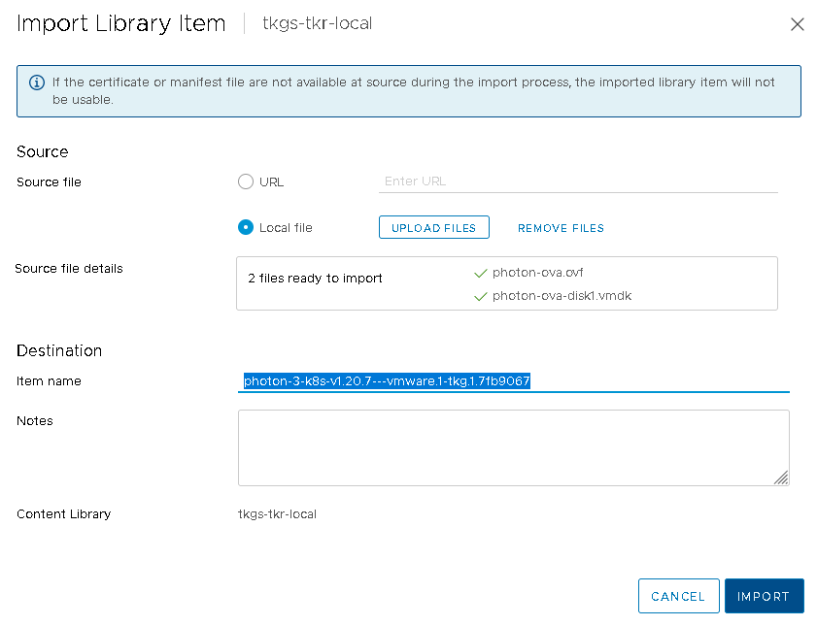
- Verify that the local content library is populated with the vSphere Kubernetes release.
  - In the Recent Tasks pane, monitor the uploading task for the library item and verify that it is successfully Completed.
  - In the local content library view, select Templates > OVF & OVA Templates.
  - Verify that the vSphere Kubernetes release metadata is listed and its content is stored locally.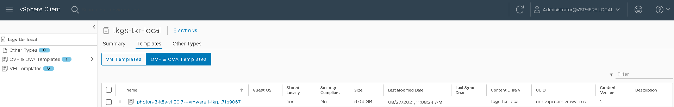
What to do next
Associate the content library for the VKS clusters with the Supervisor. See Add or Update VKS Content Libraries on a Supervisor.

Enable Publishing of a Local Content Library
You can create a local content library and enable publication, allowing other content libraries to subscribe. This approach lets you control the vSphere Kubernetes release images that are available for use, while providing VKS cluster operators with a subscription-style service.
Instead of subscribing to the VMware Content Delivery Network for vSphere Kubernetes releases, where all images are published and remain, you can create a local content library that provides a limited subset of vSphere Kubernetes releases. Such an approach is convenient when you want to control which images are available, such as in continuous build environments.
Procedure
- Create a Create a Local Content Library for the Air-Gapped Environment, or edit the settings for an existing one.
- Select the check box to Enable publishing.
You receive a subscription URL for this local content library.
- Create one or more Create a Subscribed Content Library using the subscription URL.
Results
When you upload vSphere Kubernetes releases to the local content library enabled with publishing, all subscribed content libraries will receive the images on synchronization.

Add or Update VKS Content Libraries on a Supervisor
To provision VKS clusters, you have to associate a content library with vSphere Kubernetes Service on a Supervisor. You can later change the library or add additional libraries, if your environment supports this action. You might also need to remove an associated library.
To create a content library for hosting VKr images, see Create a Subscribed Content Library.
Complete these steps to change an existing content library, add a new one for use with the VKS clusters, or remove a content library associated with the VKS cluster.
When you make changes to your content library, keep in mind the following:
- The content library you use for VKS clusters is not scoped to individual vSphere Namespaces. The same content library is used for all vSphere Namespaces on a Supervisor instance. For this reason, changing the content library is only allowed at the Supervisor level.
- The content library referenced in the VM Service tile can be used only with standalone VMs. Do not add the VKS content library to the VM Service tile.
- If a content library associated with VKS is deleted from vCenter, the library remains linked to VKS. You must first remove this library from VKS to proceed with any operations. If you try to add or remove any other content library, you see an error message prompting you to unlink the library that was deleted from vCenter.
Prerequisites
To be able to add or remove a content library, make sure your environment meets the following requirements:
- vSphere version 9.0 or later.
- VKS version 3.3 or later installed.
Procedure
- Log in to the vCenter using the vSphere Client.
- Select Supervisor Management > Supervisors, and select the Supervisor instance.
- Select Configure > General.
- Under Kubernetes Service, edit, add, or remove a content library.
Add or remove a content library.  With vSphere version 9.0 and VKS version 3.3 installed. | - Click Add and select one or more content libraries that you want to associate.  - Wait for all selected content libraries to show up in the list.  - To remove one or more content libraries, select them from the list and click Remove.  - Wait for the selected content libraries to be removed from the list.  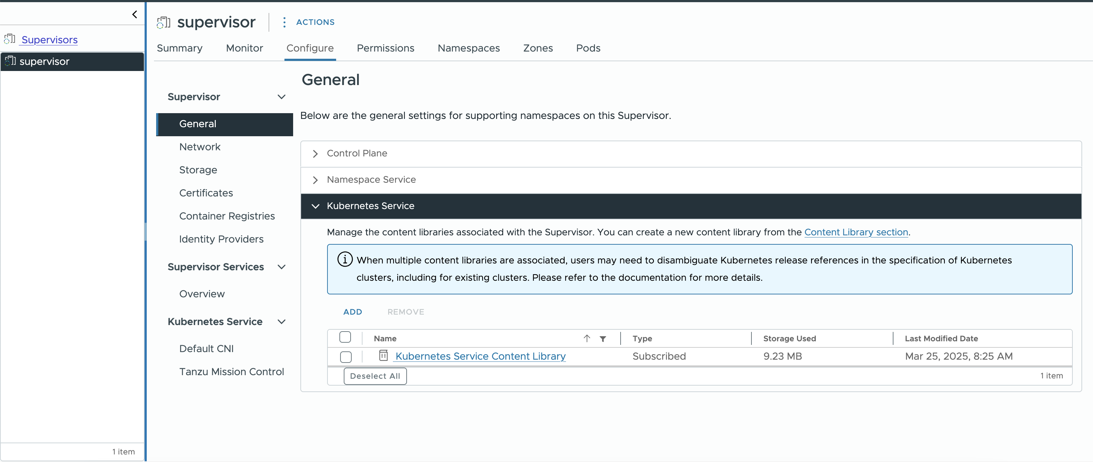
Edit a content library.  With vSphere version 8.x or earlier. | - Select Content Library > EDIT, and select a content library you want to use.  - Wait for the content library name to change to the one that you selected.
Results
The content library you select is used for the VKS across all vSphere Namespaces created on Supervisor.

Resource Requests for Components in VKS Clusters
Resource requests are defined for components running in VKS clusters to ensure that they are allocated optimal resources to run smoothly.

Core Components Resource Requests
Table 4-7. Static Pods Requirements
Pod Name | Namespace | Target Node | CPU Request | Memory Request | Memory Limit
kube-apiserver | kube-system | Control plane | 250m | - | -
kube-controller-manager | kube-system | Control plane | 200m | - | -
kube-scheduler | kube-system | Control plane | 100m | - | -
etcd | kube-system | Control plane | 100m | 100Mi | -
Table 4-8. Deployments
Deployment Name | Namespace | Replicas | CPU Request | Memory Request | Memory Limit
antrea-controller | kube-system | 1 | 100m | 100Mi | -
calico-kube-controllers | kube-system | 1 | - | - | -
coredns | kube-system | 2 | 100m | 70Mi | 170Mi
guest-cluster-cloud-provider | vmware-system-cloud-provider | 1 | - | - | -
kapp-controller | tkg-system | 1 | 150m | 300Mi | -
metrics-server | kube-system | 1 | 50m | 75Mi | -
pinniped-concierge | pinniped-concierge | 2 | 100m | 128Mi | -
secretgen-controller | secretgen-controller | 1 | 50m | 100Mi | -
snapshot-controller | kube-system | 1 | - | - | -
vsphere-csi-controller | vmware-system-csi | 1 | - | - | -
Table 4-9. Daemonsets
DaemonSet Name | Namespace | Target Node | CPU Request | Memory Request | Memory Limit
antrea-agent | kube-system | All | 400m | - | -
calico-node | kube-system | All | 250m | - | -
guest-cluster-auth-svc | vmware-system-auth | Control Plane | - | - | -
kube-proxy | kube-system | All | - | - | -
vsphere-csi-node | vmware-system-csi | All | - | - | -

Standard Packages Resource Requests
Package | Version | Replicas for Deployment or Daemonset | CPU Requests | Memory Requests | CPU Limits | Memory Limits
AKO | 1.13.4+vmware.1-vks.1 | ✔ StatefulSet (Replica: 1)  ✔ Deployment (Replica: 1) | ako container: 200m  ako-gateway-api: 200m | ako container: 300Mi  ako-gateway-api: 300Mi | ako container: 350m  ako-gateway-api: 350m | ako container: 400Mi  ako-gateway-api: 400Mi
 | 2.1.2+vmware.1-vks.1 | ✔ StatefulSet (Replica: 1)  ✔ Deployment (Replica: 1) | ako container: 200m  ako-gateway-api: 200m  ako-crd-operator: 128m  vmci-relay: 50m | ako container: 300Mi  ako-gateway-api: 300Mi  ako-crd-operator: 64Mi  vmci-relay: 32Mi | ako container: 350m  ako-gateway-api: 350m  ako-crd-operator: 256m  vmci-relay: 100m | ako container: 400Mi  ako-gateway-api: 400Mi  ako-crd-operator: 128Mi  vmci-relay: 64Mi
 | 2.1.3+vmware.1-vks.1 | ✔ StatefulSet (Replica: 1)  ✔ Deployment (Replica: 1) | ako container: 200m  ako-gateway-api: 200m  ako-crd-operator: 128m  vmci-relay: 50m | ako container: 300Mi  ako-gateway-api: 300Mi  ako-crd-operator: 64Mi  vmci-relay: 32Mi | ako container: 350m  ako-gateway-api: 350m  ako-crd-operator: 256m  vmci-relay: 100m | ako container: 400Mi  ako-gateway-api: 400Mi  ako-crd-operator: 128Mi  vmci-relay: 64Mi
Autoscaler | 1.35.0+vmware.1-vks.1 | ✔ Deployment (Replica: 1) | 25m | 50Mib | - | -
 | 1.34.2+vmware.1-vks.1 | ✔ Deployment (Replica: 1) | 25m | 50Mib | - | -
 | 1.34.0+vmware.1-vks.1 | ✔ Deployment (Replica: 1) | 25m | 50Mib | - | -
 | 1.33.0+vmware.2-vks.1 | ✔ Deployment (Replica: 1) | 25m | 50Mib | - | -
 | 1.33.2+vmware.1-vks.1 | ✔ Deployment (Replica: 1) | 25m | 50Mib | - | -
 | 1.31.3+vmware.1-vks.1 | ✔ Deployment (Replica: 1) | 25m | 50Mib | - | -
Cert Manager (cert-manager-controller  cert-manager-cainjector  cert-manager-webhook) | 1.18.2+vmware.2-vks.2 | ✔ Deployment (Replica: 1) | 10m | 64Mi | - | -
 | 1.18.3+vmware.1-vks.1 | ✔ Deployment (Replica: 1) | 10m | 64Mi | - | -
 | 1.19.1+vmware.1-vks.1 | ✔ Deployment (Replica: )1 | 10m | 64Mi | - | -
 | 1.19.2+vmware.1-vks.1 | ✔ Deployment (Replica: 1) | 10m | 64Mi | - | -
Contour | 1.33.0+vmware.1-vks.1 | ✔ Daemonset (envoy default)  ✔ Deployment (contour Replica: default 2) | contour: 128m  envoy: 128m  envoyInitConfig: 128m  shutdownManager: 10m | contour: 256Mi  envoy: 256Mi  envoyInitConfig: 256Mi  shutdownManager: 16Mi | - | -
 | 1.33.0+vmware.2-vks.1 | ✔ Daemonset (envoy default)  ✔ Deployment (contour Replica: default 2) | contour: 128m  envoy: 128m  envoyInitConfig: 128m  shutdownManager: 10m | contour: 256Mi  envoy: 256Mi  envoyInitConfig: 256Mi  shutdownManager: 16Mi | - | -
 | 1.33.1+vmware.1-vks.1 | ✔ Daemonset (envoy default)  ✔ Deployment (contour Replica: default 2) | contour: 128m  envoy: 128m  envoyInitConfig: 128m  shutdownManager: 10m | contour: 256Mi  envoy: 256Mi  envoyInitConfig: 256Mi  shutdownManager: 16Mi | - | -
External DNS | 0.18.0+vmware.1-vks.1 | ✔ Deployment (Replica: 1) | 100m | 128Mi | - | -
 | 0.18.0+vmware.2-vks.1 | ✔ Deployment (Replica: 1) | 100m | 128Mi | - | -
 | 0.20.0+vmware.1-vks.1 | ✔ Deployment (Replica: 1) | 100m | 128Mi | - | -
Fluent Bit | 4.0.8+vmware.1-vks.1 | ✔ Daemonset | 200m | 256Mi | - | -
 | 4.0.8+vmware.2-vks.1 | ✔ Daemonset | 200m | 256Mi | - | -
 | 4.1.1+vmware.1-vks.1 | ✔ Daemonset | 200m | 256Mi | - | -
 | 4.2.2+vmware.1-vks.1 | ✔ Daemonset | 200m | 256Mi | - | -
Harbor | v2.14.2+vmware.1-vks.1 | ✔ Deployment (Replica: 1) | harbor-core: 500m  harbor-database: 1000m  harbor-jobservice: 500m  harbor-portal: 100m  harbor-redis: 200m  harbor-registry: 500m  harbor-registryctl: 200m  (optional) harbor-trivy: 500m  (optional) harbor-exporter: 100m | harbor-core: 512Mi  harbor-database: 1Gi  harbor-jobservice: 512Mi  harbor-portal: 128Mi  harbor-redis: 256Mi  harbor-registry: 512Mi  harbor-registryctl: 256Mi  (optional) harbor-trivy: 1Gi  (optional) harbor-exporter: 128Mi | harbor-core: 1000m  harbor-database: 2000m  harbor-jobservice: 1000m  harbor-portal: 300m  harbor-redis: 500m  harbor-registry: 1000m  harbor-registryctl: 500m  (optional) harbor-trivy: 2000m  (optional) harbor-exporter: 300m | harbor-core: 2Gi  harbor-database: 2Gi  harbor-jobservice: 2Gi  harbor-portal: 256Mi  harbor-redis: 1Gi  harbor-registry: 2Gi  harbor-registryctl: 512Mi  (optional) harbor-trivy: 4Gi  (optional) harbor-exporter: 256Mi
 | 2.14.1+vmware.1-vks.1 | ✔ Deployment (Replica: 1) | harbor-core: 500m  harbor-database: 1000m  harbor-jobservice: 500m  harbor-portal: 100m  harbor-redis: 200m  harbor-registry: 500m  harbor-registryctl: 200m  (optional) harbor-trivy: 500m  (optional) harbor-exporter: 100m | harbor-core: 512Mi  harbor-database: 1Gi  harbor-jobservice: 512Mi  harbor-portal: 128Mi  harbor-redis: 256Mi  harbor-registry: 512Mi  harbor-registryctl: 256Mi  (optional) harbor-trivy: 1Gi  (optional) harbor-exporter: 128Mi | harbor-core: 1000m  harbor-database: 2000m  harbor-jobservice: 1000m  harbor-portal: 300m  harbor-redis: 500m  harbor-registry: 1000m  harbor-registryctl: 500m  (optional) harbor-trivy: 2000m  (optional) harbor-exporter: 300m | harbor-core: 2Gi  harbor-database: 2Gi  harbor-jobservice: 2Gi  harbor-portal: 256Mi  harbor-redis: 1Gi  harbor-registry: 2Gi  harbor-registryctl: 512Mi  (optional) harbor-trivy: 4Gi  (optional) harbor-exporter: 256Mi
Istio | 1.27.1+vmware.1-vks.1 | ✔ Daemonset (ztunnel, istio-cni)  ✔ Deployment  (istiod Replica: 2, istio-support/istio-ingressgateway/istio-egressgateway Replica: 1) | istiod: 500m  istio-cni-node: 100m  ztunnel: 200m  istio-support: 100m  istio-ingressgateway: 100m  istio-egressgateway: 100m  istio-proxy: 100m  waypoint-proxy: 100m | istiod: 2048Mi  istio-cni-node: 100Mi  ztunnel: 512Mi  istio-support: 64Mi  istio-ingressgateway: 128Mi  istio-egressgateway: 128Mi  istio-proxy: 128Mi  waypoint-proxy: 128Mi | - | -
 | 1.27.4+vmware.1-vks.1 | ✔ Daemonset  ✔ Deployment  (istiod Replica: 2, istio-support/istio-ingressgateway/istio-egressgateway Replica: 1) | istiod: 500m  istio-cni-node: 100m  ztunnel: 200m  istio-support: 100m  istio-ingressgateway: 100m  istio-egressgateway: 100m  istio-proxy: 100m  waypoint-proxy: 100m | istiod: 2048Mi  istio-cni-node: 100Mi  ztunnel: 512Mi  istio-support: 64Mi  istio-ingressgateway: 128Mi  istio-egressgateway: 128Mi  istio-proxy: 128Mi  waypoint-proxy: 128Mi | - | -
 | 1.27.5+vmware.1-vks.1 | ✔ Daemonset  ✔ Deployment (istiod Replica: 2, istio-support/istio-ingressgateway/istio-egressgateway Replica: 1) | istiod: 500m  istio-cni-node: 100m  ztunnel: 200m  istio-support: 100m  istio-ingressgateway: 100m  istio-egressgateway: 100m  istio-proxy: 100m  waypoint-proxy: 100m | istiod: 2048Mi  istio-cni-node: 100Mi  ztunnel: 512Mi  istio-support: 64Mi  istio-ingressgateway: 128Mi  istio-egressgateway: 128Mi  istio-proxy: 128Mi  waypoint-proxy: 128Mi | - | -
 | 1.28.2+vmware.1-vks.1 | ✔ Daemonset  ✔ Deployment (istiod Replica: 2, istio-support/istio-ingressgateway/istio-egressgateway Replica: 1) | istiod: 500m  istio-cni-node: 100m  ztunnel: 200m  istio-support: 100m  istio-ingressgateway: 100m  istio-egressgateway: 100m  istio-proxy: 100m  waypoint-proxy: 100m | istiod: 2048Mi  istio-cni-node: 100Mi  ztunnel: 512Mi  istio-support: 64Mi  istio-ingressgateway: 128Mi  istio-egressgateway: 128Mi  istio-proxy: 128Mi  waypoint-proxy: 128Mi | - | -
Prometheus | 3.5.0+vmware.1-vks.2 | ✔ Daemonset (prometheus-node-exporter)  ✔ Deployment (alertmanager Replica: 1, kube-state-metrics Replica: 1, pushgateway Replica: 1, prometheus server Replica: 1, configmap-reload Replica: 1, (optional) prometheus-operator Replica: 1, (optional) prometheus-admission-wehbook Replica: 2) | alertmanager: 50m  kube-state-metrics: 50m  prometheus-node-exporter: 50m  pushgateway: 50m  configmap-reload: 50m  prometheus server: 250m | alertmanager: 64Mi  kube-state-metrics: 64Mi  prometheus-node-exporter: 64Mi  pushgateway: 64Mi  configmap-reload: 64Mi  prometheus server: 512Mi | - | -
 | 3.5.0+vmware.2-vks.1 | ✔ Daemonset (prometheus-node-exporter)  ✔ Deployment (alertmanager Replica: 1, kube-state-metrics Replica: 1, pushgateway Replica: 1, prometheus server Replica: 1, configmap-reload Replica: 1, (optional) prometheus-operator Replica: 1, (optional) prometheus-admission-wehbook Replica: 2) | alertmanager: 50m  kube-state-metrics: 50m  prometheus-node-exporter: 50m  pushgateway: 50m  configmap-reload: 50m  prometheus server: 250m | alertmanager: 64Mi  kube-state-metrics: 64Mi  prometheus-node-exporter: 64Mi  pushgateway: 64Mi  configmap-reload: 64Mi  prometheus server: 512Mi | - | -
 | 3.5.0+vmware.3-vks.1 | ✔ Daemonset (prometheus-node-exporter)  ✔ Deployment ( alertmanager Replica: 1,  kube-state-metrics Replica: 1,  pushgateway Replica: 1,  prometheus server Replica: 1,  configmap-reload Replica: 1,  (optional) prometheus-operator Replica: 1,  (optional) prometheus-admission-wehbook Replica: 2 | alertmanager: 50m  kube-state-metrics: 50m  prometheus-node-exporter: 50m  pushgateway: 50m  configmap-reload: 50m  prometheus server: 250m  (optional)prometheus-operator:100m  (optional)prometheus-admission-wehbook:50m | alertmanager: 64Mi  kube-state-metrics: 64Mi  prometheus-node-exporter: 64Mi  pushgateway: 64Mi  configmap-reload: 64Mi  prometheus server: 512Mi  (optional)prometheus-operator:100Mi  (optional)prometheus-admission-wehbook:50Mi | (optional)prometheus-operator:200m  (optional) prometheus-admission-wehbook:200m | (optional)prometheus-operator:200Mi  (optional) prometheus-admission-wehbook:200Mi
SRIOV | 3.10.0+vmware.1-vks.1 | ✔ Daemonset | sriov-device-plugin: 250m | sriov-device-plugin: 40Mi | sriov-device-plugin: 1000m | sriov-device-plugin: 200Mi
 | 3.10.0+vmware.3-vks.1 | ✔ Daemonset | sriov-device-plugin: 250m | sriov-device-plugin: 40Mi | sriov-device-plugin: 1000m | sriov-device-plugin: 200Mi
 | 3.11.0+vmware.1-vks.1 | ✔ Daemonset | sriov-device-plugin: 250m | sriov-device-plugin: 40Mi | sriov-device-plugin: 1000m | sriov-device-plugin: 200Mi
Telegraf | 1.35.4+vmware.1-vks.1 | ✔ Daemonset  ✔ Deployment (Replica: 1) | 100m | 256Mi | - | -
 | 1.35.4+vmware.2-vks.1 | ✔ Daemonset  ✔ Deployment (Replica: 1) | 100m | 256Mi | - | -
 | 1.36.4+vmware.1-vks.1 | ✔ Daemonset  ✔ Deployment (Replica: 1) | 100m | 256Mi | - | -
Windows GMSA Webhook | 0.13.0+vmware.3-vks.1 | ✔ Deployment (Replica: 2) | 300m | 256Mi | - | -
 | 0.13.0+vmware.4-vks.1 | ✔ Deployment (Replica: 2) | 300m | 256Mi | - | -
PV CSI Webhook | 3.6.0+vmware.1-vks.1 | ✔ Deployment (Replica: 1) | 60m | 300Mi | - | -
 | 3.6.0+vmware.2-vks.1 | ✔ Deployment (Replica: 1) | 60m | 300Mi | - | -
 | 3.7.0+vmware.1-vks.1 | ✔ Deployment (Replica: 1) | 10m | 30Mi | - | -
SecretStore | 1.6.2+vmware.1-vks.1 | ✔ StatefulSet (Replica: 1) | 250m | 64Mi | 500m | 128Mi
Velero | 1.17.2+vmware.1-vks.1 | ✔ Daemonset (node-agent)  ✔ Deployment (velero server: Replica: ) | node-agent: no resource limitation  velero server: 500m | node-agent: no resource limitation  velero server: 128Mi | node-agent: no resource limitation  velero server: 1000m | node-agent: no resource limitation  velero server: 512Mi
 | 1.16.2+vmware.3-vks.1 | ✔ Daemonset  ✔ Deployment (Replica:1) | node-agent: no resource limitation  velero server: 500m | node-agent: no resource limitation  velero server: 128Mi | node-agent: no resource limitation  velero server: 1000m | node-agent: no resource limitation  velero server: 512Mi

VKr and OS Image Resolution Process
This topic describes how the system resolves VKr images.

VKr Resolution
When you create or update a cluster, the system selects a compatible, ready VKr and corresponding OS images for the control plane and each machine deployment. The selection is based on annotations and the cluster's spec:topology:version you set.
You can set the following annotations:
run.tanzu.vmware.com/resolve-tkr
run.tanzu.vmware.com/resolve-os-image
In VKS earlier than 3.4, you can set these annotations in a ClusterClass. Starting with VKS 3.4, annotations defined in a ClusterClass are no longer applied to clusters.
In VKS 3.4 and later, specify them in the Cluster topology. For more information, see Using builtin-generic-v3.4.0 ClusterClass with VKS 3.4.0 and Later.
spec:
topology:
class: builtin-generic-v3.4.0
controlPlane:
metadata:
annotations:
run.tanzu.vmware.com/resolve-os-image: os-name=ubuntu <==== annotation for cp
replicas: 1
variables:
- name: storageClass
value: wcpglobal-storage-profile
- name: vmClass
value: best-effort-small
version: v1.32.0---vmware.6-fips-vkr.2
workers:
machineDeployments:
- class: node-pool
metadata:
annotations:
run.tanzu.vmware.com/resolve-os-image: os-name=ubuntu <=== annotation for md
name: node-pool
replicas: 1
If no matching VKr or OS images are found, the cluster create or update request is denied.
On success, the following happens:
- The cluster is labeled with the resolved VKr, run.tanzu.vmware.com/tkr.
- spec.topology.version is set to the Kubernetes version of the resolved VKr.

Understanding VKr Deactivated Status
Sometimes a VKr might not be ready and the reason indicates that it is deactivated. A deactivated VKr can still be compatible with the current VKS release. A VKr is marked as deactivated if it has been superseded by a new VKr patch. This occurs only if a critical bug is identified in an existing patch.
Always refer to the VKr Release Notes for details.
If a VKr is deactivated, clusters currently using that VKr remain operational. Adding a new nodepool to the cluster requires an upgrade to a new VKr patch. New clusters cannot be created with a deactivated VKr.

Example Scenario: Deactivated VKr
In this scenario, VKr 1.35.2 supersedes VKr 1.35.0. When both VKrs are present in the VKS content library, VKr 1.35.0 is marked as deactivated. If you query the VKrs, you see that VKr 1.35.0 is compatible but not ready.
# kubectl get kr
NAME VERSION READY COMPATIBLE CREATED TYPE
v1.35.0---vmware.2-vkr.4 v1.35.0+vmware.2-vkr.4 False True 164m
v1.35.2---vmware.1-vkr.3 v1.35.2+vmware.1-vkr.3 True True 112m
When you describe the VKr, the status.conditions field confirms that it is deactivated.
status:
conditions:
- lastTransitionTime: "2026-04-13T21:18:50Z"
message: deactivated
reason: Deactivated
severity: Warning
status: "False"
type: Ready
- lastTransitionTime: "2026-04-13T20:36:32Z"
status: "True"
type: Compatible
- lastTransitionTime: "2026-04-13T20:26:23Z"
message: ' '
status: "True"
type: Type
Your attempts to create a cluster using the deactivated VKr version 1.35.0 result in an error similar to the following:
Warning: cluster.x-k8s.io/v1beta1 Cluster is deprecated; use cluster.x-k8s.io/v1beta2 Cluster
Error from server (Forbidden): error when creating "cluster.yaml": admission webhook "tkr-resolver-cluster-webhook.tanzu.vmware.com" denied the request: Could not resolve KR/OSImage
Missing compatible KR/OSImage for the cluster
Control Plane, filters: {k8sVersionPrefix: v1.35.0, osImageSelector: os-name=photon}
MachineDeployment node-pool-1, filters: {k8sVersionPrefix: v1.35.0, osImageSelector: os-name=photon}

Handling Missing VKr Upgrade Versions
The updatesAvailable condition on a cluster determines the VKr version to which the cluster can be upgraded. The updatesAvailable evaluation takes the resolve-os-image annotation into account. As a result, you might encounter a situation where you expect to see a new compatible VKr for an upgrade, but the updatesAvailable list is empty or missing expected versions.
This behavior typically occurs if the new VKr image is published to a different content library than the one explicitly set in the annotation during the cluster's creation.
Note When you provision a VKS cluster using the Cloud Consumption Interface (CCI) UI, the system automatically sets the run.tanzu.vmware.com/resolve-os-image annotation on your cluster, which makes this issue more likely to occur. However, even without CCI, you can encounter this behavior if a new VKr is published to a content library different from the one currently configured in the cluster's annotation.

Resolution
If your updatesAvailable list is missing expected VKr images, verify the resolve-os-image annotation on your cluster object. To proceed with the upgrade when the new image resides in a different content library, perform one of the following actions while updating the VKr version in the cluster spec:
- Unset the content library: Remove the content-library key from the annotation entirely if no image conflicts exist across your linked libraries.
- Update the content library: Change the content-library value to match the ID of the new content library that contains the target VKr image.

Example Scenario
You created a cluster named test-cluster using the CCI UI with an image from a content library named cl-11. The UI automatically sets the following annotation on your cluster's control plane and worker nodes:
run.tanzu.vmware.com/resolve-os-image: content-library=cl-11
Later, a new compatible VKr version v1.35.2---vmware.1-fips-vkr.1 becomes available in your environment. You expect to be able to upgrade, but when you check the cluster's status, the new version is missing from the updatesAvailable condition.
- Identify the new image and its content library.
Use kubectl to list the available OS images for the new version in your environment:
$ kubectl get osimage -A | grep v1.35.2
vmi-843b236a8f02c5e42v1.35.2+vmware.1-fips photon5 amd64 vmi 2d9h
Next, use the ID of the image (vmi-843b236a8f02c5e42) or the version string to look up the corresponding ClusterContentLibraryItem (cclitem):
$ kubectl get cclitem -A | grep v1.35.2
clitem-843b236a8f02c5e42ob-24537963-photon-5-amd64-v1.35.2---vmware.1-fips-vkr.1 cl-22 OVF True true 8083576284 true 2d10h
From the output above, you can see that the new OS image resides in a new content library: cl-22. Because your cluster is constrained to only look for images within cl-11, the update is not available.
- Update the cluster spec.
To resolve this and upgrade your cluster, modify the cluster spec to update the annotation to point to the new content library while simultaneously updating the cluster's topology version:
apiVersion: cluster.x-k8s.io/v1beta1
kind: Cluster
metadata:
name: test-cluster
namespace: test-ns
spec:
topology:
# 1. Update the version to the new Kubernetes Release
version: v1.35.2---vmware.1-fips-vkr.1
controlPlane:
replicas: 1
metadata:
annotations:
# 2. Update the annotation to point to the new content library
run.tanzu.vmware.com/resolve-os-image: content-library=cl-22
workers:
machineDeployments:
- class: node-pool
name: node-pool-1
metadata:
annotations:
# 3. Ensure worker node annotations are updated as well
run.tanzu.vmware.com/resolve-os-image: content-library=cl-22

Resolve VKr Image Conflicts When Using Multiple Content Libraries
When you create or update a VKS cluster, the VKr resolver might deny the request if it can’t find a matching VKr image, or if it finds multiple matching images with the same Kubernetes version, name, VKr version, and architecture. This conflict can occur when multiple content libraries linked to the Supervisor environment contain the same VKr images. You can resolve this issue by adding an annotation to the cluster spec to specify which library to use.
To avoid conflicts, you need to add the following annotation when you create or update clusters:
run.tanzu.vmware.com/resolve-os-image: content-library=cl-****,
where cl-**** is the name of the ClusterContentLibrary resource from the Supervisor.
If this annotation is omitted and duplicates exist, the operation fails with the error:
Error from server (Forbidden): error when creating "<yaml_name>": admission webhook "tkr-resolver-cluster-webhook.tanzu.vmware.com" denied the request: Could not resolve KR/OSImage
For existing clusters, depending on the operation, one the following applies:
- If you upgrade the cluster and the target image belongs to multiple content libraries associated with VKS, you must specify the resolve-os-image annotation.
- In VKS earlier than 3.5, for classy clusters created with ClusterClass 3.2.0 and later, if you scale up the cluster and the image belongs to multiple content libraries associated with VKS, you must specify the resolve-os-image annotation.
- If you scale up the cluster and the resolved image no longer exists, for example, if the content library association was removed from VKS, the image resolution fails.
Use the following steps as an example of how to add the annotations.
Procedure
- To check if you have multiple matching OS images in your environment, run this command.
# k get osImage -A | grep v1.32.0
You get the output similar to the following.
vmi-13333a0941f57a218 v1.32.0+vmware.6-fips windows 2022 amd64 vmi 17h
vmi-195e8697ba2d4c1d5 v1.32.0+vmware.6-fips ubuntu 22.04 amd64 vmi 17h
vmi-5aa61c54221622089 v1.32.0+vmware.6-fips photon 5 amd64 vmi 17h
vmi-943b236a8f02c5e31 v1.32.0+vmware.6-fips photon 5 amd64 vmi 2d9h
vmi-9a3e89c883cdacffa v1.32.0+vmware.6-fips ubuntu 22.04 amd64 vmi 2d9h
- Run this command to list content library items.
# k get cclitem -A | grep v1.32.0
clitem-13333a0941f57a218 windows-2022-amd64-v1.32.0---vmware.6-fips-vkr.1 cl-46b783ecd58a48773 OVF True true 10185968638 true 18h
clitem-195e8697ba2d4c1d5 ob-24537997-ubuntu-2204-amd64-v1.32.0---vmware.6-fips-vkr.2 cl-46b783ecd58a48773 OVF True true 12882906066 true 17h
clitem-5aa61c54221622089 ob-24537963-photon-5-amd64-v1.32.0---vmware.6-fips-vkr.2 cl-46b783ecd58a48773 OVF True true 8083573698 true 17h
clitem-943b236a8f02c5e31 ob-24537963-photon-5-amd64-v1.32.0---vmware.6-fips-vkr.2 cl-5680136bf02b1aa5d OVF True true 8083576284 true 2d10h
clitem-9a3e89c883cdacffa ob-24537997-ubuntu-2204-amd64-v1.32.0---vmware.6-fips-vkr.2 cl-5680136bf02b1aa5d OVF True true 12882908652 true 2d10h
- Specify the content library from which the image should be used for the Kubernetes cluster node creation.
apiVersion: cluster.x-k8s.io/v1beta1
kind: Cluster
metadata:
name: test-cluster-windows
namespace: test-ns
spec:
clusterNetwork:
services:
cidrBlocks: ["198.51.100.0/12"]
pods:
cidrBlocks: ["192.0.2.0/16"]
serviceDomain: "cluster.local"
topology:
class: builtin-generic-v3.2.0
version: v1.32.0---vmware.6-fips-vkr.2
controlPlane:
replicas: 1
metadata:
annotations:
run.tanzu.vmware.com/resolve-os-image: os-name=photon,content-library=cl-5680136bf02b1aa5d
workers:
machineDeployments:
- class: node-pool
name: node-pool-windows
metadata:
annotations:
run.tanzu.vmware.com/resolve-os-image: os-type=windows
replicas: 1
variables:
overrides:
- name: vmClass
value: best-effort-large
# Use a larger footprint for Windows node
variables:
- name: vmClass
value: best-effort-medium
- name: storageClass
value: wcpglobalstorageprofile
You need to specify the content library part in the resolve-os-image annotation for workers as well if you have multiple Windows images coming from different content libraries.

Configuring vSphere Namespaces for Hosting VKS Clusters
A vSphere Namespace provides the runtime environment for VKS clusters. To provision a VKS cluster, you first configure a vSphere Namespace with users, roles, compute, storage, content library, and virtual machine classes. This configuration is inherited by VKS clusters that run in that namespace.

Using vSphere Namespaces with VKS Clusters
A vSphere Namespace is a network-scoped tenancy on Supervisor. vSphere Namespaces are used to host VKS clusters, and provide networking, role permissions, persistent storage, resource quota, and content library and VM class integration.

vSphere Namespace Network
A vSphere Namespace network is a subnet carved from the Supervisor > Workload Network > Namespace Network. The Namespace subnet prefix defines the size of the subnet reserved for each vSphere Namespace. The default is /28.
The vSphere Namespace network provides connectivity for VKS clusters to Supervisor. By default, the vSphere Namespace will use cluster level network configurations and allocate IP addresses from its subnet. When you create a vSphere Namespace, a /28 overlay segment and corresponding IP pool is instantiated to service pods in that vSphere Namespace.
When the first VKS cluster is provisioned in a vSphere Namespace, the VKS cluster will share the same subnet as its vSphere Namespace. For each subsequent VKS cluster that is provisioned in that vSphere Namespace, a new subnet is created for that cluster and connected to its vSphere Namespace gateway.
There is a shared load balancer instance in the vSphere Namespace that is responsible for routing kubectl traffic to each VKS cluster control plane. In addition, for each Kubernetes service load balancer that is resourced on the VKS cluster, a layer-4 load balancer instance is created for that service.
VKS clusters within the same vSphere Namespace share a SNAT IP for north-south connectivity. East-west connectivity between namespaces is no SNAT.
The vSphere Namespace is typically non-routable. However, if you are using NSX networking, you can override the vSphere Namespace Network with a routable subnet. See Override Workload Network Settings for a vSphere Namespace.

vSphere Namespace Resource Pools
In a single vSphere Zone Supervisor deployment, when you create a vSphere Namespace, a resource pool backing that namespace is created. The vSphere Namespace provides a logical unit of resources on Supervisor, including compute, storage, permissions, classes, and images. When you configure a CPU or memory limit on a vSphere Namespace, for example, the same resource limits are applied to the resource pool backing that namespace. In this fashion vSphere Namespaces enable multi-tenancy in Supervisor.
The same multi-tenant experience applies to Supervisor deployed across three vSphere Zones. When a vSphere Namespace is created on a zoned Supervisor, the system creates a resource pool in each of the vSphere clusters supporting that Supervisor. This enables a VKS cluster provisioned in that vSphere Namespace to be deployed in any of the zones belonging to this Supervisor.
Using the vSphere Client, you can view the vSphere Namespace resource pool and objects by selecting the Hosts and Clusters perspective, and also by selecting the VMs and Templates view. When you provision a VKS cluster, it is created in the target vSphere Namespace. In a zoned Supervisor deployment, you will have the same resource pool in each vSphere cluster.
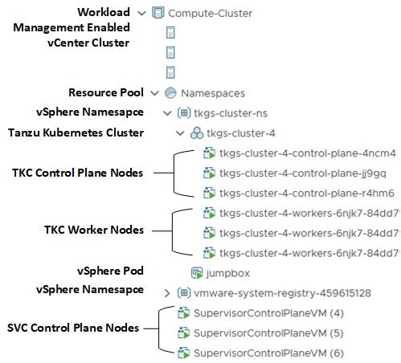

vSphere Namespace Storage for VKS Clusters
vSphere Cloud Native Storage (CNS) provides storage policies that support the provisioning of persistent volumes and their backing virtual disks for use with Kubernetes workloads.
The Container Storage Interface (CSI) is an industry standard that Kubernetes uses to provision persistent storage for containers. Supervisor runs a CNS-CSI driver that connects vSphere CNS storage to the Kubernetes environment through the vSphere Namespace. The vSphere CNS-CSI communicates directly with the CNS control plane for all storage provisioning requests that come from VKS clusters in the vSphere Namespace.
VKS clusters run a modified version of the vSphere CNS-CSI driver that is responsible for all storage related requests originating from the VKS cluster. The requests are delivered to the CNS-CSI on Supervisor, which then propagates them to the CNS on the vCenter.
The diagram shows the relationship between the vSphere Namespace, Supervisor, and VKS cluster storage mechanisms.
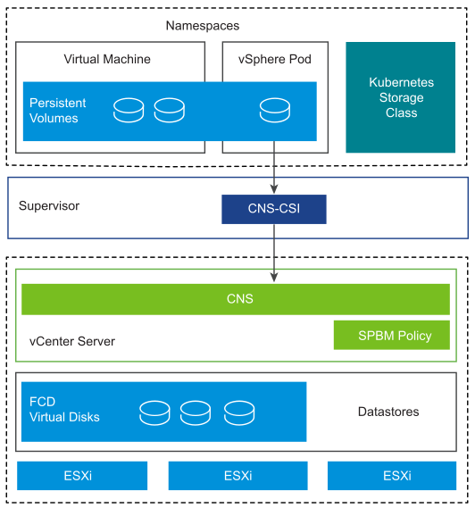

Persistent Storage Volumes for VKS Clusters
Persistent volumes are required for stateful applications in Kubernetes. For more information about persistent volumes, refer to the Kubernetes documentation.
In the vSphere environment, persistent volume objects are backed by virtual disks that reside on datastores. Datastores are represented by storage policies. When you assign a vSphere storage policy to a vSphere Namespace, the storage policy is made available as a Kubernetes storage class for each VKS cluster in that namespace.
VKS supports dynamic and static provisioning of persistent volumes. With dynamic provisioning, the persistent volume does not need to be pre-provisioned. You issue a persistent volume claim (PVC) that references a storage class available in the vSphere Namespace. VKS automatically provisions the corresponding persistent volume with a backing virtual disk. See Creating Persistent Storage Volumes Dynamically.
With static provisioning, you use an existing storage object and make it available to a cluster. You define the persistent volume by providing the details of the existing storage object, its supported configurations, and mount options. See Creating Persistent Storage Volumes Statically.
The diagram illustrates the dynamic persistent volume provisioning workflow. You create a PVC using kubectl on the VKS cluster. This action generates a matching PVC on Supervisor and triggers the CNS-CSI driver, which invokes the CNS create volume API.
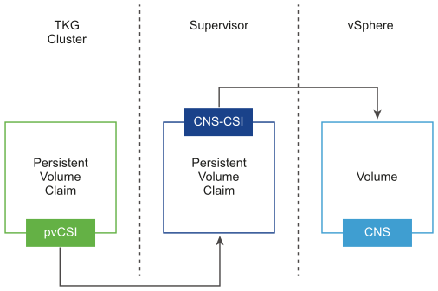

Storage Class Editions for VKS Clusters
To configure a vSphere Namespace, you assign one or more vSphere storage policies. When the vSphere storage policy is applied, it is converted to a Kubernetes storage class and replicated on Supervisor. Likewise the VKS controller replicates the storage class on each VKS cluster deployed in that vSphere Namespace.
On the VKS cluster side you will see two editions of the storage class: one with the user-defined name specified when the vSphere storage policy was created, and the other with *-latebinding appended to the name.
The late binding edition of the storage class can be used by developers to bind to a persistent storage volume after the compute node is selected by the VKS pod scheduler. For more information on which storage class to use and when, see Using Storage Classes for Persistent Volumes.
kubectl get sc
NAME PROVISIONER RECLAIMPOLICY VOLUMEBINDINGMODE ALLOWVOLUMEEXPANSION AGE
wcpglobal-storage-profile csi.vsphere.vmware.com Delete Immediate true 2m43s
wcpglobal-storage-profile-latebinding csi.vsphere.vmware.com Delete WaitForFirstConsumer true 2m43s

vSphere Namespace Creation
There are several ways in which to create vSphere Namespaces.
Administrators can create vSphere Namespaces using the vSphere Client. See Create a vSphere Namespace for Hosting VKS Clusters.
vCenter Single Sign-On users who are granted the Owner role permission for a vSphere Namespace can create vSphere Namespaces in a self-service manner using kubectl. See Enable vSphere Namespace Creation Using Kubectl.
VMware exposes vCenter APIs for managing the life cycle of vSphere Namespaces, and provides software development kits (SDKs), including:
- The Namespace Management APIs provide REST-based resources for managing vSphere Namespaces.
- The Namespaces APIs provide REST-based resources to manage access control of subjects on vSphere Namespaces.
- The vSphere Automation SDK for Java provides several packages for automating the creation and life cycle management of vSphere Namespaces.
- Likewise the vSphere Automation SDK for Python provides several packages for automating the creation and life cycle management of vSphere Namespaces.

Create a vSphere Namespace for Hosting VKS Clusters
You provision VKS clusters in a vSphere Namespace.
Create a vSphere Namespace to host one or more VKS clusters.
Procedure
- Log into vCenter using the vSphere Client.
- SelectSupervisor Management > Namespaces > New Namespace.
- Select the vSphere cluster where Supervisor is enabled.
- Enter a name for the vSphere Namespace.
The name must be in a DNS-compliant format and the name must be unique across all Supervisor instances managed by vCenter.
- Enter a description for the vSphere Namespace.
- Specify the Namespace Network based on the type of network stack used for Supervisor.
Network Stack
vSphere Networking | Select a Workload Network from the Network menu.
NSX Networking | Inherit the network from Supervisor, in which case no action is needed.  Or, select Override cluster network settings and customize the network for this vSphere Namespace. See Override Workload Network Settings for a vSphere Namespace.
- Click Create to create the vSphere Namespace.
The namespace is created on the Supervisor.
- Configure the vSphere Namespace for VKS clusters. See Configure a vSphere Namespace for VKS Clusters.

Configure a vSphere Namespace for VKS Clusters
You deploy one or more VKS clusters in a vSphere Namespace. Configuration settings applied to the vSphere Namespace are inherited by each VKS cluster deployed there.

Configure Persistent Storage for the vSphere Namespace
You can assign one or more vSphere storage policies to a vSphere Namespace. An assigned storage policy controls datastore placement of persistent volumes in the vSphere storage environment.
Typically a vSphere administrator defines a vSphere storage policy. If you are using vSphere Zones, the storage policy must be configured with the Zonal topology. See Create a vSphere Storage Policy for VKS Clusters.
To assign a vSphere storage policy to a vSphere Namespace:
- Select Supervisor Management > Namespace and the target vSphere Namespace.
- From the Storage tile, select Add Storage.
- Select one or more storage policies from the available options.
For each vSphere storage policy you assign to a vSphere Namespace, the system creates two matching Kubernetes storage classes in that vSphere Namespace. These storage classes are replicated to each VKS cluster deployed in that vSphere Namespace. See Using Storage Classes for Persistent Volumes.

Set Capacity and Usage Limits for the vSphere Namespace
When you configure a vSphere Namespace, a resource pool for the vSphere Namespace is created on vCenter. By default this resource pool is configured without any capacity and usage quota; resources are limited by the infrastructure.
In the Capacity and Usage tile for the vSphere Namespace, you can configure the following Limits.
CPU | The amount of CPU resources to reserve for the vSphere Namespace.
Memory | The amount of memory to reserve for the vSphere Namespace.
Storage | The total amount of storage space to reserve for the vSphere Namespace.
Storage Policy Limit | Set the amount of storage dedicated individually to each of the storage policies that are associated with the vSphere Namespace.
Typically, for VKS cluster deployments, you do not need to configure resource quota on the vSphere Namespace. If you do assign quota limits, it is important to understand their potential impact on VKS clusters deployed there.
CPU and Memory Limits
Storage and Storage Policy Limits

Associate the VKr Content Library with the VKS
To provision VKS clusters you have to associate a content library with VKS on the Supervisor.
- Create a content library for hosting VKr images.
For information, see Create a Local Content Library for the Air-Gapped Environment or Create a Subscribed Content Library.
- Add a content library to the Supervisor.
See Add or Update VKS Content Libraries on a Supervisor.

Associate VM Classes with the vSphere Namespace
vSphere Supervisor provides several default Using VM Classes with VKS Clusters, and you can create your own.
To provision a VKS cluster, associate one or more Using VM Classes with VKS Clusters with the target vSphere Namespace. Bound classes are available for use by VKS cluster nodes deployed in that vSphere Namespace.
To associate the default VM classes with a vSphere Namespace, log in to the vCenter using the vSphere Client and complete the following procedure.
- Select Supervisor Management > Namespace and the target vSphere Namespace.
- For the VM Service tile, select Add VM Class.
- Select each of the VM classes you want to add.
  - To add the default VM classes, select the check box in the table header on page 1 of the list, navigate to page 2 and select the check box in the table header on that page. Verify that all classes are selected.
  - To create a custom class, click Create New VM Class. Refer to the VM Services documentation for instructions.
- Click OK to complete the operation.
- Confirm that the classes are added. The VM Service tile shows Manage VM Classes.

Verify vSphere Namespace Configuration
A configured vSphere Namespace includes Status, Permissions, Storage, Capacity and Usage, Content Library, and VM Classes.
Figure 4-22. Configured vSphere Namespace
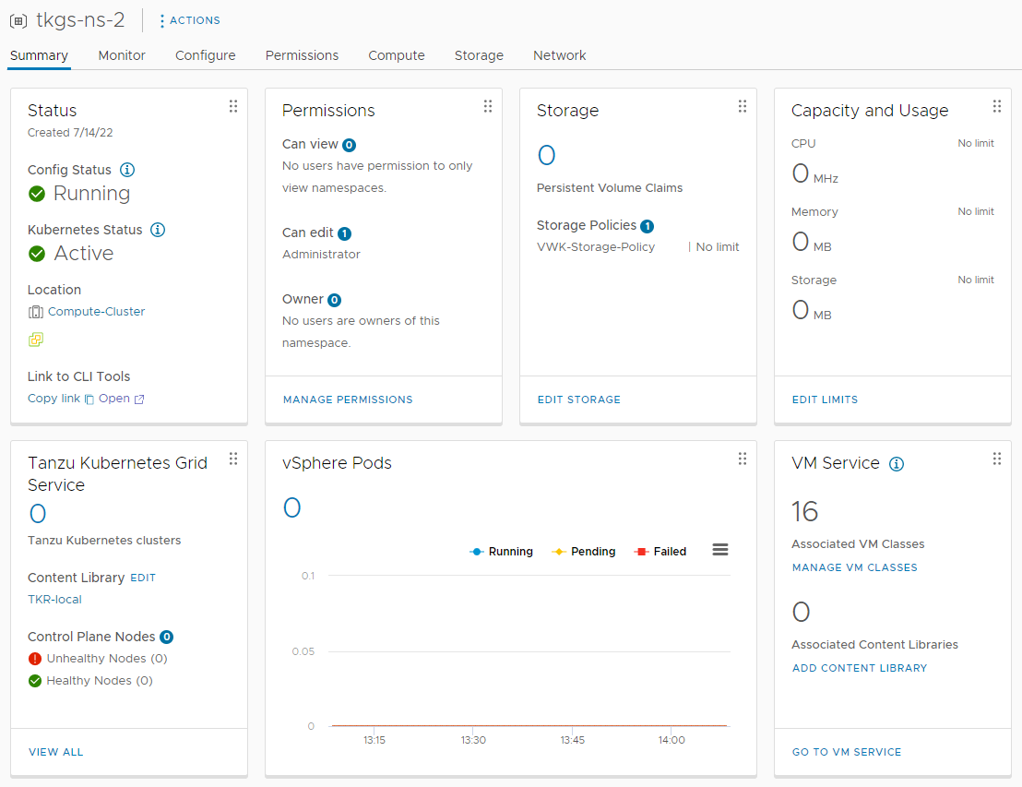
The Status tile includes a link to VCF CLI. The DevOps page is served by the Supervisor control plane load balancer. Provide the link to VKS cluster users to download VCF CLI.

Configure vSphere Namespace Permissions for vCenter Single Sign-On Users and Groups
Set permissions on the vSphere Namespace so that vCenter Single Sign-On users and groups can access VKS clusters provisioned there.
Once you have created a vSphere Namespace, you configure it for VKS clusters by adding users/groups and assigning roles. See Configure a vSphere Namespace for VKS Clusters.
Prerequisites
Users, groups, and role permissions are set at the vSphere Namespace level. To access Supervisor and VKS clusters, you must first create a vSphere Namespace. See Create a vSphere Namespace for Hosting VKS Clusters.
Procedure
- Log into vCenter using the vSphere Client.
- Select Workload Management > Namespaces.
- Select the vSphere Namespace you created.
- Select Permissions > Add Permissions.
- Identity Source: Select vsphere.local for vCenter SSO users and groups.
Note If you are using an external identity provider, see Connecting to VKS Clusters on Supervisor Using an External Identity Provider.
- User/Group Search: Select the vCenter SSO user or group configured for TKG cluster operations or TKG developers.
- Role: Assign the user or group to a role by selecting the appropriate role: Can View, Can Edit, or Owner.
Can View | Can read TKG cluster objects in the vSphere Namespace. No permissions mapped to Kubernetes roles. See Role Permissions and Bindings.
Can Edit | Can create, read, update, and delete TKG cluster objects in the vSphere Namespace. Can operate TKG clusters provisioned in the vSphere Namespace as the Kubernetes cluster-admin. See Role Permissions and Bindings.
Owner | Same permissions as Can Edit, with the additional permission to create and manage vSphere Namespaces using kubectl. Only available with vCenter SSO. See Role Permissions and Bindings.
- Complete the configuration of the vSphere Namespace. See Configure a vSphere Namespace for VKS Clusters.

Override Workload Network Settings for a vSphere Namespace
When you deploy Supervisor, you configure the default settings for the workload network. If you have enabled Supervisor with NSX networking, you can override the default workload network settings when you create a vSphere Namespace. Overridden workload network settings apply only to this vSphere Namespace segment.

Override Workload Network Settings (NSX Only)
When you create a vSphere Namespace, a network segment is created. By default, this network segment is derived from the Workload Network configured in Supervisor. See vSphere Namespace Network for more information.
If Supervisor is configured with NSX networking, during the creation of a vSphere Namespace, you have the option of choosing to Override cluster network settings for the vSphere Namespace. Choosing this option lets you customize the vSphere Namespace network by adding CIDRs to the Ingress, Egress, and Namespace Network fields. The new CIDRs you add override existing CIDRs for this vSphere Namespace instance.
If you have configured NSX version 4.1.1 or later, and have installed, configured, and registered the NSX Advanced Load Balancer version 22.1.4 or later with Enterprise license on NSX, the load balancer that is used with NSX is NSX Advanced Load Balancer. If you have configured versions of NSX earlier than 4.1.1, the NSX load balancer is used. For more information, see Supervisor Networking in the Supervisor documentation.
The typical use case for overriding Supervisor network settings is to provision a VKS cluster with routable pod networking. Refer to the configuration settings in the table for details on how to do this and links to examples.
Table 4-10. vSphere Namespace Network Planning Considerations
Consideration | Description
NSX Required | To override Supervisor network settings for a particular vSphere Namespace, Supervisor must be configured with NSX networking.
NSX Installation | To override Supervisor network settings for a particular vSphere Namespace, the installation of NSX must include an Edge Cluster dedicated for Tier-0 Gateways (routers) and another Edge Cluster dedicated for Tier-1 Gateways. Refer to the NSX installation guide Installing and Configuring vSphere with Tanzu.
IPAM Required | If you override Supervisor network settings for a particular vSphere Namespace, the new vSphere Namespace network must specify Ingress, Egress, and Namespace Network subnets that are unique from Supervisor and from any other vSphere Namespace network. You will need to manage IP address allocation accordingly.
Supervisor Routing | Supervisor must be able to route directly to the VKS cluster nodes and ingress subnets. When selecting a Tier-0 Gateway for the vSphere Namespace, you have two options for configuring the required routing:  - Use a Virtual Routing and Forwarding (VRF) Gateway to inherit the configuration from the Supervisor Tier-0 Gateway  - Use the Border Gateway Protocol (BGP) to configure routes between the Supervisor Tier-0 Gateway and the dedicated Tier-0 Gateway  Refer to the NSX Tier-0 Gateways documentation for details on these options.
Configuration fields for overriding Supervisor network settings.
Table 4-11. vSphere Namespace Configuration Options for Overriding Workload Network Settings
Component | Configuration
Tier-0 Gateway | The NSX Tier-0 Gateway connects Supervisor to the physical network. The selected Tier-0 Gateway will be associated with the Tier-1 Gateway that is created for the vSphere Namespace.  Selecting a new Tier-0 Gateway overrides the Tier-0 Gateway configured when Supervisor was enabled. In this case you must configure new CIDR ranges. If you select a VRF Gateway that is linked to the Tier-0 Gateway, the network and subnets are automatically configured.  Once you select a Tier-0 Gateway and complete its configuration, you cannot change the Tier-0 Gateway.
Load Balancer Size | Select the size of the load balancer instance on the Tier-1 gateway for the vSphere Namespace.  Set the size of the load balancer to small (default), medium or large. Only a set number of Load balancer instances per Edge Node can be defined. Refer to Config Max for details.  Note If you are using the NSX Advanced Load Balancer, this setting is supported beginning with vSphere 8 U2 and avi-22.1.5.
NAT Mode | NAT mode is selected by default. This means that the Namespace Network subnet is expected to be non-routable, and you must configure the Namespace Network, Ingress, and Egress CIDRs.  Deselecting NAT mode tells the system you are going to provide a routable CIDR range for the Namespace Network. If you deselect NAT mode, the VKS cluster node IP addresses are directly accessible from outside the Tier-0 Gateway, and you do not have to configure the Egress CIDR.  To provision a cluster using no NAT mode, deselect NAT mode and refer to the examples: Provisioning VKS Clusters.
Namespace Network CIDR | The Namespace Network CIDR is a subnet that operates as an IP pool whereby the Namespace Subnet Prefix describes the size of any subsequent CIDR block that is carved out from that IP pool.  Each time a vSphere Namespace is created, a subnet from the Namespace Network is allocated. The subnet size carved out from this block is /24, which means a maximum of 256 pods can be created per vSphere Namespace. Refer to Config Max for details.  The Namespace Network CIDR is used to allocate IP addresses to VKS clusters attached to vSphere Namespace segments.  If NAT mode is selected, the CIDR is expected to be non-routable. If NAT mode is unchecked, Namespace Network CIDR must be routable.
Namespace Subnet Prefix | Enter the subnet prefix that specifies the size of the subnet reserved for namespaces segments. Default is 28.  Namespace subnet prefix defines the IP subnet created for each vSphere Namespace segment. For example, setting a /24 prefix would result in a vSphere Namespace segment with an IP subnet of 254 IP addresses to allocate to VKS clusters deployed there.  Additional example:  Namespace Network CIDR = 192.168.1.0/24  Namespace Subnet Prefix = /28  In this case, VKS can provide 16x 192.168.1.x/28 CIDR blocks from the 192.168.1.0/24 subnet. This allows the instantiation of 16 VKS cluster Namespace networks to which your VKS-managed VMs are connected to. For example, every cluster receives a dedicated Namespace CIDR and in this case that could be 192.168.1.0/28 and the next cluster namespace subnet would be 192.168.0.16/28 and so on.
Ingress | Ingress IP CIDR block is used to allocate IP addresses for Kubernetes services that are published by a service type load balancer and by an ingress controller across all vSphere Namespaces. VKS cluster services and ingress get their IP addresses from this CIDR block.  Enter a CIDR annotation that determines the ingress IP range for the virtual IP addresses published by the load balancer service for VKS clusters.  Note This setting is not applicable for the NSX Advanced Load Balancer.
Egress | Egress IP CIDR is used to allocate IP addresses for SNAT (Source Network Address Translation) for traffic exiting the vSphere Namespace to access external services.  Enter a CIDR annotation that determines the egress IP range for the SNAT IP addresses.

Using VM Classes with VKS Clusters
To size VKS cluster nodes, you specify the virtual machine (VM) class. The platform provides default VM classes, and you can create your own. To use a VM class, you associate it with the target vSphere Namespace and reference the class in the cluster manifest.

About VM Classes
A virtual machine (VM) class is a request for resource reservations for processing power on the virtual machine (VM), including CPU and memory (RAM). For example, the VM class type named "guaranteed-large" reserves 4 CPU and 16 GB RAM.
Note The VM disk size is set by the OVA template, not the VM class definition. For vSphere Kubernetes releases, the disk size is 16 GB.
There are two reservation types for VM classes: guaranteed and best effort. The guaranteed class fully reserves its configured resources. This means that for a given cluster the spec.policies.resources.requests matches the spec.hardware settings. The best effort class allows resources to be overcommitted. For production workloads it is recommended that you use the guaranteed VM class type.
Warning Because the best effort VM class type allows resources to be overcommitted, you can run out of resources if you have set limits on the vSphere Namespace where you deploy the VKS cluster. If contention occurs and the control plane is impacted, the cluster may stop running. For this reason use the guaranteed VM class type for production clusters. If you cannot use the guaranteed VM class type for all production nodes, at a minimum use guaranteed for the control plane nodes.

Using VM Classes with VKS Clusters
To use a VM class with a VKS cluster, the VM class must be bound to the vSphere Namespace where the cluster is provisioned. To do this, you associate the class with the target namespace. See Configure a vSphere Namespace for VKS Clusters.
To list the VM classes available in the target vSphere Namespace, use the command kubectl get virtualmachineclass.
Note If you experience issues with this command, see Troubleshoot VM Class Errors.
VM class definitions are not immutable. Any VM class can be edited, including the default VM class definitions. If a VM class is edited, existing VKS cluster nodes remain unaffected. New VKS clusters use the modified class.
Caution If you edit a VM class that is in use by a VKS cluster, and then scale out that cluster, the new node(s) will use the edited class definition, but the existing nodes will use the initial class definition, resulting in a mismatch of classes.

Default VM Classes
The table lists default VM class types that are used as deployment sizes for VKS cluster nodes.
To avoid overcommitting resources, production workloads should use the guaranteed class type. To avoid running out of memory, do not use the small or extra small class size for any worker node where you are deploying workloads in any environment (development, test, or production).
Note If your storage class specifies 4KN as a target storage format for persistent volumes, make sure to use VM classes compatible with ESX 9.0 and later.
Table 4-12. Default VM Classes
Class | CPU | Memory (GB) | Reserved CPU and Memory
guaranteed-8xlarge | 32 | 128 | Yes
best-effort-8xlarge | 32 | 128 | No
guaranteed-4xlarge | 16 | 128 | Yes
best-effort-4xlarge | 16 | 128 | No
guaranteed-2xlarge | 8 | 64 | Yes
best-effort-2xlarge | 8 | 64 | No
guaranteed-xlarge | 4 | 32 | Yes
best-effort-xlarge | 4 | 32 | No
guaranteed-large | 4 | 16 | Yes
best-effort-large | 4 | 16 | No
guaranteed-medium | 2 | 8 | Yes
best-effort-medium | 2 | 8 | No
guaranteed-small | 2 | 4 | Yes
best-effort-small | 2 | 4 | No
guaranteed-xsmall | 2 | 2 | Yes
best-effort-xsmall | 2 | 2 | No

Custom VM Classes
vSphere Supervisor supports custom VM classes for use with VKS Service clusters. Once you have defined a custom VM class, you must associate it with the target vSphere Namespace before you can use it with a cluster. Refer to the VM Services documentation for details.

System Resource Reservations in VKS Nodes
VKS nodes reserve a portion of CPU and memory for system components that are required for Kubernetes and VKS to function reliably. These reservations ensure that critical system processes do not compete with application workloads for resources.
Because of these reservations, the allocatable CPU and memory available to workloads is lower than the total capacity defined by the VM class used for the node.

Node Resource Reservations
To ensure cluster and node stability, VKS reserves resources for essential system daemons. These reservations ensure that critical system components do not compete with user workloads for CPU and memory.
Note System resource reservations are supported on Linux nodes only. This functionality is not available for Windows nodes.
Because of these reservations, a difference exists between the node's total resources, which are based on the underlying VM class, and the resources available for application requests.

CPU Reservations
The systemReserved CPU in a VKS node is calculated using the following formula, which is based on the total capacity of the underlying virtual machine. This calculation determines the amount of CPU resources reserved exclusively for system daemons.
- 6% of first 1000m (first core)
- 1% of next 1000m (up to 2000m, or two cores)
- 0.5% of next 2000m (up to 4000m, or four cores)
- 0.25% of cores above 4000m (above four cores)
The following example illustrates how to calculate the CPU reserved for a best-effort-large VM class (four cores) used in a node:
- Total CPU: 4000m
- Calculations for systemReserved:
  - First 1000m x 6% = 60m
  - Next 1000m x 1% = 10m
  - Next 2000m x 0.5% = 10m
  - CPU reserved = 80m (~0.08 CPU)
- Allocatable CPU:
4 CPU - 0.08 CPU = 3.92 CPU

Memory Reservations
By default, the reserved memory in a VKS node is calculated using the following method to determine the systemReserved value.
- For memory < 1024 Mi: 255 MiB reserved
- For memory = >24 MiB:
  - 25% of first 4096 MiB
  - 20% of next 4096 MiB (up to 8192 MiB)
  - 10% of next 8192 MiB (up to 16384 MiB)
  - 6% of next 114688 MiB (up to 131072 MiB)
  - 2% of any memory above 131072 MiB
If you want to change the default value, keep in mind the following:
- systemReserved is configurable in the ClusterClass as part of the resourceConfiguration variable. It uses the calculation above by default, but you can optionally override this value starting with VKS 3.2. See resourceConfiguration.
- Eviction threshold is set to the Kubernetes default of 100 MiB. This value is not configurable.
- kubeReserved is set to 0 and is not configurable.
The following example illustrates the memory reserved for a best-effort-large VM class (16 GB memory) used in a node:
- Total memory: 15258.8 MiB
- Calculations for systemReserved:
  - First 4096 MiB x 25% = 1024 MiB
  - Next 4096 MiB x 20% = 819 MiB
  - Next 8192 MiB x 10% = 819 MiB
  - Memory reserved = 2662 MiB (~2.7 GB)
- Eviction threshold is 100 MiB (~0.1 GB)
- Allocatable memory = 16 GB - 2.8 GB = 13.2 GB

Allocatable Resources for Default VM Classes
Using the above reservation model, allocatable CPU and memory for default VM classes are calculated as follows.
Note The small and xsmall VM classes are not recommended for running application workloads. See Using VM Classes with VKS Clusters.
In the table, 1 vCPU = 1000 millicore.
VM class | CPU Capacity (vCPU/millicore) | Reserved CPU (vCPU) | Allocatable CPU (vCPU) | Memory Capacity (GB/GiB) | Reserved Memory (GB) | Allocatable Memory (GB)
8xlarge | 32/32000 | 0.15 | 31.85 | 128/119.209 | 9.55 | 118.45
4xlarge | 16/16000 | 0.11 | 15.59 | 128/119.209 | 9.55 | 118.45
2xlarge | 8/8000 | 0.09 | 7.91 | 64/59.6046 | 5.71 | 58.29
xlarge | 4/4000 | 0.08 | 3.92 | 32/29.8023 | 3.79 | 28.21
large | 4/4000 | 0.08 | 3.92 | 16/14.9012 | 2.78 | 13.22
medium | 2/2000 | 0.07 | 1.93 | 8/7.45058 | 1.92 | 6.08
small | 2/2000 | 0.07 | 1.93 | 4/3.72529 | 1.11 | 2.89
xsmall | 2/2000 | 0.07 | 1.93 | 2/1.86265 | 0.61 | 1.39

Verify vSphere Namespace Readiness for Hosting VKS Clusters
Once you have configured a vSphere Namespace, log in to Supervisor and verify that the vSphere Namespace is ready for hosting VKS clusters.

Verify vSphere Namespace Configuration for VKS Service Cluster Provisioning
In preparation for provisioning VKS clusters, complete this task to verify that the vSphere Namespace is properly configured.
- Log in to the Supervisor and switch to the target namespace.
See Connecting to vSphere Supervisor and VKS Clusters.
- Describe the vSphere Namespace.
kubectl describe ns VSPHERE-NAMESPACE-NAME
This command returns the name of each storage class available in the vSphere Namespace as well as resource quota.
- List and describe the available vSphere Kubernetes releases.
kubectl get tanzukubernetesreleases
This command returns those VKrs that are in the content library configured for the vSphere Namespace and that have been synchronized with or uploaded to the library.
- List the available virtual machine classes.
kubectl get virtualmachineclass
This command returns the VM classes that are associated with the namespace. Only bound VM classes can be used to provision VKS cluster nodes.

Enable vSphere Namespace Creation Using Kubectl
You can enable the vSphere Namespace Service to let developers manage the lifecycle of vSphere Namespaces using kubectl.
By enabling the vSphere Namespace Service on Supervisor, developers assigned to the Owner role in a vSphere Namespace can create their own vSphere Namespaces using the kubectl create namespace <NAME> command.
When you enable the vSphere Namespace Service, you define a namespace template and activate it. Developers who are assigned to the Owner role use the template to create namespaces.
Procedure
- Log into the vCenter using the vSphere Client.
- Select Supervisor Management > Supervisors and select the Supervisor instance.
- In the Configure tab, select Supervisor > General.
- Select Namespace Service.
- Toggle the Status switch to enable the feature.
The Create Namespace Template page appears.
- In the Configuration pane, configure resource limitations to the namespace.
Option | Description
CPU | The amount of CPU resources to reserve for the namespace.
Memory | The amount of memory to reserve for the namespace.
Storage | The total amount of storage space to reserve for the namespace.
Storage Policy | Set the amount of storage dedicated individually to each of the storage policies that you associated with the namespace.
VM Classes | Select the VM classes. Use Ctrl to select multiple.
Content Library | Select the VKr content library.
- Click Next.
- In the Permissions pane, add DevOps engineers and groups to empower them to use the template to create namespaces.
  - Select the vsphere.local identity source (must use vSphere SSO)
  - Select a user or a group
  - Select the Owner role
- In the Review and Confirm pane, the properties you configure are displayed.
Review the properties and click Done.
- Verify that the vSphere Namespace Service is Active.
A vSphere Namespace template is configured and is in Active state. vSphere Namespace users/groups assigned to the Owner role can use the template to create vSphere Namespaces using the kubectl command kubectl create namespace <NAME>.

Integrating TMC with VKS Clusters
This section provides topics for integrating Tanzu Mission Control with VKS clusters.

Registering Tanzu Mission Control Hosted with Supervisor
You can integrate VKS on Supervisor with Tanzu Mission Control. Doing so allows you to manage VKS clusters using the TMC web interface.

Using VKS Clusters with Tanzu Mission Control
The general workflow for using VKS clusters with Tanzu Mission Control and Tanzu Application Platform is as follows:
Step | Action
1 | Provision a VKS workload cluster  See Provisioning VKS Clusters
2 | Register Supervisor with TMC  See Register Supervisor with Tanzu Mission Control
3 | Attach the VKS workload cluster to TMC  See Managing the Lifecycle of Tanzu Kubernetes Clusters in the VMware Tanzu Mission Control Product Documentation
4 | Install Tanzu Application Platform  See Tanzu Application Platform documentation

Register Supervisor with Tanzu Mission Control
Supervisor ships with a vSphere Namespace dedicated for Tanzu Mission Control. To register Supervisor with Tanzu Mission Control, install the TMC Agent in the vSphere Namespace and complete the registration process using TMC.
Complete this procedure to install the TMC Agent on Supervisor. Note that this procedure requires you to use the vSphere Client and TMC web interface simultaneously.
- Log in to the Supervisor.
See Connecting to vSphere Supervisor and VKS Clusters.
- Run the following command to list the namespaces.
kubectl get ns
- The vSphere Namespace for TMC is named svc-tmc-cXX (where XX is a number). Verify that it exists and is active.
- Log in to the Tanzu Mission Control web interface.
- Register Supervisor with Tanzu Mission Control. See Register a Management Cluster with Tanzu Mission Control in the VMware Tanzu Mission Control Product Documentation .
- Using the Tanzu Mission Control web interface, copy the Registration URL for Supervisor that is available at the Administration > Management Clusters page.
- If necessary, open a firewall port on Supervisor for the port required by Tanzu Mission Control (typically 443). See Outbound Connections Made by the Cluster Agent Extensions in the VMware Tanzu Mission Control Product Documentation .
- Log in to the vSphere Supervisor environment using the vSphere Client.
- Select Supervisor Management and the target Supervisor.
- Select Configure and select Kubernetes Service > Tanzu Mission Control.
- Paste the registration URL in the Registration URL field.
- Click Register.
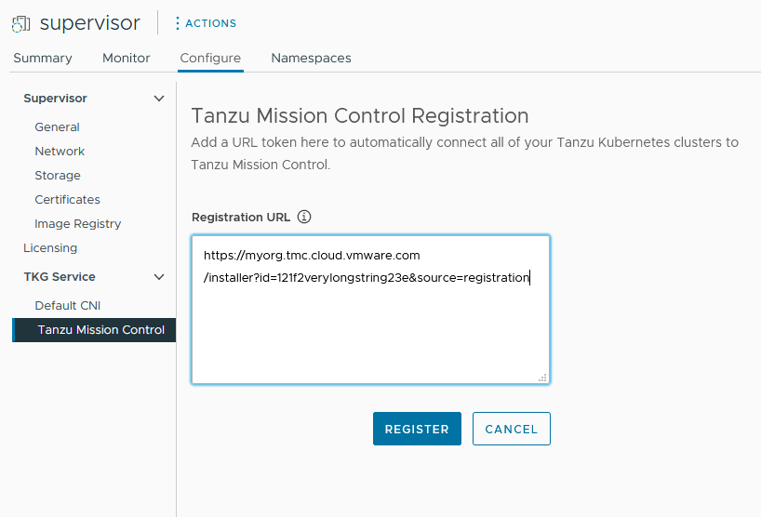
Once Supervisor is registered with TMC, use the TMC web interface to provision and manage VKS clusters. Refer to the VMware Tanzu Mission Control Product Documentation for instructions.

Uninstall the Tanzu Mission Control Agent from Supervisor
To uninstall the Tanzu Mission Control agent from the Supervisor, see Manually Remove the Cluster Agent from a Supervisor Cluster in vSphere with Tanzu in the VMware Tanzu Mission Control Product Documentation .

Registering Tanzu Mission Control Self-Managed with Supervisor
To register Tanzu Mission Control Self-Managed with Supervisor, create and apply a custom resource definition for the TMC Agent.

About Tanzu Mission Control Self-Managed
For more information about Tanzu Mission Control Self-Managed, including how to install and configure, refer to the documentation Installing and Running VMware Tanzu Mission Control Self-Managed.

Register Tanzu Mission Control Self-Managed with Supervisor
To integrate Tanzu Mission Control Self-Managed with Supervisor, create a custom resource definition with that references the TMC Agent. Supervisor includes a Kubernetes namespace for TMC where the agent is installed.
Complete the following procedure.
- Install Tanzu Mission Control Self-Managed as described in the documentation. See Installing and Running VMware Tanzu Mission Control Self-Managed.
- Using a web browser, access the Tanzu Mission Control Self-Managed local deployment.
- Export the root CA certificate for the Tanzu Mission Control Self-Managed installation.
  - If you are using a well-known CA, click the lock icon to the left of the address bar in the browser and view the certificate. If you are using a private CA, click the not secure button and view the certificate.
  - On the certificate dialog pop-up, select the Details tab and then the Exportbutton to download a copy of the CA cert.
  - Open the ca cert file with the text editor of your choice to access the CA cert content
- Log in to the Supervisor and switch to the target namespace where the VKS cluster running Tanzu Mission Control Self-Managed is provisioned.
See Connecting to vSphere Supervisor and VKS Clusters.
- Run the following command to list the Kubernetes namespaces.
kubectl get ns
- The Kubernetes namespace on Supervisor for TMC is named svc-tmc-cXXXX (where XXXX is a number). For example, svc-tmc-c1208. Verify that this Kubernetes namespace exists and is active.
- Use a text editor to create the custom resource definition named agentconfig.yaml. This file includes the TMC namespace, the hostname of your TMC Self-Managed deployment, and the CA cert contents.
  - Enter the name of the Kubernetes Namespace for TMC in the namespace field.
  - Enter the CA certificates in the caCerts fields.
  - Enter the TMC host name in the allowedHostNames field.
apiVersion: "installers.tmc.cloud.vmware.com/v1alpha1"
kind: "AgentConfig"
metadata:
name: "tmc-agent-config"
namespace: "<namespace>"
spec:
caCerts: |-
-----BEGIN CERTIFICATE-----
Certificate1
-----END CERTIFICATE-----
-----BEGIN CERTIFICATE-----
Certificate2
-----END CERTIFICATE-----
allowedHostNames:
- "google.com"
- Apply the AgentConfig yaml file that you created.
kubectl apply -f agentconfig.yaml
- Complete the registration process using the web interface for your Tanzu Mission Control Self-Managed installation. Refer to the Tanzu Mission Controldocumentation for instructions.

